# ENTITY

### Entity

entity is like a class in java which is basically a kind of business object having a set of properties and methods. Example Policy entity or claim entity.

### Entity types

* Non-Persistent entity (virtual entity)
* Subtype entity
* Delegate entity
* View entity

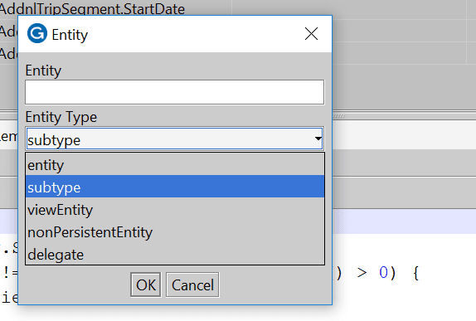

### Virtual entity

virtual entities are entities constructed entirely within the code. They exist during the run time but the data from them is neither read from the database nor written to the database.

### Can we create object of super type entity?

Super type entities are abstract in nature; therefore, it is not possible to create an object of parent entity.

### Difference between ETX and ETI?

ETX file contains an extension which extends a base entity whereas ETI file defines a new entity.

### EIX entity

These entities are specific to guidewire base application and can be found in metadata folder. These are read only.

### Entity fields

* Data
* Foreign key
* Array key
* Typekey

### Array Key Field

Array key field stores reference of related object in the data field. These fields are not stored inside the database

### Subtype entity

Subtyped entities are entities that share the parent child relationship. All the fields in the parent entity are inherited by the child entity. Here for the subtype entities a separate table is not maintained instead the details of the child table are also stored in the parent table only.

for the super type entity, it is not possible to create the object as it is abstract in nature. Example for ABContact we cannot create the object. However, we can create the object at the child level therefore we can create the object for ABPerson, ABVendor or ABVenue.

### Major subtype entities in claimcenter

1. Incident.etx
   1. Injury Incident
   2. Vehicle Incident
   3. Property Incident
   4. Dwelling Incident
   5. Property Incident
2. Contact.etx
   1. Person
   2. Place
   3. Venue
3. Transaction.etx
   1. Payment
   2. Reserve
   3. RecoveryReserve
   4. Recovery

### Application entity

#### Custom entities

* + Customer creates custom entities for the business purpose.
  + Customer can create a completely new entity which will have extension. eti or an existing entity can be extended.
  + Here the entities created will have either (.eti) or (.etx) extension.
  + For custom entities, Guidewire recommends that the entity name should end with _Ext (or start with Ext),

#### Application entities

* + Application entities are specific to application be it claimcenter, policy center or billing center. These entities are provided by the product.
  + These entities can also have (.eti) or (.etx) extension

#### Platform entities

* + These entities are common to all the guidewire applications and can be found in /metadata/entity folder.
  + Such entities have extension of (.eix) type or (.eti) type.
  + These entities are read only and cannot be edited.

### Extendible entity

extendible entity is basically for the use of internal entities provided by the claimcenter. If its set to true, then it’s possible to add more fields to that entity otherwise we cannot.

By default, this field is set to true.

### What is extending an entity

There are entities which are provided already with the application and guidewire allows us to customize them without changing its existing behaviour. Therefore, we cannot edit an entity provided by the application directly. Instead we must create an extension for it.

So here extension is used in order to customize the application entities, like adding new fields in them.

### How to extend an entity?

Choose the eti file, right click and go to entity extension.

### How many extendible entities one entity have?

Mostly there is one extension per entity.

### Can we extend eti?

Yes, we can extend an eti file, but only those eti files we are able to extend which are provided by the application. Any new entity which we create cannot be extended.

### Final entity

If this field is set to true, then it is not possible to create subtype of the entity. By default, this field is set to true

### Can we create multiple subtypes of an entity?

Yes, we can create multiple subtypes of an entity. An example of this is ABContact entity having subtypes Person, Place and Vendor.

### Delegates

* Delegate is an abstract entity.
* This delegate has a certain set of fields and methods and provides different kind of implementation depending upon the behaviour.
* Depending upon the behaviour of the delegate we can incorporate that feature in the entity.
* For example, claim, exposure, activities are assignable in nature as they all incorporate behaviour of delegate “Assignable”
* In order to make any entity have a delegate feature we need to mention “implements” delegate name in the entity.

#### Sample delegates

* Assignable
* Extractable
* Validatable

### Ways to achieve sharing in data model

* Subtype
* Delegate (used when multiple entities need same small feature)
* interface

### DTI (data type information)

.dti is a file which contains the data type information about a specific column parameter. For example, if we use the datatype of varchar then (varchar.dti) file will contain the information about the datatype, that is the kind of parameters we can apply with this datatype.

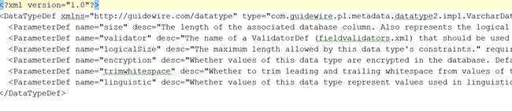

# DATA MODEL

### Data model

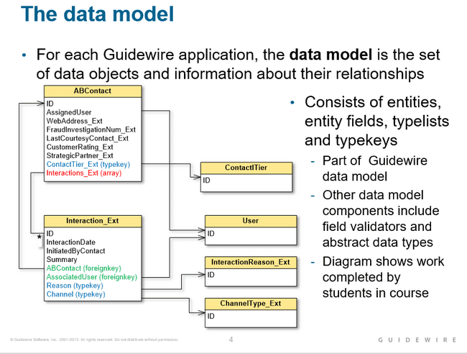

# SUBTYPES

### Subtype entity

Subtype is a child entity which inherits all the properties of the parent entity. Example ABPerson is the child entity which inherits all the properties of the parent entity ABContact.

### Subtype limitation

* child inherits all features of parent’s event unwanted
* child cannot inherit from multiple supertypes

### How to create subtype

To create a subtype, go to entity folder, right click and choose entity. From there we need to specify the type of entity we need to create. Thereafter, choose subtype from that.



Also need to specify the supertype for which the entity is created.

This will create an entity of supertype inheriting all its properties.

### How to create subtype extension?

Extension must be created for the application provided entities. We cannot create an extension for entity created by us.

To create subtype extension, we must choose the application provided entity which can be found in the metadata folder right click and choose entity extension

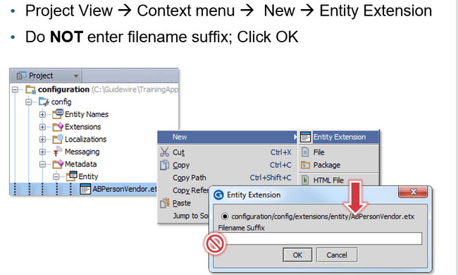

### Extension not allowed

For the entities created by us/user, it is not possible to create entity or subtype extension. Such entities should be directly edited.

### How to create entity and then its subtype

* first create an entity of entity type, which should not be final example entity1
* After that we need to create another entity of type “subtype” and specify the name of supertype “entity1”
* If entity1 is marked as final, then we cannot create the subtype of that particular entity.

# TYPELIST

### What is typelist?

Typelist is a set of defined values when rendered on screen they are displayed in form of dropdown menu.

Typelist are a combination of typekeys that represents set of choices to user in UI.

They can be found in extensions/typelist

Application specific typelist can be found in the metadata

### Kinds of typelist

* Custom typelist which are created by the user (eti)
* Extendable typelist are typelist which user can extend from the application typelist and customize.
* Application typelist are specific to application
* Base typelist are common to all the applications.

### Types of typelist

* Virtual typelist
* Subtype typelist

### Typekey

Typekey is an entity field which is associated with a typelist.

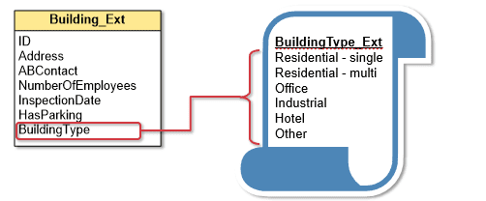

### Typecode

Typecode represents the fields of typelist, that is the choices which user will get to choose from the dropdown.

### How to configure typekey

Add the field Typekey in the entity and specify the associated typelist to it.

### Typelist filter

Typelist filter is used to define a subset of typecodes so that we can control the number of typecodes to display in the user interface.

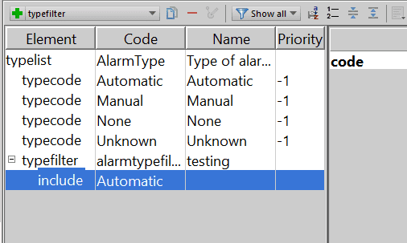

### How to create a typelist filter

We need to choose the typefilter element and then use option “include into filter” option and then specify the typecodes which are needed into the filter.

### How to reference typelist filter

We need to go to the entity and then select the typekey from there. There in the option of typefilter we need to specify the name of the filter.

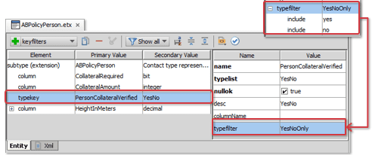

### Typecode category

* Typecode category is used to build relationship between one or more typecodes of parent typelist with one or more typecodes of child typelist.
* So here we are trying to build dependency between two typelist elements.
* So here one typecode of parent could have multiple children of typecodes in child typelist and one typecode of child typelist can have multiple parents.

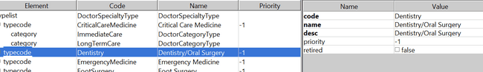

### KeyFilter

* After building the relationship with typecode we need to create a filter to implement the relationship so that when user chooses one typecode from a typelist a certain typecode from another typelist must be shown.
* For example, if doctor category of surgeon is chosen then doctor speciality chosen can be operation
* Similar if doctor category is chosen is ENT then speciality can be something else but not operation which is of a surgeon.
* So here keyfilter is used to filter the typecodes of child typelist depending upon the typecode chosen for the parent typelist.
* But here the key filter will create the dependent dropdown.

### How to implement dependent dropdown

To implement dependent dropdown, we need to

* Create a category first example doctor category entity

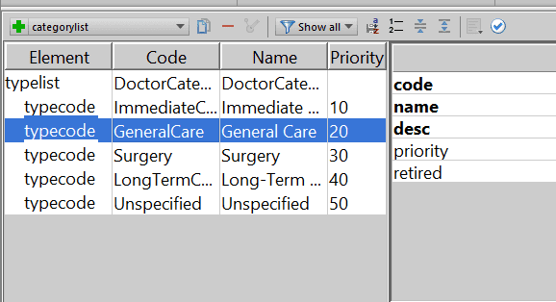

* In whichever typelist we want to have filter, we must create a typecode category and select the typecode from the above category entity.

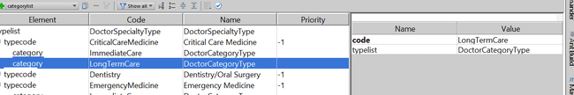

* Now in whichever entity we have the typekey filed for the above typelist we must create a key filter to implement the logic as till now only relationship is build.

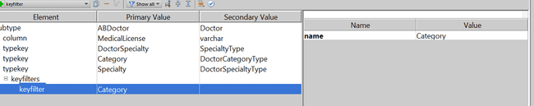

So now first the option to choose doctor category will be given to user which will list all the typecode, next when the option to choose the speciality is given to user it will be filtered based upon the relationship we have built.

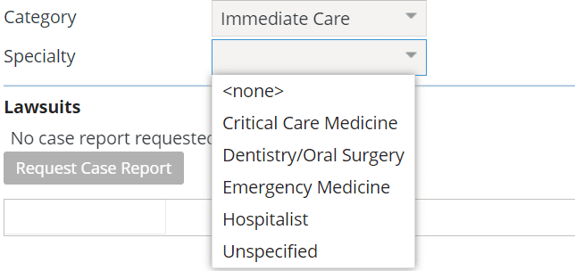

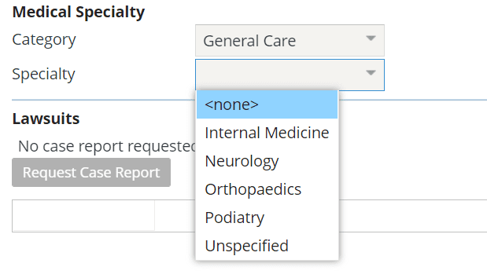

# INTEGRATION-WEB SERVICES

### Guidewire web services

Guidewire web service is a web service hosted by the guidewire application that external systems use.

Guidewire webservices are applicable for integration points when

* The request is synchronous
* External request uses the SOAP protocol.

### What kind of web service guidewire support?

Guidewire support WS -I web services which provides an XSD for data validation.

### Steps to create guidewire WSI- I web service

* Create package
* Create the gosu class
* Add the web service annotations
* Add methods
* Deploy your changes

### Where to create web service in studio?

In studio under the gsrc folder if there is webservice folder then right click on it, and then create the new package. Name the package as needed and inside it create the gosu web services class.

Do not create anything in the gw folder as it is reserved for internal purposes.

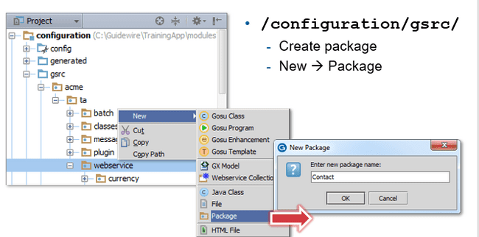

### Gosu class/web service annotations

#### @WsiWebService

This annotation is used to specify that the gosu class is a web service.

#### @WsiPermission

* Annotation used to specify the permissions needed by the user to invoke the web service.

Syntax: @WsiPermission({abedit}) or @WsiPermission ({abedit, abcreate})

* Please note that it is mandatory to specify @WsiPermission. If no permission is needed by the user to invoke the web service, then we must mention like.

@WsiPermission{{}}

* This annotation can be used at the method level as well.

#### @WsiAvailability

This annotation specified the minimum system run level when the web service becomes available.

@WsiAvailability(MAINTAINANCE}

#### @WsiExportable

This annotation is used at the class level to specify that the class object can be used as the return type for the API call from the client and is XML serializable.

### Gosu class object used as return type

* If we want api to return a class object, then that class must be annotated with @WsiExportable annotation.
* And mandatory the class must be declared as final to ensure that is cannot be subtyped.

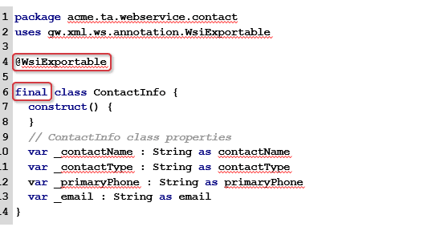

### Can web service return object of guidewire entity?

No, the API cannot return an instance of guidewire entity. It can only return instances of classes which are marked as final and @WsiExportable

### When is WSDL generated?

WSDL is generated when external system requests it.

### When to regenerate WSDL?

When making changes to methods or introducing new methods the WSDL has to be regenerated.

### WSDL url

Localhost:<port>/application_name/ws

Example : localhost:8080/ab/ws

### Consuming external WS-I web service

* Create package for web service collection
* Create web service collection

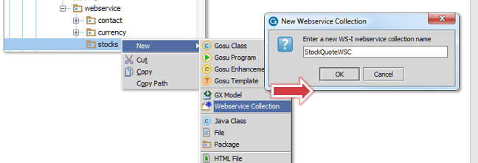

* Fetch the resources
* Restart server
* Reference the web service in gosu

### Sample web service

**package** externalapp.webservice  
**uses** gw.api.server.AvailabilityLevel  
**uses** gw.xml.ws.**annotation**.WsiAvailability  
**uses** gw.xml.ws.**annotation**.WsiWebService  
  
*/*  
  
var value=new acme.ta.webservice.calculatortest.calcwsc.calculatorapi.CalculatorAPI();  
value.Config.Http.Authentication.Basic.Username="su"  
value.Config.Http.Authentication.Basic.Password="gw"  
print("value is " + value.calculate(1,3))  
  
*/*@WsiWebService  
@WsiAvailability(AvailabilityLevel.MAINTENANCE)  
**class** CalculatorAPI {  
  
 **function** calculate(number1: **float**, number2: **float**): **float** {  
 **return** (number1+ number2)  
 }  
}

## Interview

### Can we call web service from batch process(custom or defined)

Yes

### How to generate wsdl for local web services.

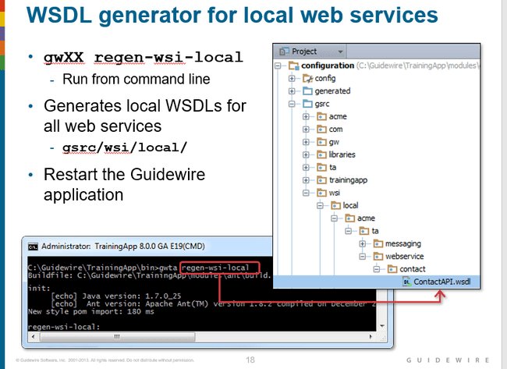

# INTEGRATION-MESSAGING INTRO(C1)

### What is messaging

Messaging is asynchronous integration mechanism between claimcenter and external system.

Messaging is triggered by new or changed business data. The external system replies messages back to the guidewire application.

Example : claimcenter sending request for police report about the accident.

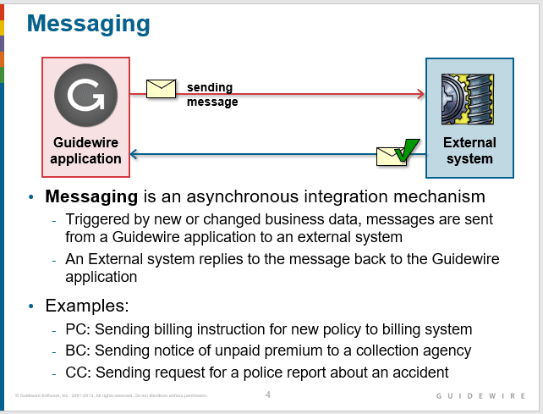

### Why architecture of guidewire messaging is asynchronous?

The overall architecture of messaging is asynchronous. It is possible for a message to be sent to an external system synchronously.

But messages are not processed immediately upon being placed in the message table. Therefore, since the message processing aspect is asynchronous, the overall architecture is asynchronous.

### What is physical message table?

This table stores messages which are unsent or sent waiting acknowledgement or sent but acknowledged with an error.

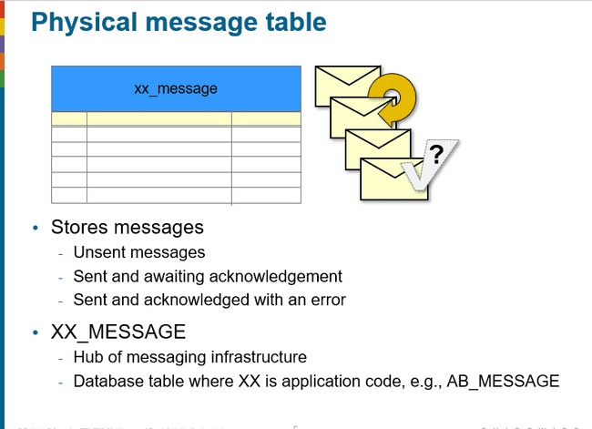

### Message table example

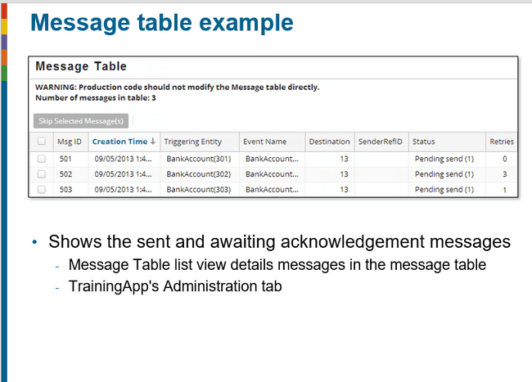

### Stages of messaging

1. Event Fired
2. Payload generation
3. Send message to external system
4. Processing acknowledgement

Message creation is triggered by adding an event to the event aware entity. This almost always involved a data change.

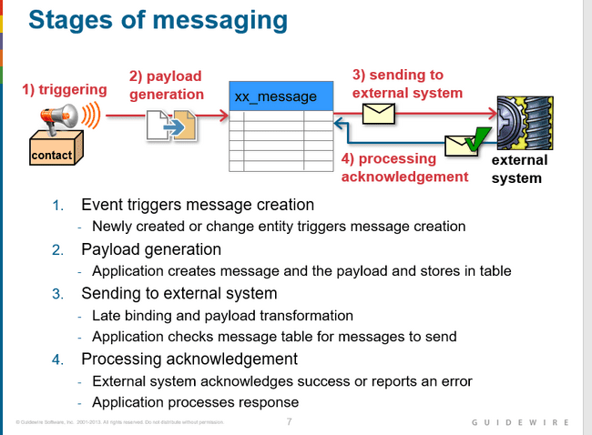

### Primary components of a message

1. Event
2. Event Fired Rule Set
3. Message Payload
4. Message
5. Message table
6. Destination
7. Messaging plugins

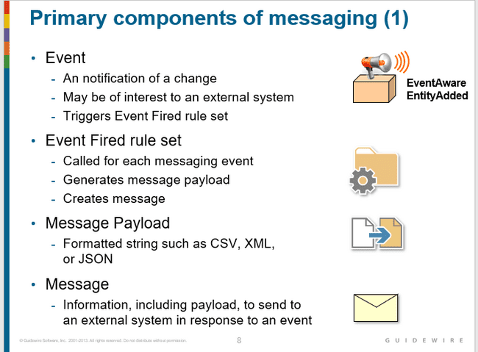

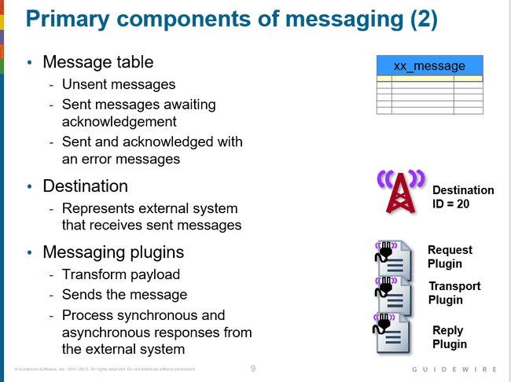

### What are three possible status of message in message table?

1. Sent
2. Not sent
3. Sent waiting acknowledgement

### What Is messageContext?

The MessageContext entity, which is used to simplify creation of the message.

So, using the message context object we can easily create the message. This object can provide us additional details like the triggering entity name and the event associated to it as well.

### What is event aware delegate

For all entities that implement the EventAware delegate, the Guidewire application automatically creates specific events: entityNameChanged, entityNameRemoved, and entityNameAdded.

### Why is there a lag between event fired and the payload print?

This lag is going to occur because the message table is screened for new messages only once in few seconds.

# INTEGRATION-MESSAGING TRIGGERING(C1)

### What are messaging entities

1. Event Aware entity
2. Message Context
3. Message

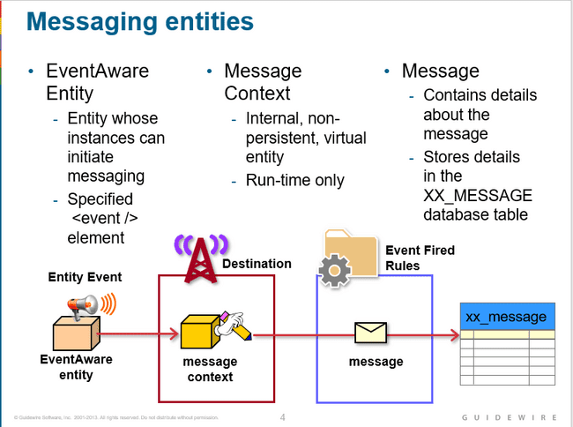

### Event aware entity

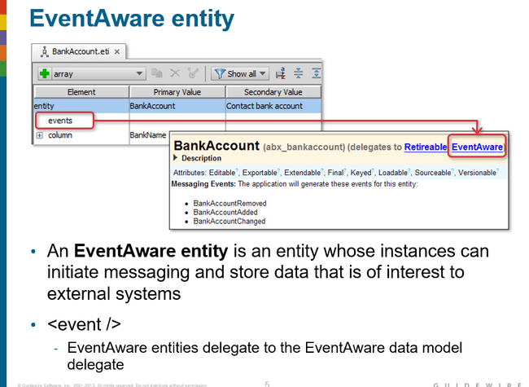

### Messaging events

Messaging event occurs when the instance of the event aware is changed. By default, 3 instances are provided by the guidewire which are Added, Changed and Removed.

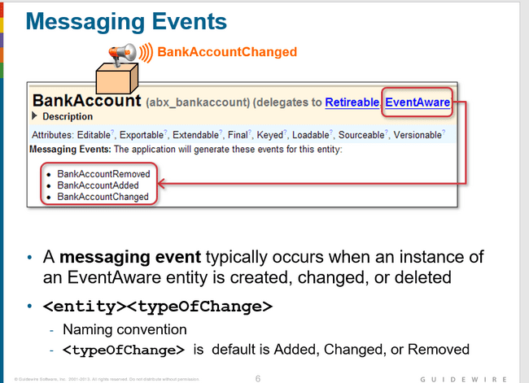

### MessageContext Entity

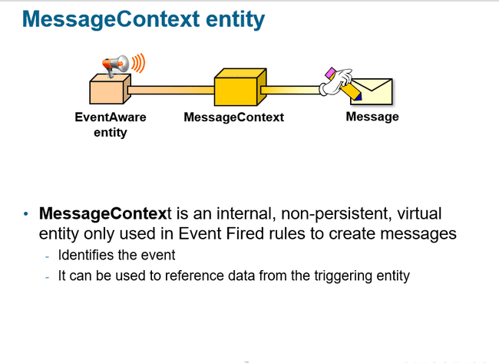

Message Context entity can be used to get information like destination id, event name and root object.

Using message context entity, we can get the data information about the entity which has triggered the message.

### Message entity

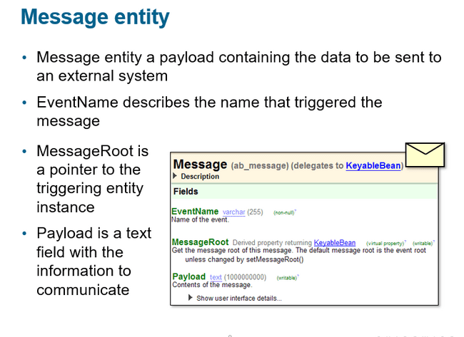

Avoid unnecessarily large or complex messages if possible. A message is information to send to an external system in response to an event.

### Triggering message events in code/custom event

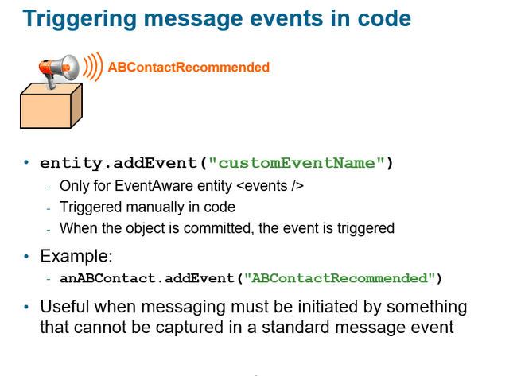

Example : when we want to trigger an event when the button is clicked, we can go for it.

### Destination

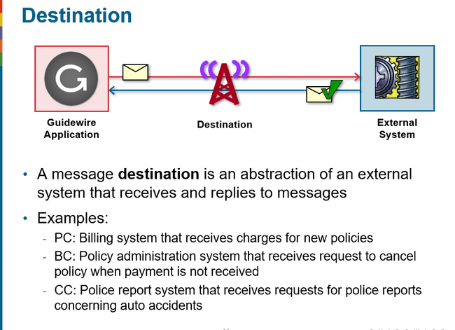 Each Guidewire message is sent to a single destination only. If there is a situation where multiple external systems need to receive the same information in response to a single event, then the Event Fired rules should create multiple messages, one for each destination of interest.

Every message should receive a response. The response indicates to Guidewire that the message has been successfully processed. In some cases, the response comes immediately upon sending the message and simply indicates the message was successfully consumed. In other cases, the response comes sometime after the message is sent. The response can also contain data from the external system (such as a verification code or a report).

### Destination message event

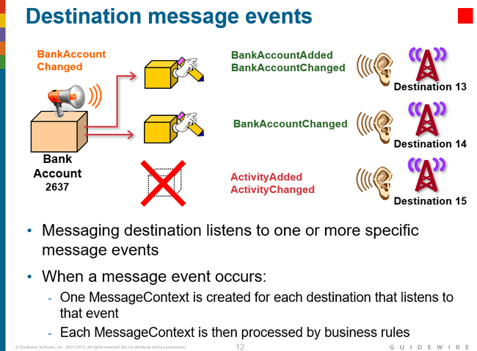

### Defining a message destination

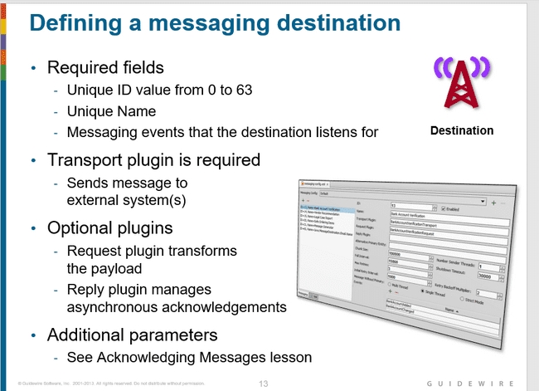

### Messaging editor

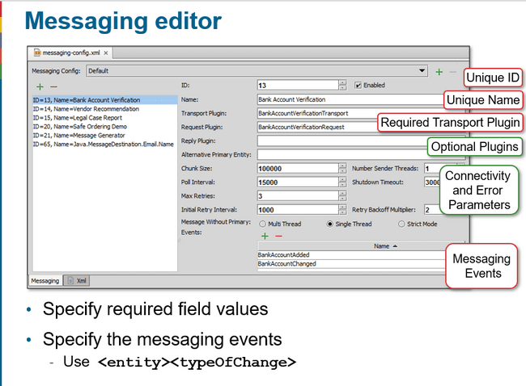

### Event fired rule set

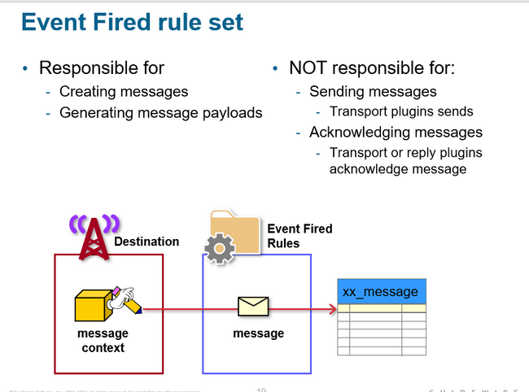

### Creating message from message context

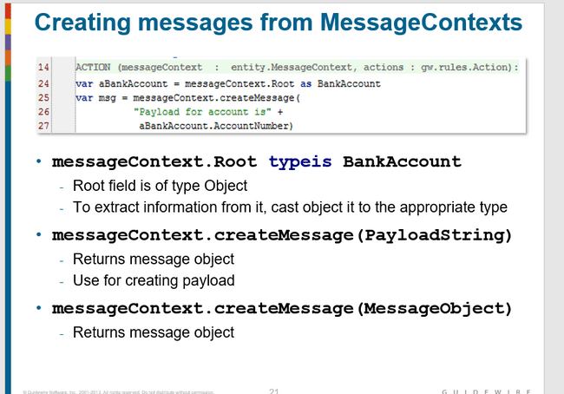

### Modifying data in event fired rule set

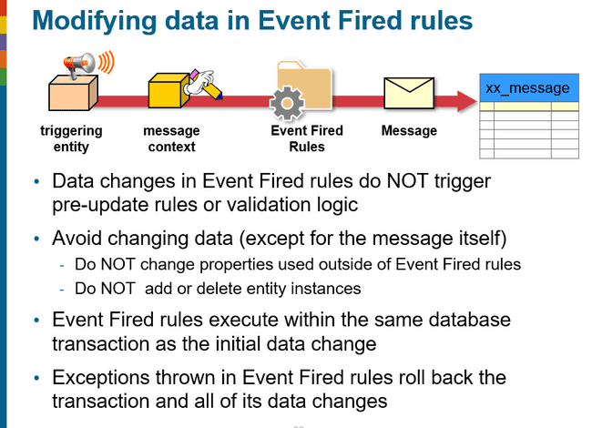

### Questions

#### When does a message event get triggered?

Message event gets triggered on change of event aware entity like entity added, removed or changed

#### What is the primary purpose of the MessageContext entity?

To create messages.

#### A Guidewire application has seven destinations and an event-aware entity called Escalation. When an Escalation is created, what is the maximum number of MessageContexts that might get created? What is the minimum?

Maximum is 7 when all seven destinations listen to EscalationAdded. Zero, which would occur if none of the destinations listen to EscalationAdded.

#### What plugin is required for every destination? What does this plugin do?

This plugin is used to send messages to the external system.

#### Why does every Event Fired rule cast the MessageContext.Root object it receives?

MessageContext.Root is of type Object, but message payloads typically need to work with the MessageContext.Root as the type of entity that triggered the message event. Therefore, the MessageContext.Root entity must be cast to be of that type

# INTEGRATION-MESSAGING PAYLOAD(C1)

### Message payload

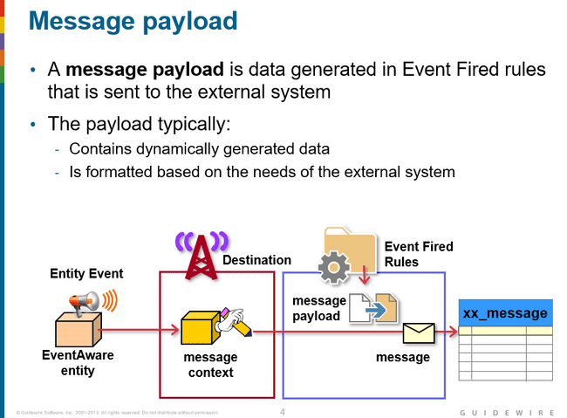

### Ways to generate XML Payload

* GOSU Templates
* XML Models

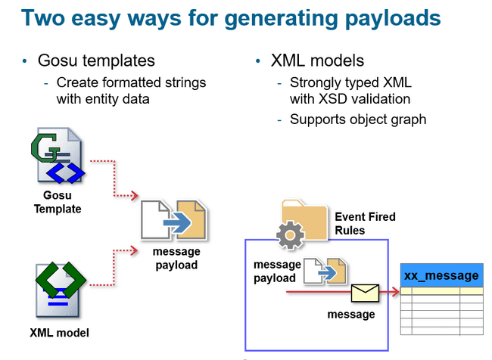

### What is Late Binding

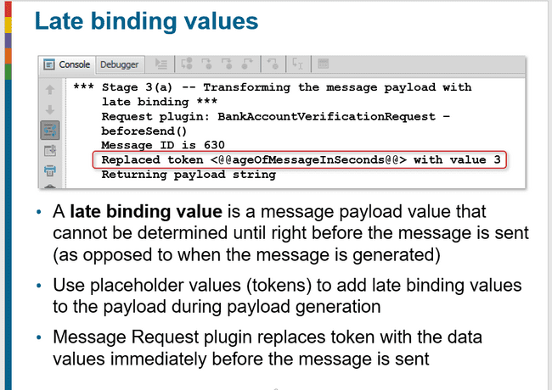

### Error in message payload generation

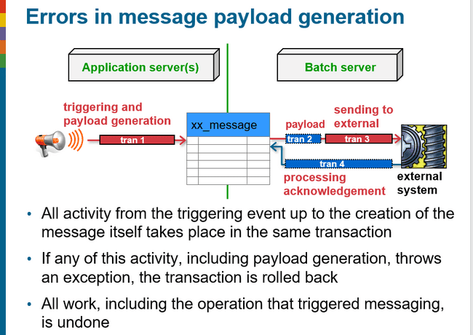

### Gosu template

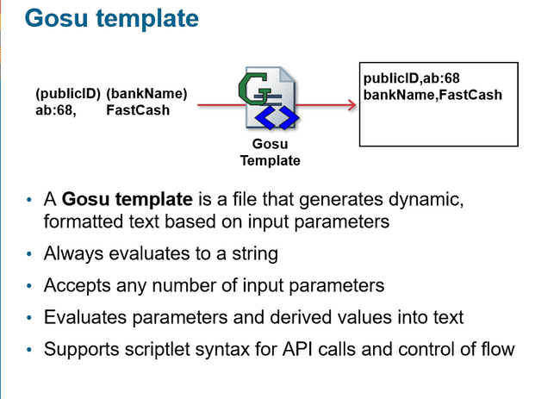

### Gosu model

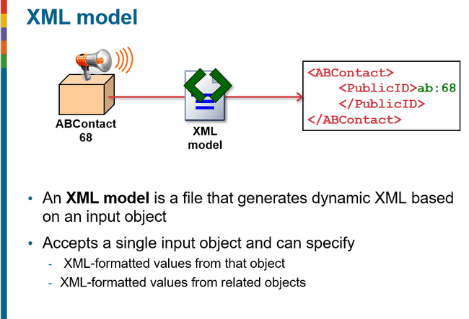

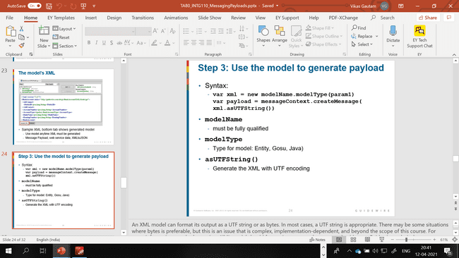

### Mostly using DTO

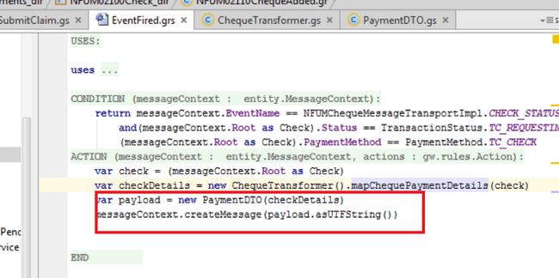

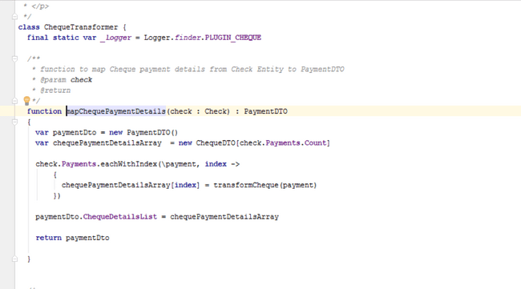

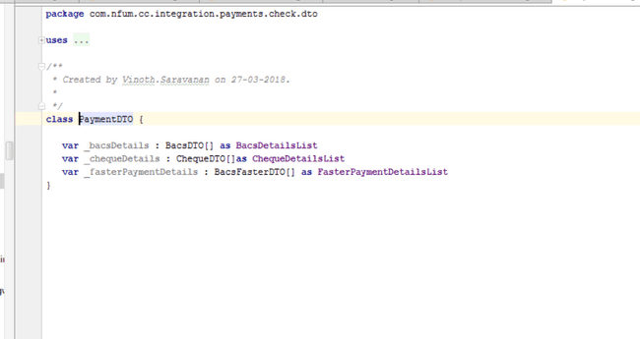

# INTEGRATION-MESSAGE SENDING(C1)

### Messaging plugins

* Request plugin
* Response plugin
* Transport plugin

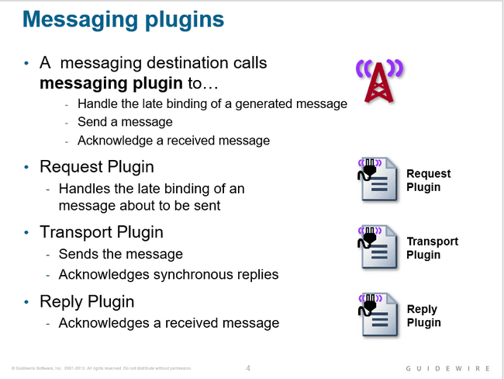

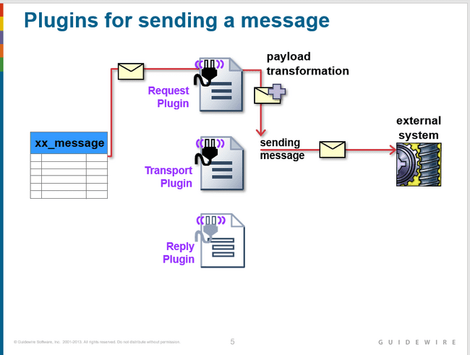

### Sender Reference ID

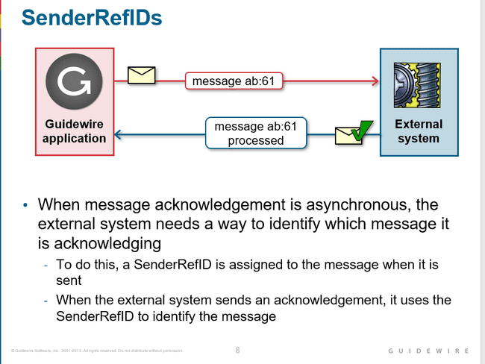

When an asynchronous reply is received, the SenderRefID is used to locate the message to acknowledge, even if the message was sent multiple times. As long as all automatically retried messages have the same SenderRefID as the original, Guidewire can find the correct message to acknowledge, regardless of which specific instance the external system is replying to.

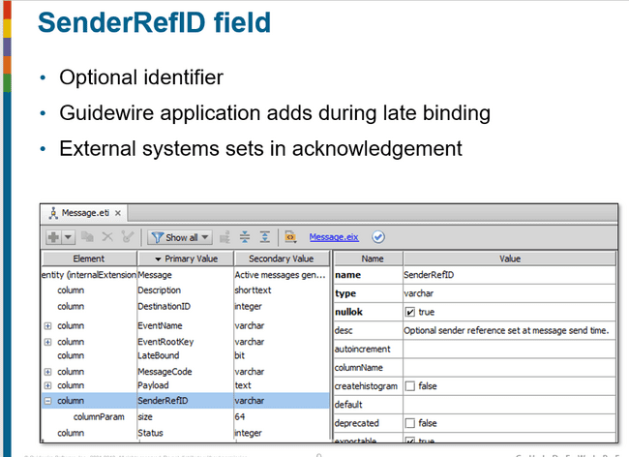

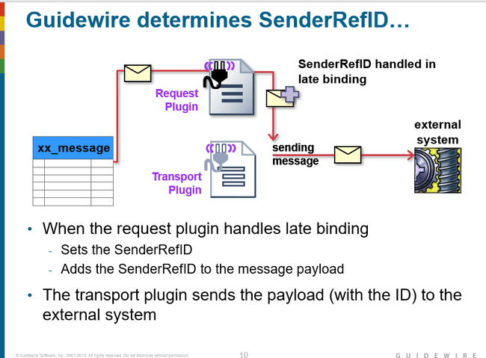

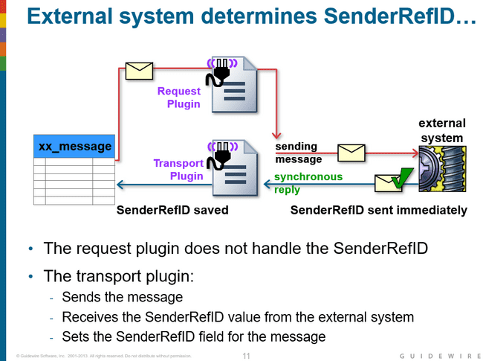

### Late binding values

Good candidates for late binding include:

* send timestamp
* The message ID and/or its public ID
* An identifier from the external system that was sent in reply to a previous message

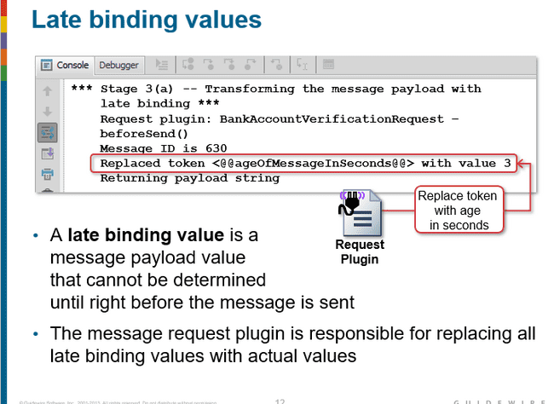

### Message Request plugin

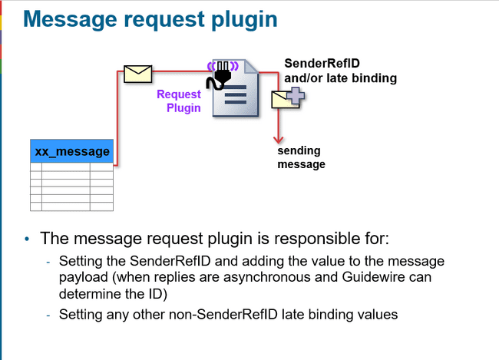

### Message Request plugin-before send() override

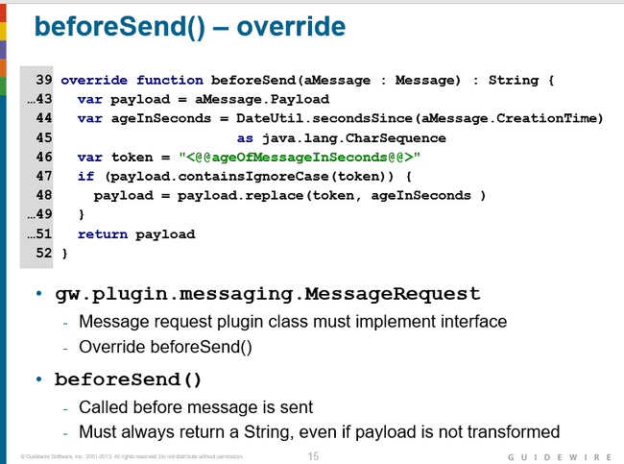

Payload transformation is done in the request plugin's beforeSend() method. It is called immediately before the message is sent. The method must always return a payload.

If the payload is not transformed, then the original payload should be returned.

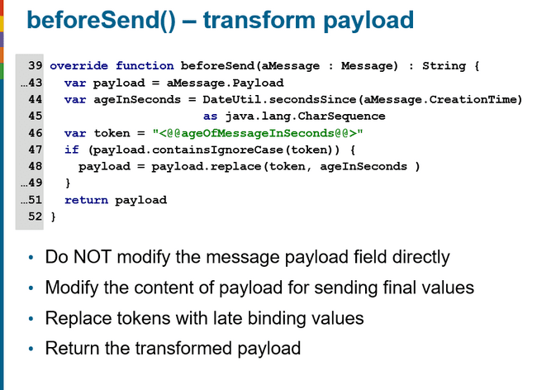

### Setting sender reference id in beforeSend()

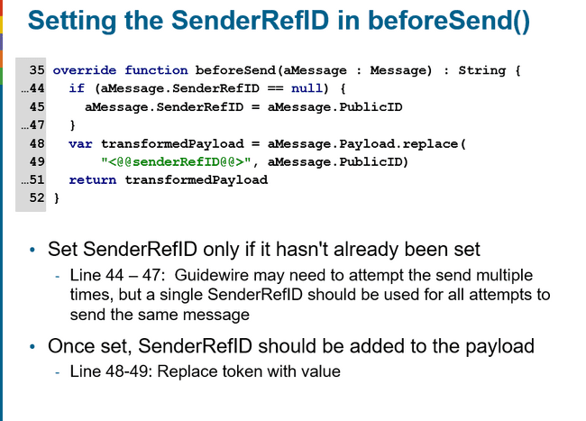

### Message Request plugin implementation

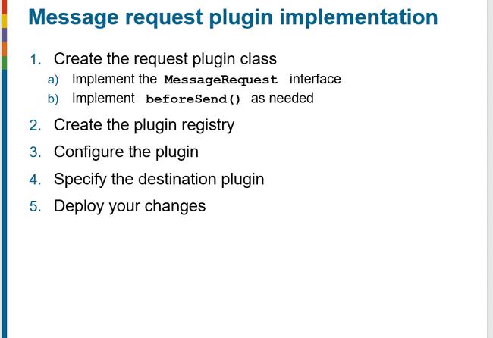

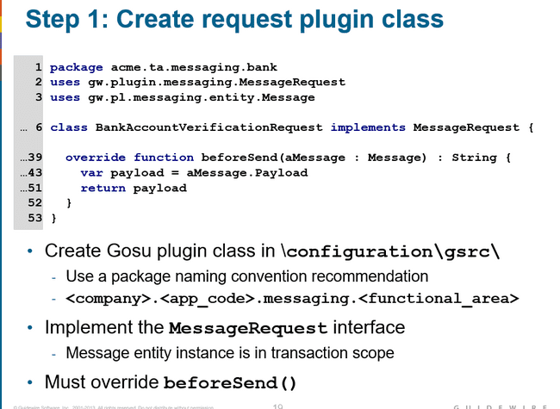

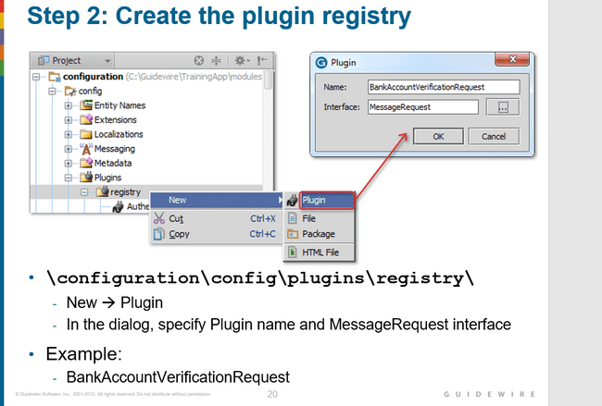

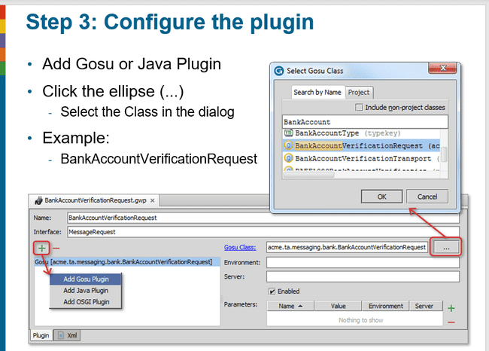

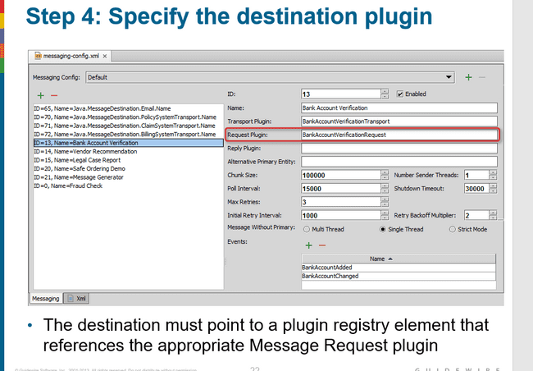

### Message Transport plugin

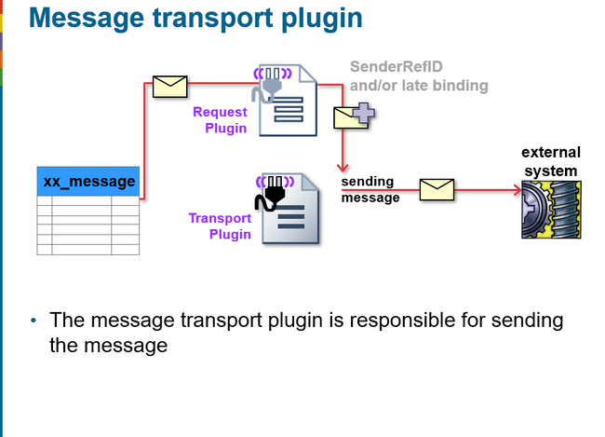

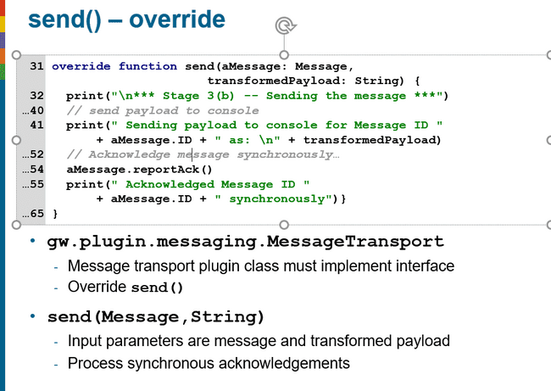

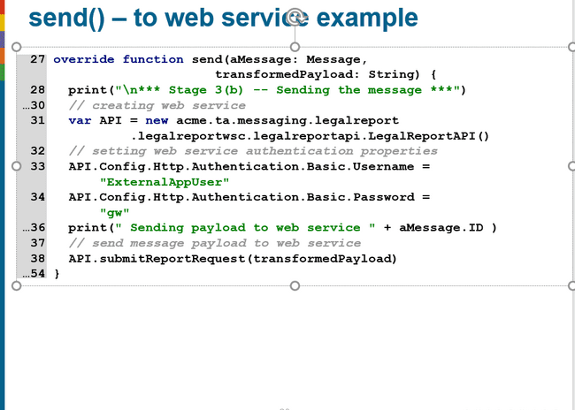

### Message Transport plugin implmentation

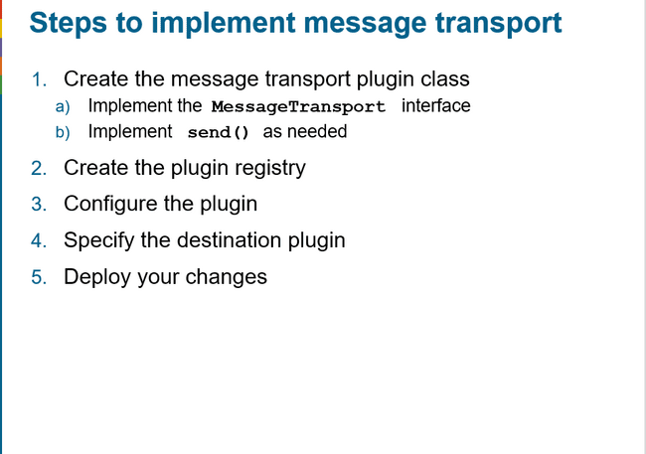

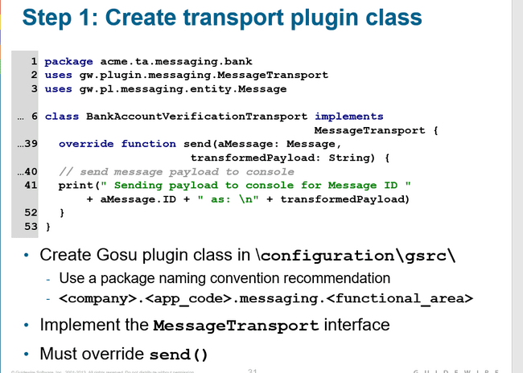

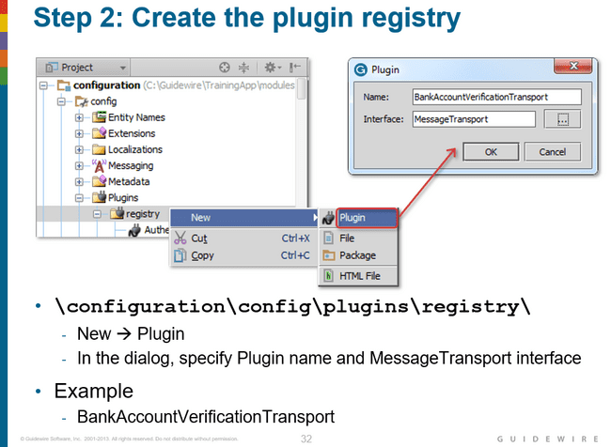

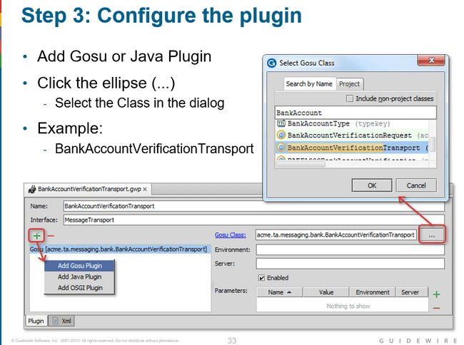

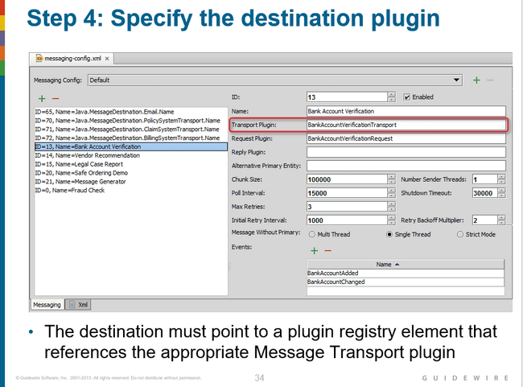

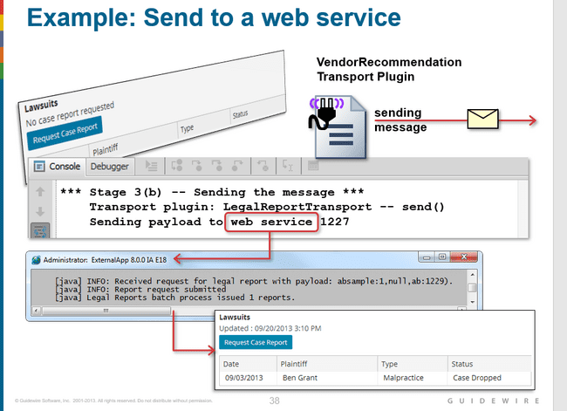

### Best practices for sending messages

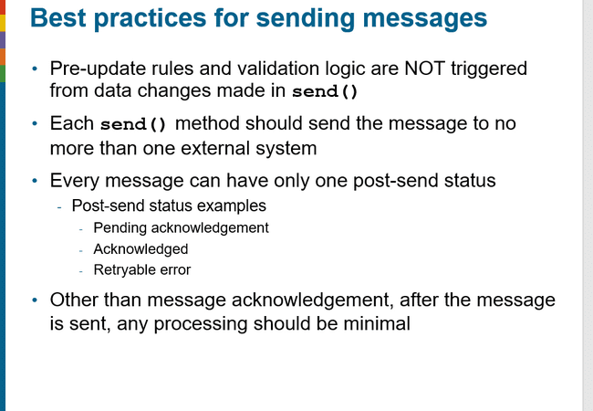

### Safe ordering

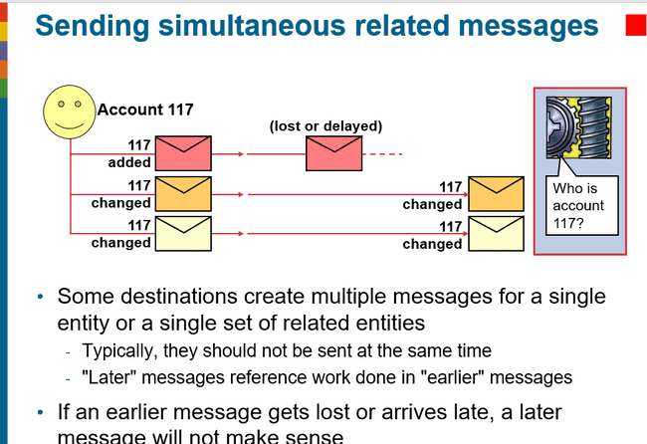

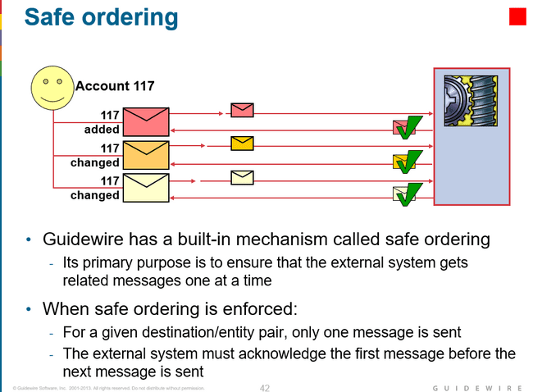

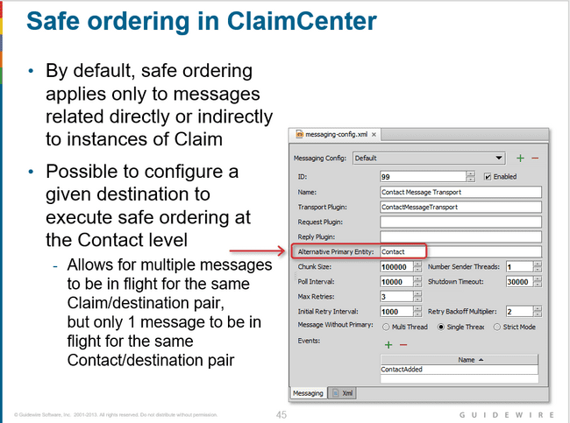

### Message retry scenarios

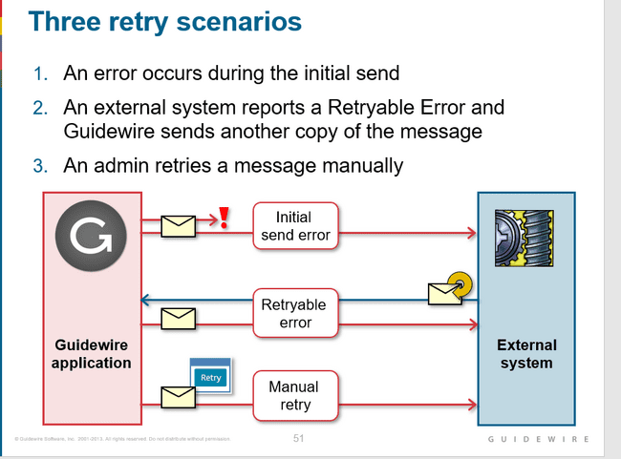

A retryable error is an error in which the external system received the message but could not process it, and the reason for the error is expected to be temporary (such as when the error resulted from a network resource being unavailable).

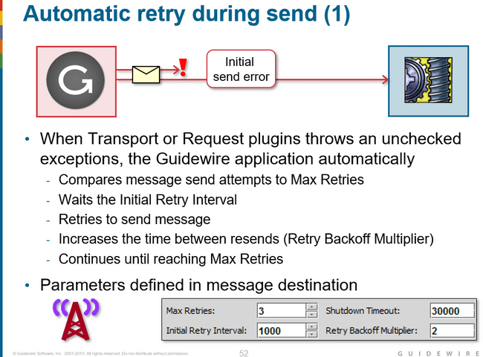

Sometimes, a message request or transport plugin has a send error and expects it to be temporary.

For example, a database connection may not be available, or an initial attempt to reach the external system may have timed out. If the request plugin throws an exception from its beforeSend() method, or if the transport plugin throws an exception from its send() method, the application retries the message after a delay time. Guidewire halts sending other messages for that destination pair during the retry delay.

Initial Retry Interval - The amount of time (in milliseconds) to wait before attempting to resend a message after an exception is thrown.

Max Retries - The number of retries to attempt

Retry Backoff Multiplier - The amount to increase the time between resends, specified as a multiplier of the time previously attempted.

Shutdown Timeout - The length of time to wait before attempting to shut down the messaging subsystem.

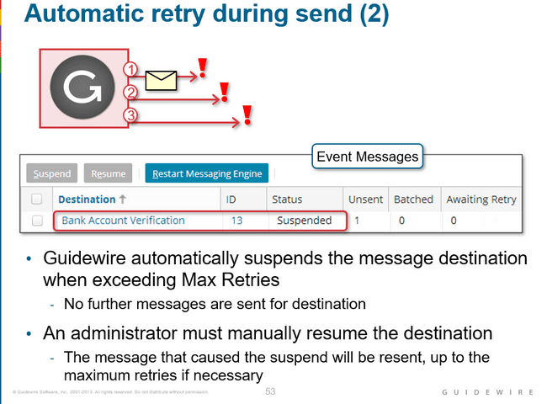

A message causes the destination to be suspended when:

* The beforeSend() or send() method throws an exception, AND
* The message has reached the retry limit.

If the message that throws the exception is safe-ordered, the next message for the entity/destination pair is not sent until the first message has been sent successfully and acknowledged in some fashion

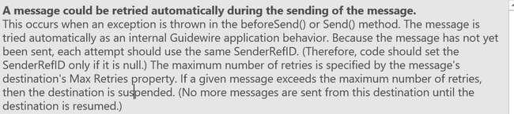

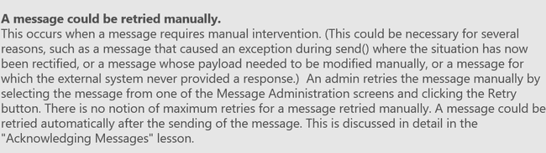

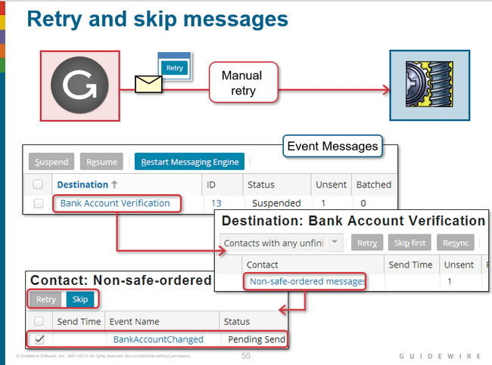

Every Guidewire application has an Event Messages screen on the Administration tab. The Event Messages screen shown above is present in every Guidewire application. It is used to administer messages.

To manually retry or skip a specific message:

* From the "Event Messages" screen, click the Destination name.
* From the "Destination: <Destination Name>" screen, click the appropriate link.
* If the destination has messages associated to non-safe-ordered entities, the screen will have a "Non-safe-ordered messages" link.
* If the destination has messages associated to safe-ordered entities, the screen will have a "Safe-ordered messages" link for each safe-ordered entity.

From the next screen, click the appropriate message or messages

When you manually retry a message, Guidewire attempts to resend the message by calling the same methods as the first attempt: the beforeSend() method (if a reply plugin has been implemented) and the send() method. If the issue that caused the original problem has not been rectified, the message will cause another exception, and after the Max Retries has been exceeded, the destination will be suspended again.

When you skip a message, the message is moved from the Message table to the MessageHistory table. The status of the message is set to "13" (skipped). Then the next message in its order (if there is one) can be sent. Note that skipping a message implies that the information that it was expected to carry to the external system is lost

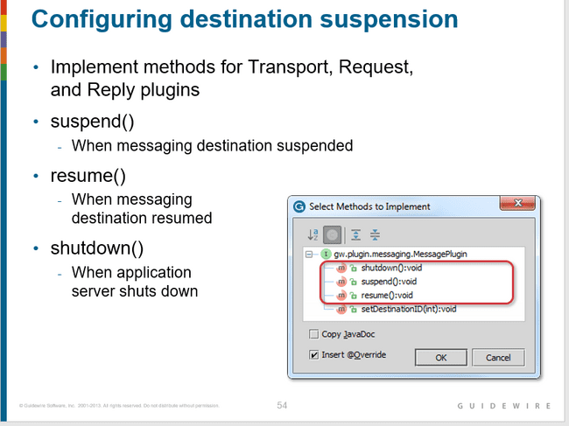

### Questions

#### With regards to payload generation and payload transformation on which server does it take place.

Payload generation occurs on the application server. Payload transformation occurs on the batch server.

#### At what point in time payload generation take place

Payload generation occurs during Event Fired rules (right after the triggering event occurs). Payload transformation occurs right before the message is sent (in the request plugin's beforeSend() method, which is called immediately before the transport plugin's send() method).

#### Under what circumstance would you need to "late bind" a message payload?

You would need to "late bind" a message if information that needs to go in the message payload is not known at the time the message payload is generated in Event Fired rules

#### Every destination can optionally have a request plugin, but it must have a transport plugin. Why is the transport plugin required?

The transport plugin is required because it is used to send the message when it is processed from the Message table. Without a transport plugin, messages for a given destination would have no way of being sent to the corresponding external system

#### Can one destination have two transport plugins? Can one transport plugin be used by two destinations?

A destination cannot have two transport plugins, but a transport plugin class can be used by two (or more) similar destinations

#### Why should the send() method never send a message to multiple external systems?

The message acknowledgement architecture assumes that each message is sent to only one destination. If a given send() method sent a message to multiple destinations, then there could be multiple acknowledgements, errors, or unprocessed messages, and the messaging architecture would not be able to identify the state of the message

# INTEGRATION-MESSAGES ACKNOWLEDGING(C1)

## Message acknowledging

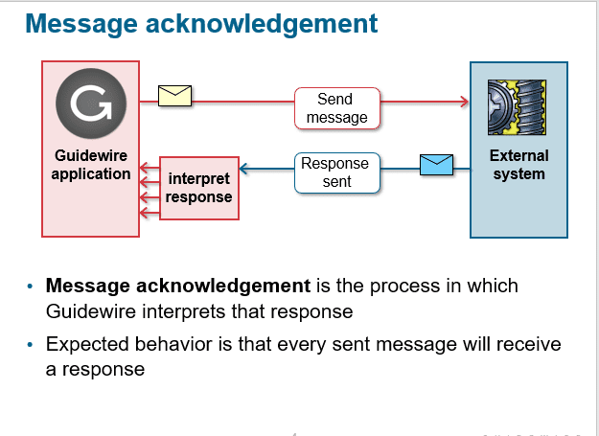

Guidewire expects that every sent message will immediately or eventually be followed by a response from the external system

There is the possibility that the external system never sends a response for a given message

## Interpreting the external system response

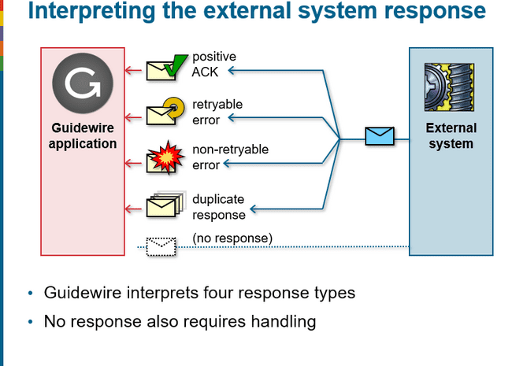

Guidewire can interpret a response to be one of four types: positive acknowledgement, retryable error, non-retryable error, an duplicate response. Guidewire must also react when the external system never sends a response to a message

**NOTE:** non-retryable error is a deprecated response in Guidewire 8.

## Message and Message History

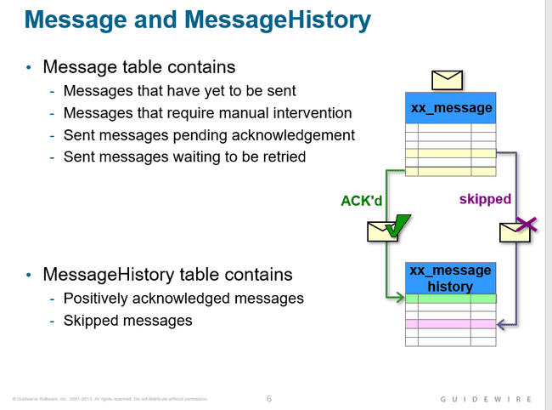

A message can move from the message table to the message history table if the message is positively acknowledged or skipped.

The Message table contains messages that need further processing. The MessageHistory table contains messages that do not need further processing

A message can move from the message table to the message history table if the message is positively acknowledged or skipped. Otherwise, the message remains in the message table.

Over time, the message history table accumulates a large number of message histories and therefore needs to be pruned on a regular basis. The MessageToolsAPI has a purgeCompletedMessages() method that can be used to do this.

## Message Statuses

* Pending send - 1
* Pending acknowledgement - 2
* Retryable error-4
* Error-3

## Positive acknowledgements(status 10)

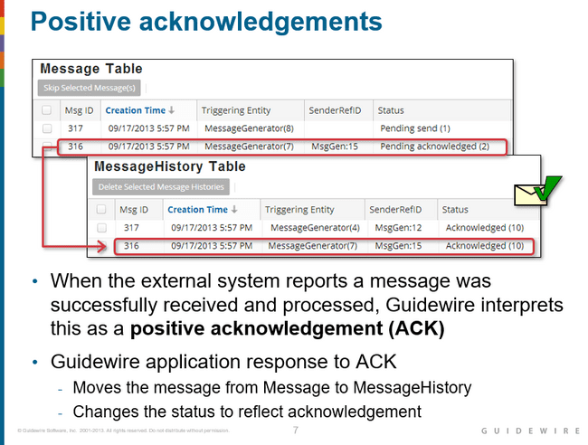

## Negative acknowledgements

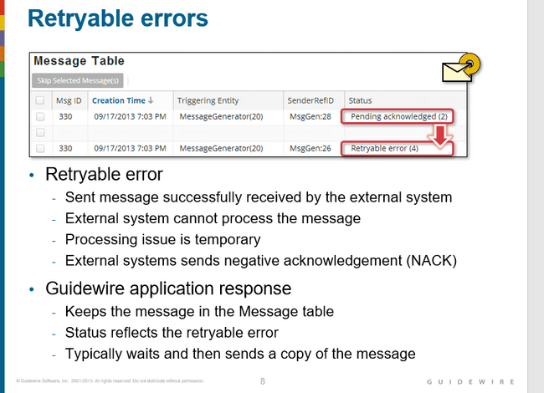

A retryable error indicates a condition that is expected to be temporary. For example, the external system might be unreachable due to network problems, the file system is full, a database lock exists and has not been released, or the external system simply reports a temporary error.

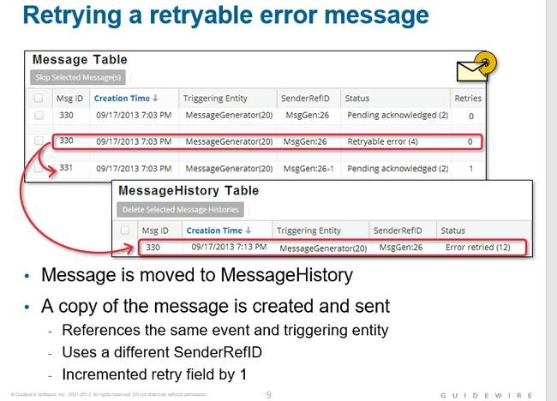

There are two messages, one with an ID of 330 and one with an ID of 331. The first message had a status of "Pending acknowledged" and then had a status of "Retryable error".

When the error was retried, Message 330 was moved to the MessageHistory table, and Message 331 was created and sent.

Even though Message 331 has a different SenderRefID, it is linked to the same triggering entity (MessageGenerator(20)). So, Message 330 and Message 331 are two separate message instances that relate to the same logical business event.

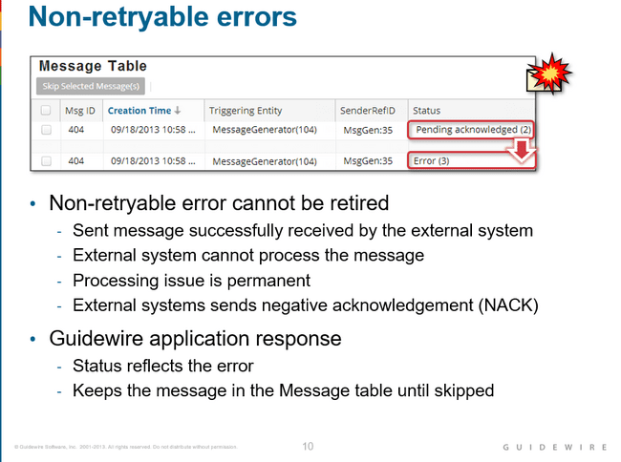

If the message was not successfully processed, and the issue is expected to be permanent, Guidewire reports this as a non-retryable error which is also referred to as a negative acknowledgement (NACK).

## Duplicate message

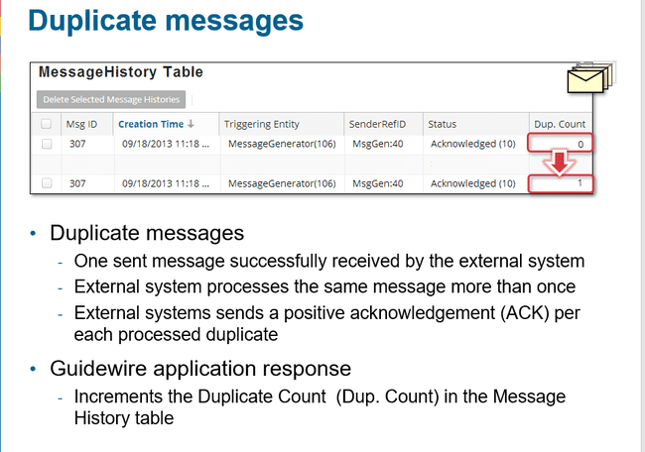

## No Response

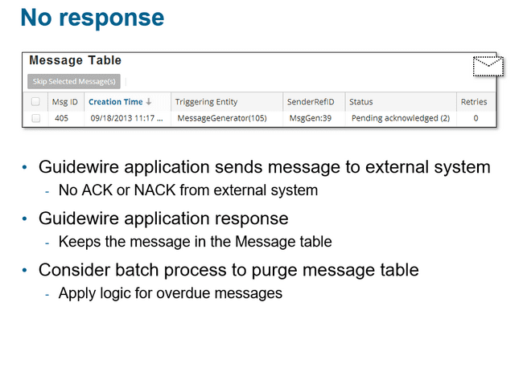

If no reply is received for a message, the message remains in the Message table. There is no time frame at which the message is automatically resent or abandoned. Typically, a custom batch process or third-party database tool checks the Message table for messages whose responses are overdue and then takes appropriate steps to fix the situation.

The Message table should be checked for messages that have not received a reply within a timely fashion. This could be a Guidewire custom batch process or a database tool that monitors the Message table. Each non-response message typically requires manual evaluation to determine the cause of the non-response and the appropriate steps to fix the situation.

## Acknowledgement strategies

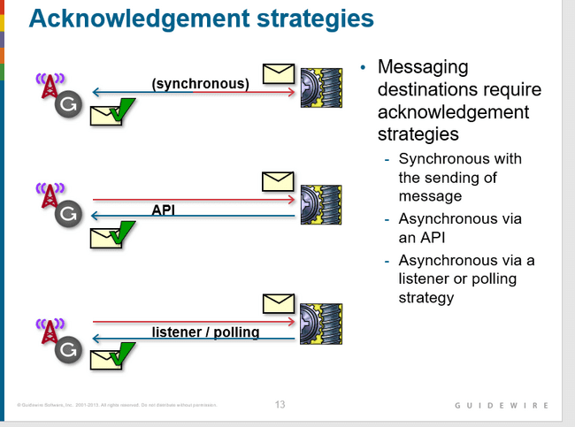

Typically, each destination expects to receive acknowledgements in one of three ways:

* synchronous with the sending of message,
* asynchronous from an API
* asynchronous with a listener or polling mechanism

## Acknowledgement plugins

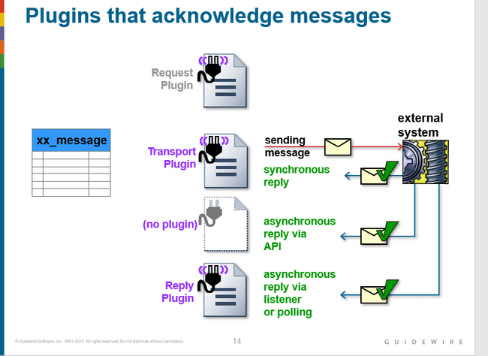

Every destination has up to three plugins that are used for messaging. Two of these plugins could play a role in acknowledging a message, though it is possible that no plugin is used for acknowledgement.

The request plugin is an optional plugin that is responsible for payload transformation. It is not involved in the acknowledgement of messages.

The transport plugin is a required plugin that is responsible for sending the message to the external system. If the acknowledgement is received synchronously, then this plugin also processes the reply.

An external system can acknowledge a message using a remote call (either the IMessageToolsAPI or a custom-built web service). If a remote call is used, then the message reply is handled independent of the destination's plugins.

The reply plugin is an optional plugin that initializes a listener queue and associates it to the destination. It processes acknowledgements sent asynchronously using the listener queue.

Like predefined plugins, messaging plugins can be implemented in Gosu or Java.

**Message acknowledgement transactions**

## Message acknowledgement transactions

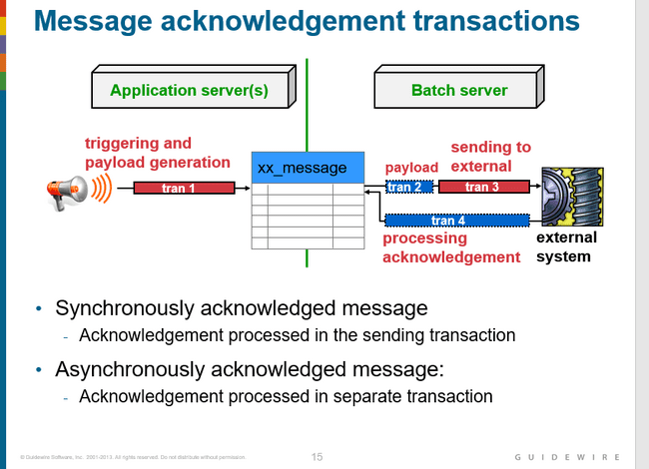

## Synchronous Acknowledgement

### Reporting positive acknowledgement (Synchronous ack)

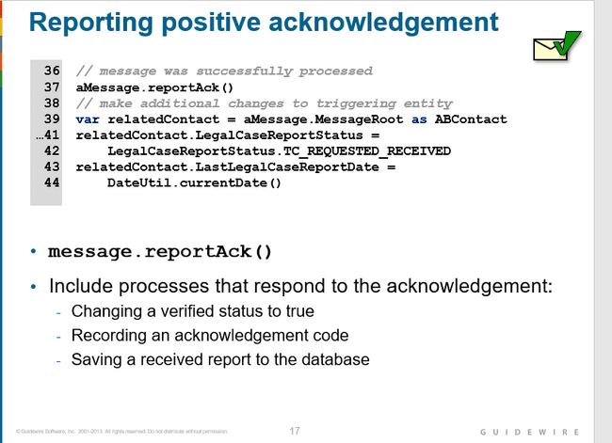

In some cases, messaging is used to request reports from external systems, such as:

* A police report detailing an accident or burglary of insured items.
* A medical report detailing customary prices for given medical procedures.
* A fraud report detailing that a claim for a given loss has already been filed.

In these cases, the external system responds with the report. The messaging code must both report positive acknowledgement of the message and save the report to the Guidewire database

### Reporting retryable errors (below max)

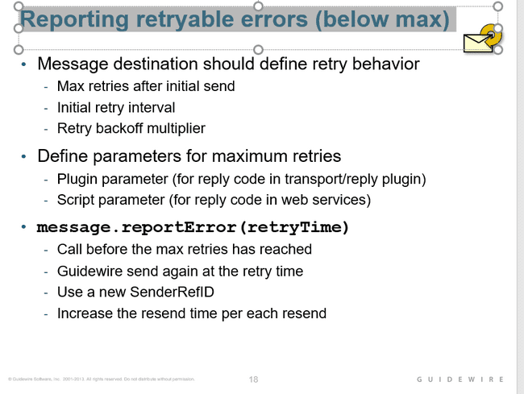

Every destination should have a specific number of times a message can be retried after the initial send. The number of retries should be specified using either a plugin parameter for the reply code in the transport or reply plugin or a script parameter for the reply code in the web services handler.

Before the max has been reached, report the error using message.reportError(whenToResendMessage). Then, when sending the retry message, use a new SenderRefID even though it pertains to the same message event, it must be treated as a new message. The amount of time between resends should increase with each resend.

If a message is resent two or more times because the external system reported a retryable error, each message should use a different SenderRefID. This is because the external system may treat two messages with the same ID as the same message. (In other words, the external system may be "duplicate aware".) If the second message uses the same SenderRefID as the first, then the external system may ignore it or report it as a duplicate, which would prevent the message from ever getting processed.

You can also manually retry any message using the Event Messages administration screens.

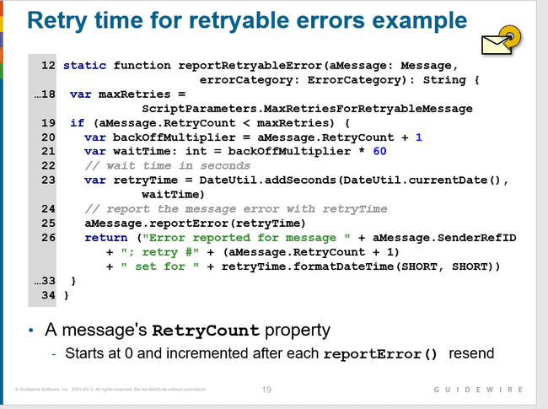

### Reporting retryable errors (at max retries)

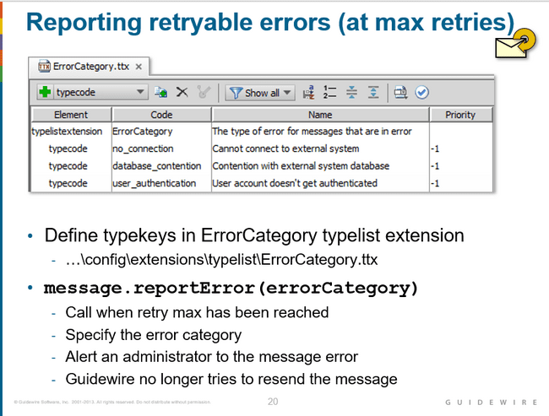

ErrorCategory is a typelist that identifies the error reason for a message. In each base application, the typelist is empty.

When a given message's retry max has been reached, report the error using message.reportError(errorCategory). Alert an administrator to the issue as it pertains to the message error. Guidewire will no longer try to resend the message.

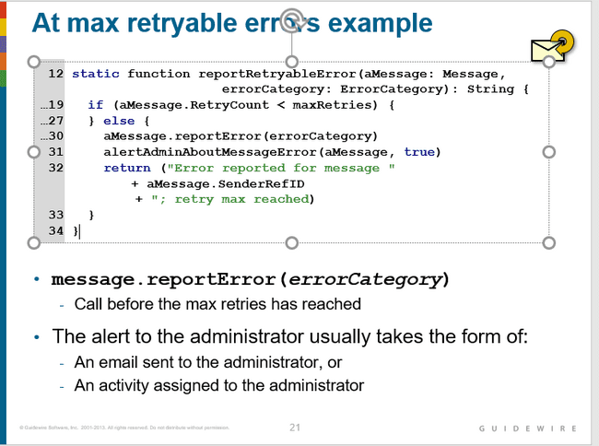

### Reporting non retryable errors

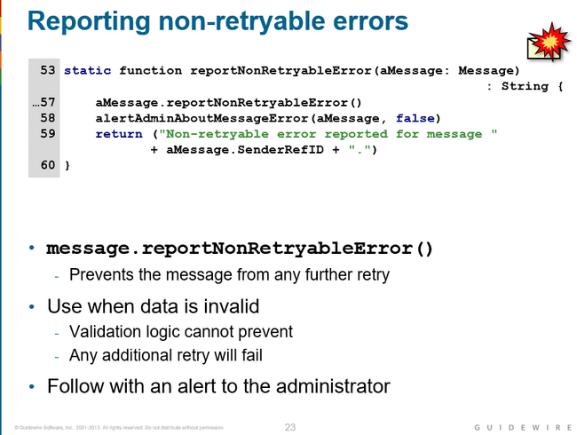

### Reporting duplicates

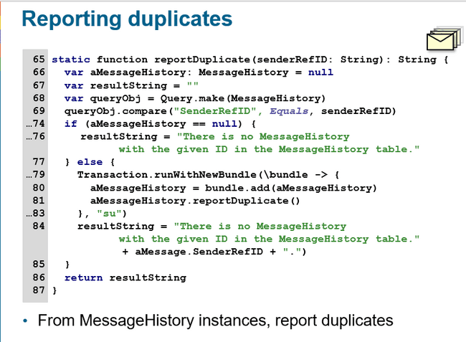

Duplicates can be reported only from MessageHistory instances. When an external system reports a duplicate, the integration code should simply find the related entry in the MessageHistory table (based on the message identifier, such as the SenderRefID) and report the duplicate.

### Messages without responses

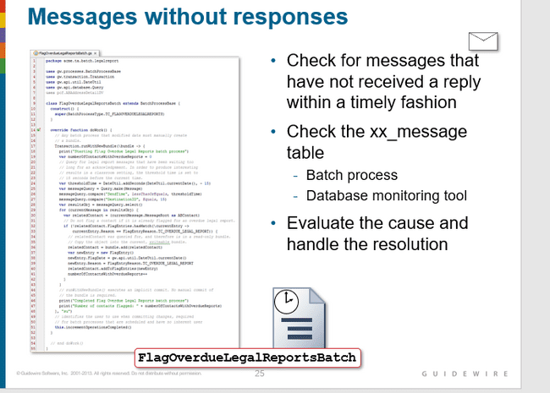

Periodically, the Message table should be checked for messages that have not received a reply within a timely fashion. This could be a Guidewire custom batch process or a database tool that monitors the Message table. Each message typically requires manual evaluation to determine the cause of the non-response and the appropriate steps to fix the situation.

## Custom web service acknowledgment

There is a base application API, MessageToolsAPI, that can also be used to acknowledge a given message. However, for a given message, the only thing you can do is acknowledge it. You cannot execute any associated data changes. Because custom web services provide the flexibility to execute any required logic, Guidewire recommends that acknowledgements should be received through a custom web service.

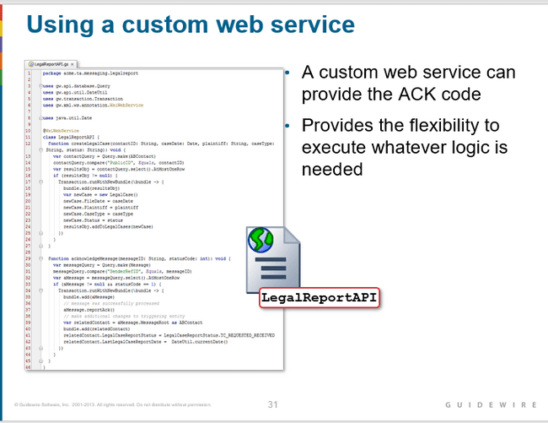

## Reply plugin acknowledgement

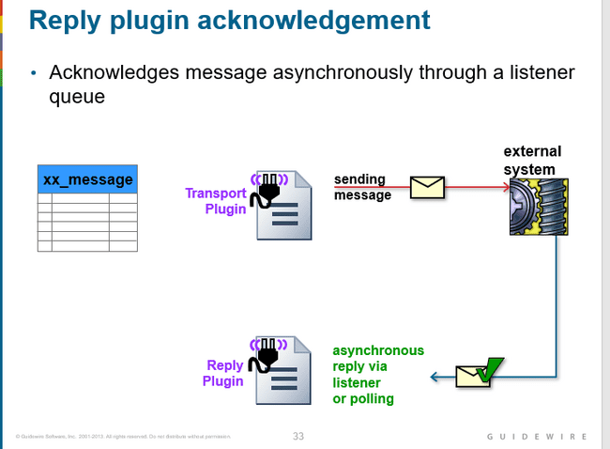

The reply plugin is an optional plugin that initializes a listener queue and associates it with the destination.

The reply plugin is implemented to receive replies as dictated by the external system, such as:

A listener to a JMS message queue

A socket listener

An RMI server

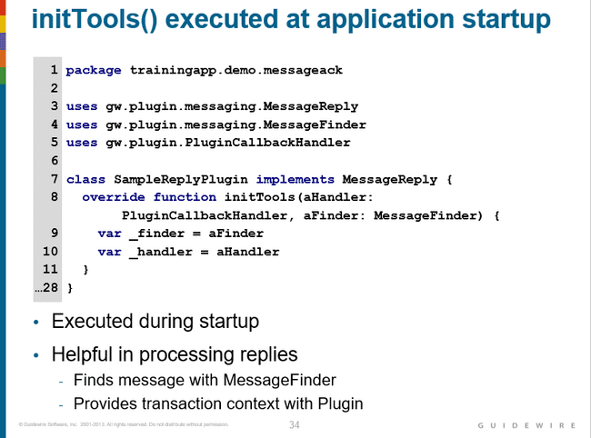

initTools() is method specified in the reply plugin that is executed during server startup. It provides resources that may be useful in processing replies. Like both the request and transport plugins, a reply plugin also includes the same set of lifecycle methods including resume(), shutdown(), and suspend(). Reply plugins also have a setDestinationID() method.

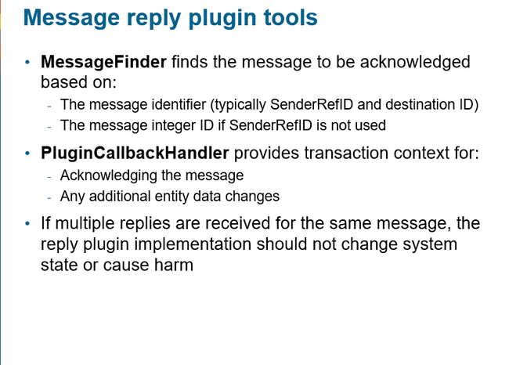

## Message Administration

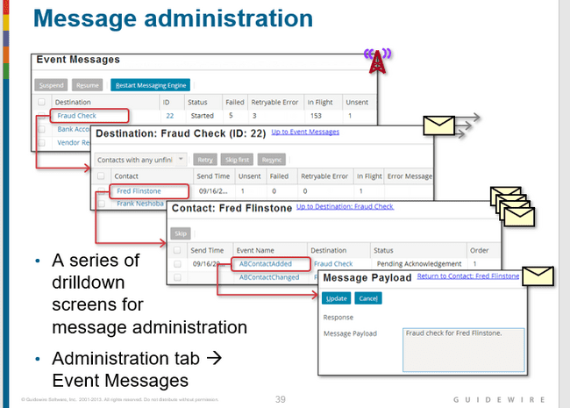

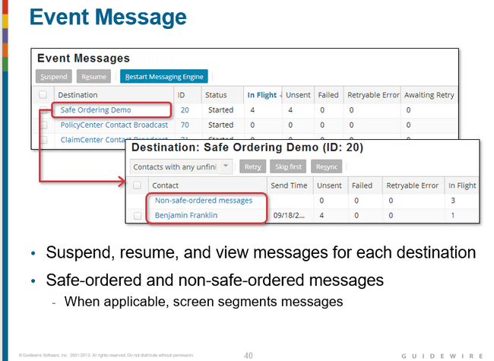

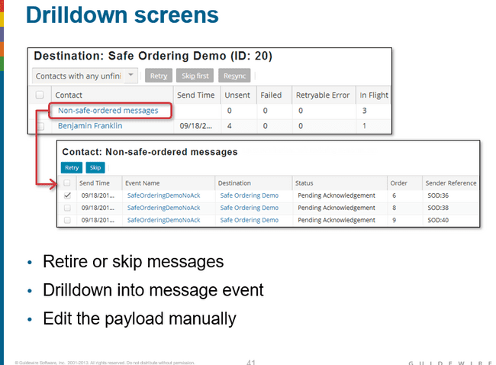

## Questions

#### What are the four possible ways Guidewire can interpret an external system's response to a message?

Positive acknowledgement, retryable error, non-retryable error, duplicate. (There could also be no response to a message.)

#### Under what three circumstances is an entry added to the MessageHistory table?

The message is positively acknowledged, skipped, or retried. (For the first two, the message is removed entirely from the Message table. For the third, a copy of the original message remains in the Message table.)

#### Under what circumstances are acknowledgements processed:

*By the transport plugin?*

When the reply is received synchronously.

*By the reply plugin?*

When the reply is received asynchronously through a listener or polling

*Without involvement from any plugin?*

When the reply is received asynchronously by an external system call to an API

#### When should you use each of the following methods?

*aMessage.reportError(retryTime)?*

When the message needs to be retried and the message has not reached its maximum number of retries.

*aMessage.reportError(errorCode)?*

When the message needs to be retried, but the message has reached its maximum number of retries.

# INTEGRATION-GOSU BUNDLES(C1)

## Database Transactions

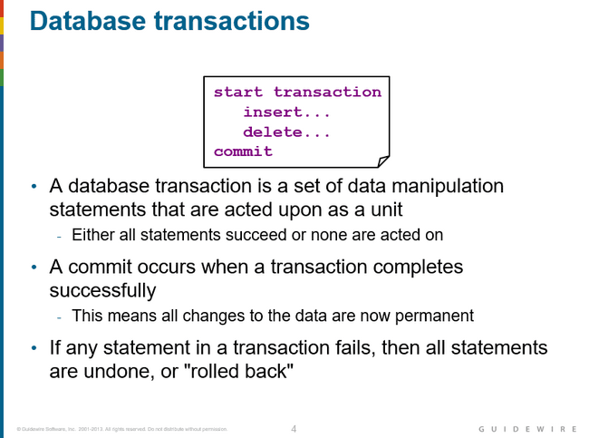

## What is Bundle

Bundle is a Guidewire class that implements the entity BundleProvider.

An entity of type entity.KeyableBean, and/or as entity that implements the KeyableBean delegate. This simply means that the entity is to be inserted into the database when the bundle is committed.

The add method add beans to the bundle. The remove method marks a bean for removal.

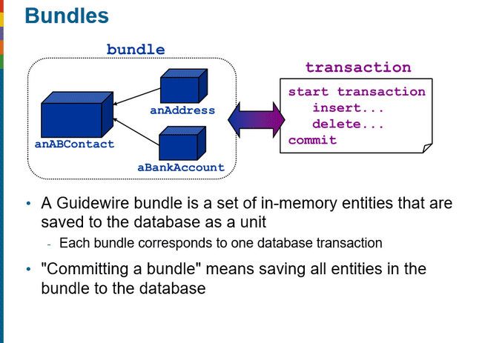

## Automatic bundle processing

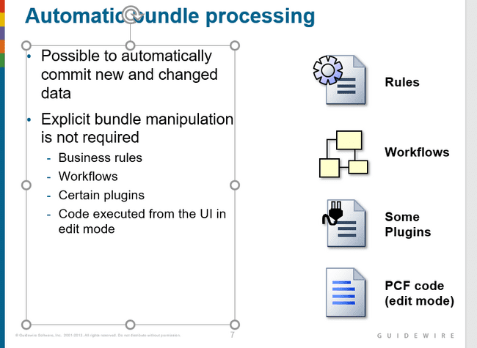

## Manual bundle processing

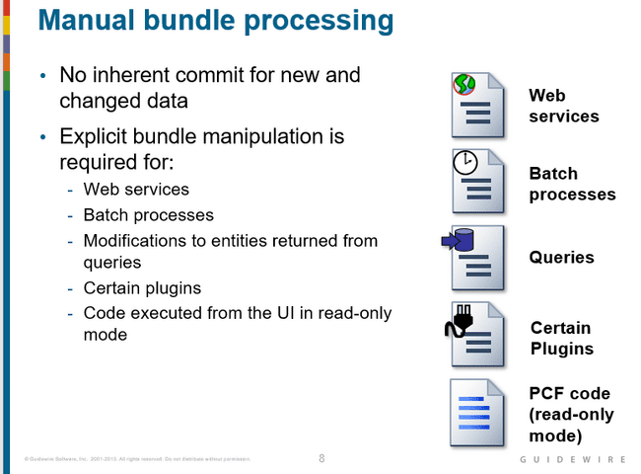

## Keyable Bean

Keyable beans are the database backed up entities in guidewire. And only such entities can be added to the database as well.

## Type of bundles

1. Current Bundle
2. Read only bundle
3. New bundle

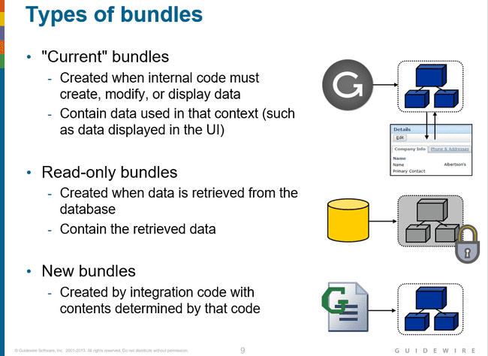

### Current bundle

A "current" bundle is a bundle that contains objects available to the current code context. This includes, but is not limited to, the user interface and plugins. These bundles are created automatically by the Guidewire application to create, modify, or edit data. Integration developers can reference entities in the current bundle. They can also commit current bundles, though in some situations this is not advisable

### Read only bundle

A read-only bundle is a bundle that contains entities retrieved from the database. This includes both entities returned as the result of a query, and entities referenced by the foreign key of a related entity when the related entity is in a read-only bundle. The entities in a read-only bundle cannot be modified. However, you can copy entities from a read-only bundle into a writeable bundle.

### New Bundle

A new bundle is a bundle created explicitly by integration code. Unlike a read-only bundle, you can modify and commit data in a new bundle. Unlike a current bundle, you can commit a new bundle without having to worry about later interaction occurring in the bundle.

## Gosu capabilities with new bundle

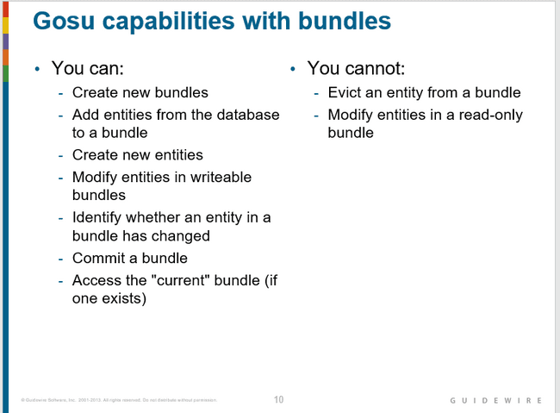

Only database-backed entities (entities of type entity.KeyableBean) can be added to a bundle. Each entity can only be in one bundle.

You cannot create a custom Gosu class (which is non-database-backed) and add instances of that class to a bundle.

"Evicting" an entity from a bundle means disassociating the entity entirely from the bundle before any commit is attempted. The term "remove" is not used here because "removing an entity" is typically used to mean flagging an entity as retired or deleted so that, when the bundle is committed, the database will logically or physically remove the corresponding row from the database table. You can "remove" an entity from a bundle using Gosu.

Removing here means retiring the entity.

The entity’s bundle is available in the Bundle property of the given entity.

## Creating new Bundle

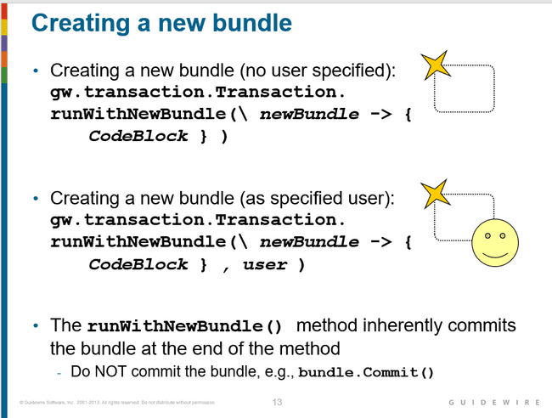

New bundles are always writeable.

In some situations, there is an inherent user. For example:

* If bundle code is executed from the UI, it is executed as the user who triggered the UI event that runs the code.
* If bundle code is executed from a web service, it is executed as the user specified by the web service call.

In other situations, there is no inherent user, such as:

* A web service that requires no authentication and where there may be no user specified in the web service call.
* A batch process.
* In these situations, you must use the second signature above and specify a user to associate the bundle to.
* In either case, commits in the bundle are limited to what the associated user has permission to do. If the user lacks the needed permissions, then an InsufficientPermissionException is thrown.
* For example, if the bundle attempts to commit changes to admin data, but the associated user lacks permission to change admin data, then the commit will fail.
* The runWithNewBundle() method inherently commits the bundle at the end of the method. Do not need to explicitly commit data within the runWithNewBundle() block.

If an entity exists in a modified form in more than one bundle and both bundles commit, the second one fails with a concurrent data modification exception.

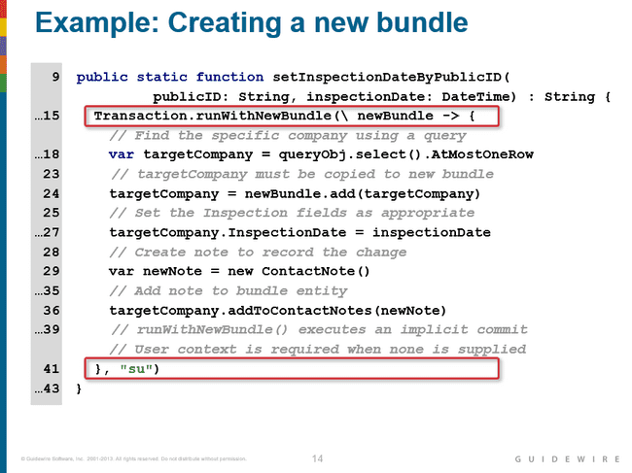

Line 15: Creates a new bundle called newBundle.

Line 18: Selects the query object. This entity instance is in a read-only bundle.

Line 24: Adds the read-only bundle entity to the new bundle! This is what allows the object to be edited with scope of the transaction.

Line 29: Creates a new ContactNote. This note is editable, however, it exists in memory and is not yet a note that exists in the database.

Line 36: Adds the ContactNote to the ABCompany instance. ContactNote is a foreign key array field for ABCompany. Guidewire automatically creates the addToContactNotes() method for foreign key array fields.

Line 41: Ends the transaction block and in doing so, commits the bundle. The specified user supplies the user context.

## Adding existing entities to bundle

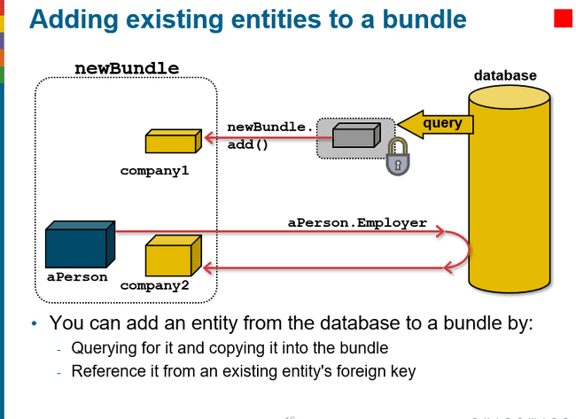

The example above depicts a bundle that initially contains only the aPerson entity. Three entities are then added to the bundle:

* company1 is added by querying for an ABCompany entity from the database, which places it into a read-only bundle, and then copying it via the add() method to the writeable bundle.
* company2 is added by referencing the company from the existing aPerson entity's Employer foreign key.

## Querying

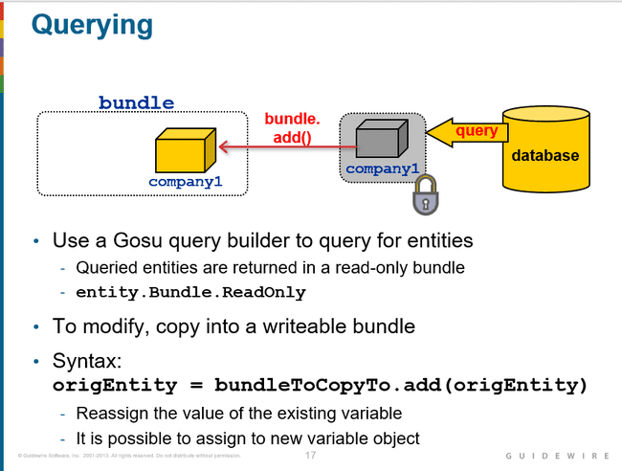

## Reference by foreign key

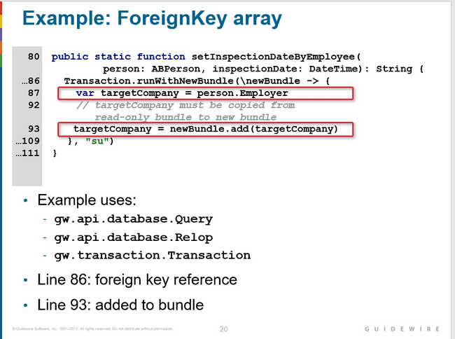

## Creating new entity example

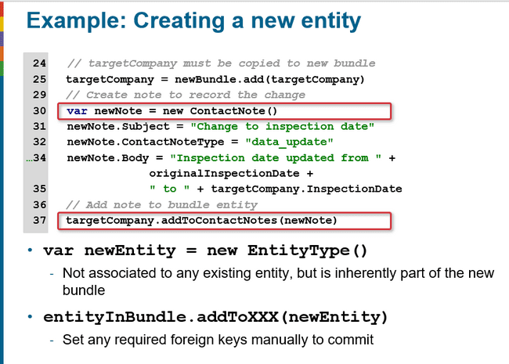

## Original values

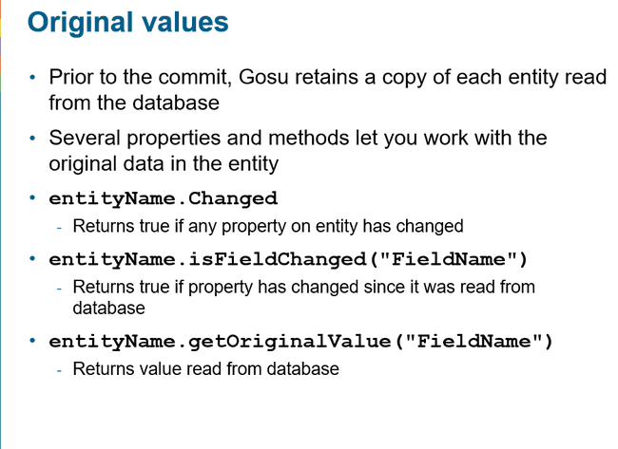

## Current bundle syntax

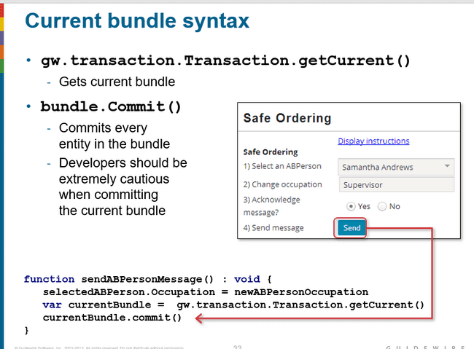

## Questions

#### Name two circumstances where Changes to data are automatically committed Changed to data must be committed in code manually.

1a. Automatic commits (possible answers): Business rules, workflows, certain plugins, code executed from the UI in edit mode

1b. Manual commits (possible answers): Web services, batch processes, queried entities that must be modified, certain plugins, code executed from the UI in read-only mode

#### What is a bundle?

A Guidewire bundle is a set of in-memory entities that are saved to the database as a unit. Each bundle corresponds to one database transaction.

#### What kind of entities are initially put into read-only bundles? Under what circumstance would you need to copy one of those entities to a writeable bundle? How is this done?

Entities that are the result of a query are put into read-only bundles, and entities referenced by foreign key are put into a read-only bundle if the referencing entity is also in a read-only bundle. You need to copy these entities to a writeable bundle if you need to modify them, which is done via the bundle's add() method.

#### Name the two ways you can add an entity from the database to a given bundle.

By a query and by foreign key from an existing entity in a bundle.

#### When you create a new entity in a bundle, what other entity is it automatically associated to?

A new entity is not automatically associated to any other entity. If a new entity must be associated to an existing entity (such as a new contact note being associated to an ABContact), then you must manually create the association.

# INTEGRATION –GOSU QUERY

## Gosu Query

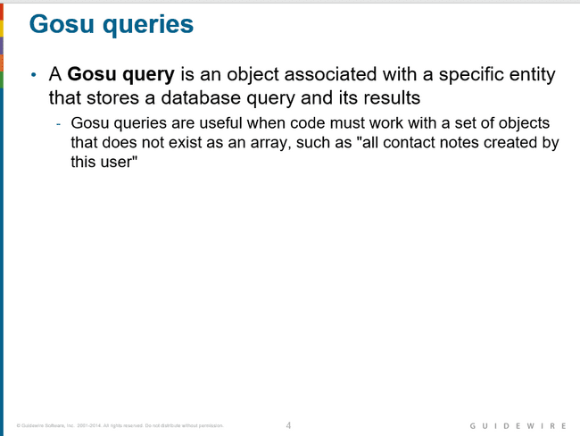

## Objects used when querying database

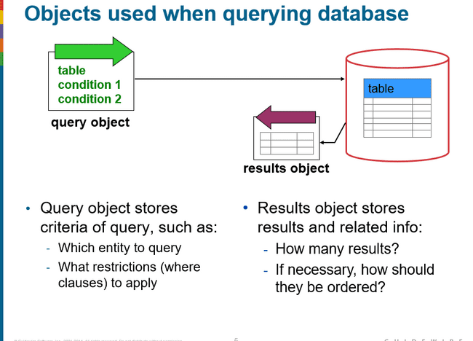

## Steps to execute the query

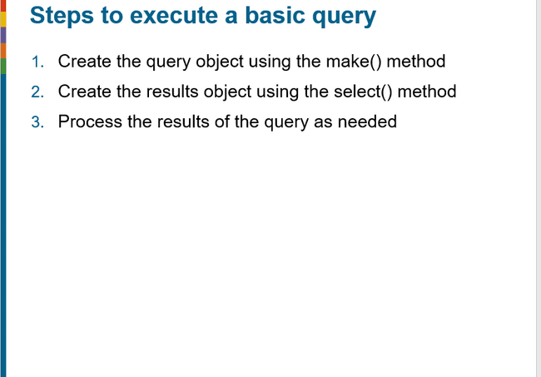

## Interview

### RowQuery

RowQuery is used to retrieve the records from the database based upon entity field which we are going to provide using a single query object.

To create a query object

Gw.api.database.Query.make(entity.Claim) ,this will return the query object

Using this query, we can select all the fields we want.

# INTEGRATION-GOSU QUERIES ONLY(C1)

### To get all the typecode

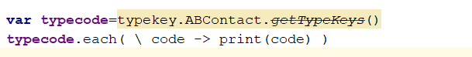

### Compare

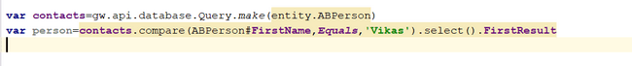

### And



### OR

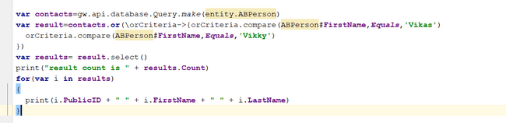

### CompareIn

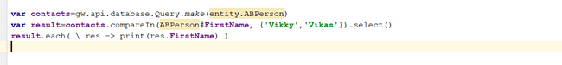

### Eliminate duplicates from result set

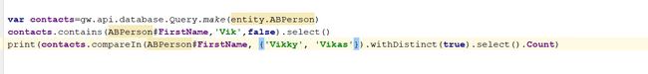

### Contains

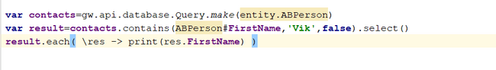

### First result

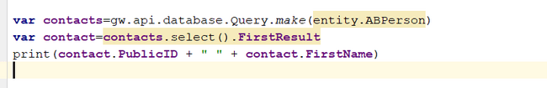

### AtMostOneRow

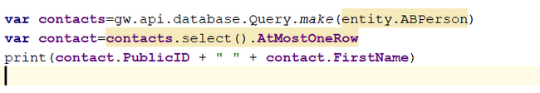

If we get more then one record then error will come.

If single item exists, method returns that single row

If no item exists, method returns null

If multiple items exist, method throws exception

### startsWith



### hasMatch

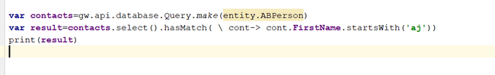

### Where

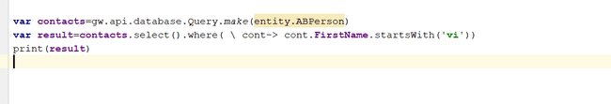

### Typeof

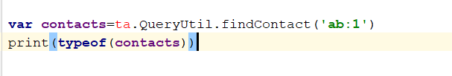

### orderBy

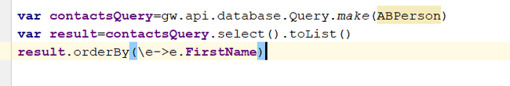

*resultsObj*.orderByDescending( \ row -> row.*FieldName* )

# INTEGRATION- BATCH JOBS

## Interview

### OOTB Codes of batch process types

Financials Escalation  
Bulk Invoice Escalation  
PurgeMessageHistory  
ActivityEscalation

Geocode  
ContactAutoSync

### Schedular-Config

This configuration file is used in order to schedule the batch jobs. To do this we need to go to this file and find the tag process configuration and make the entry for the new batch job there.

Further in the same tag we need to add the cron schedule tag as well.

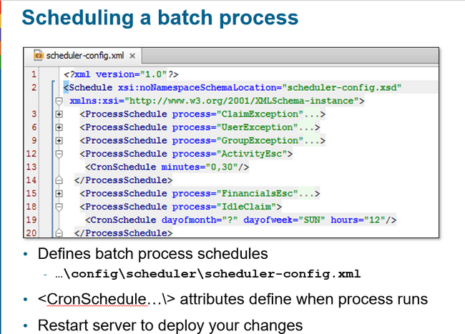

### what other methods except doWork are in class

checkInitialConditions()

- Used to determine if conditions are met to begin processing

- Return true: doWork() will be called

- Return false: only a history event will be written

- Avoids lengthy processing in doWork() if there is nothing to do

• requestTermination() method

- Called by Guidewire to request that process self-terminate

- Return true if request will be honored

- Return false if request will not be honored

- Handled by setting monitor flag in code and exiting any loops

### What is advantage of work queue over batch

Work Queues are suitable for high volume batch processing that requires the parallel processing of items to achieve an acceptable throughput rate.

While, a batch process operates on a batch of items sequentially and it’s suitable for low volume batch processing that achieve an acceptable throughput rate as the batch process processes items in sequence.

# INTEGRATION- PLUGIN

## Interview

### Some OOTB Plugins

1. IProcessesPlugin
2. MessageTransportPlugin
3. IDocumentProductionPlugin
4. IAuthenticationSevicePlugin
5. ContactMessageTransportPlugin
6. IPolicySearchAdapter
7. PolicyLocationSearchPlugin

# FIELD VALIDATIONS

### Validation can be implemented at how many levels.

* Data model level using column param and using dti
* UI level ( validation expression)

### What are the components of field validator?

* Name of validator such as Routing number
* Value that is the pattern which must be matched
* Description message that should be displayed when the pattern is not matched
* Input mask which is the optional mask applied to any field tied to validator such as “###-##”

### What are steps to implement field level validator?

* Step 1: Create error message display key

This is typically created from the display keys editor found under the localizations.

This error message is grouped under the validator and begin with the placeholder for the widget name :{0}

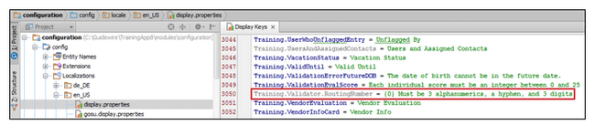

* Step 2: Create the field validator in the validators.xml

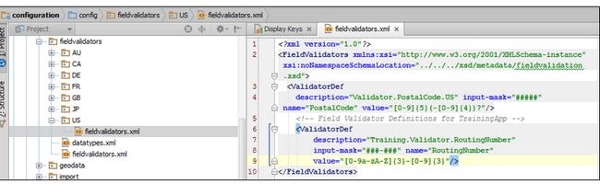

Input mask provides the watermark here.

* Step 3: Associate validator with entity field.

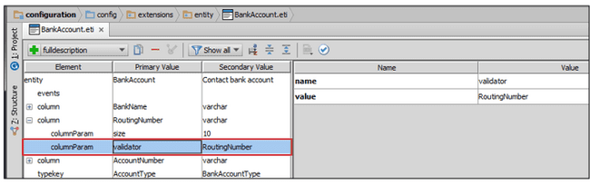

So here we need to specify the name as validator, and the value will be the name we have given in the validator reference

### Validation expression

* Validation expression is associated with a single atomic widget.
* If the expression is going to return null, then save is allowed.
* If the expression does not return null, then save is not allowed.
* Saving of the entity will take place when user tries to click on the update button.
* If this expression evaluates to not null, then when trying to submit we will get the error.
* If this expression is going to return a string, then the string is treated as the error message and the same message error message will be displayed when user tries to submit.

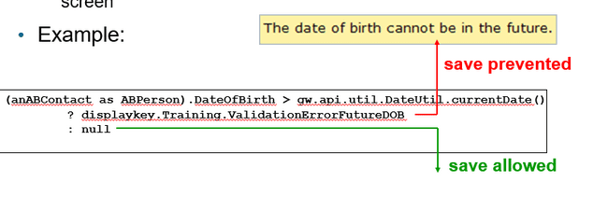

#### Validation expression syntax

* Validation expression is written in the form of the ternary operator.
* Syntax :
  + condition?null:errorMessage or condition?errorMessage:null

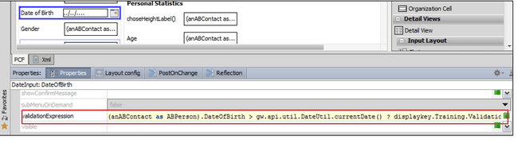

### RequestValidationExpression

This expression is different from the validation expression . This expression is executed when making any call to server.

In this expression the current value of widget entered by the user is not evaluated but the old value which is persisted in the database is evaluated.

Most of the times we make use of validation expression only.

### Note

We can implement all the data model level validations at the user interface level as well.

To specify the value in data model we have property called regex. Similarly, to specify the inputMask we have a property called as inputMask in the the properties. Therefore, all this behaviour can be achieved at the user interface level as well.

# SCRIPT PARAMETERS

### What is Script parameter

Script parameter is application wide global constant value which is maintained by the administrator.

This value can be referenced in the gosu code and is mainly used for the values that may change over the time and should not be hardcoded.

A script parameter can be referenced anywhere that Gosu can be used

### How to create a script parameter file?

Search for scriptparameters.xml file and then specify the parameter name, data type and the initial value.

### How to reference script parameter

Syntax : ScriptParamter.parameterName

### How to update the script parameter

Navigate to the admin tab script parameter section and click on the script parameter and update its value .

# PCF METHODS

### Method

A method is a set of statements that executes a logical unit of work

### Where can we declare gosu methods?

* PCF
* Enhancement
* Classes

### When PCF methods can be called?

1. When widget is clicked , here in action property we can specify the function.

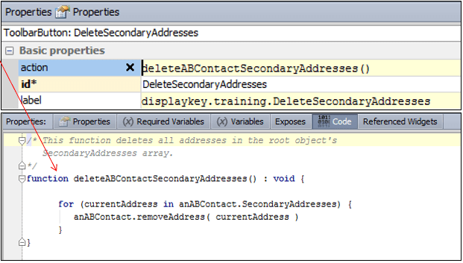

1. Input or CellButton label

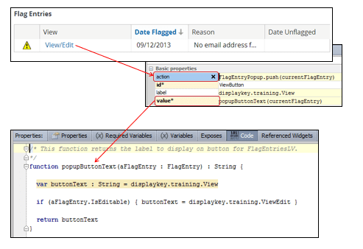

It specified the text to display once view/edit is clicked and update is made. Once update is completed it will show the text present in value property. In this case it will display view.

1. When widget value is going to change prior to value getting saved in the database
2. Navigating to locations
   1. afterEnter : executed immediately after application enters application
   2. beforeCancel or afterCancel: executed before or after application cancels out of edit mode.
   3. beforeCommit or afterCommit : executed before or after application commits out of edit mode.
   4. afterReturnFromPopPup : executed after application returns to location from popup.

### What does widget available property denote

It signifies weather the widget can be clicked or not.

### How to check if current location is in edit mode?

User can use currentLocation.editMode which if returns true will confirm that location is in edit mode otherwise it is not editable.

### How to add a button to put the current location in edit mode

Use actions property and mention, currentLocation.startEditing() to enable the editing.

# PARTIAL PAGE UPDATE

## Post on change

### Static and dynamic widget properties

Some widget properties are static in nature that is they never change like “ID” and some are dynamic which changes dependent upon the condition example “visible”.

### Post on change property

Post on change is applied on a widget like Typekey. We can write a piece of code such that whenever a value of widget changes then certain action will take place.

Example if item in typelist is changed then we can set some value in other widget.

If post on change is true for a widget then any change in the widget will lead to complete refresh of the page.

To prevent complete refresh of page and refresh only the targeted widget we can use the option target. If some target item is specified, then only that item will get refreshed preventing refreshing of completed page.

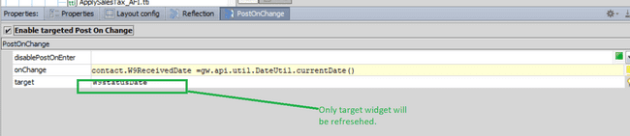

### disablePostOnEnter

this property is used to display the refresh/rendering of the widget based upon certain condition.

If the condition is satisfied, then for that condition onChange and target code will not get executed

## Reflection

### What is reflection?

Unlike post on change in case of reflection there can be more than one triggers and more than one listener

Here the triggered widget changes its value.

To enable the reflection, we must click enable client reflection on listening widget.

### What is the reflection capability?

Reflection can change listening widget VALUE and its AVAILABILITY.

### Where is reflection configured?

Reflection is configured in the reflection tab of listening widget.

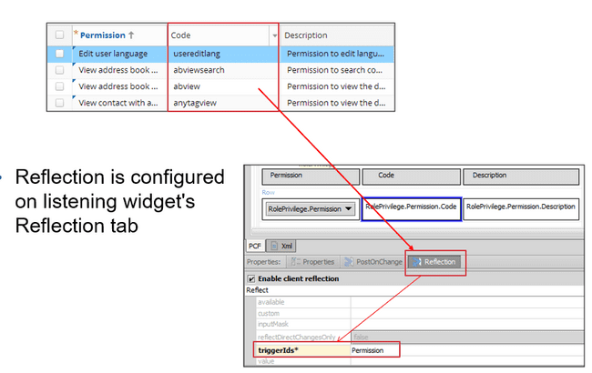

### How to configure value reflection?

Here the listener widget must specify specific properties

* Triggering widget( which is the id)
* Widget value (accessible through VALUE)

Here TOKEN is the widget that contains value of the triggering widget.

For example, triggering widget is Contact and we want to specify its email id in one of its widgets then we can say like.

VALUE.EmailAddress

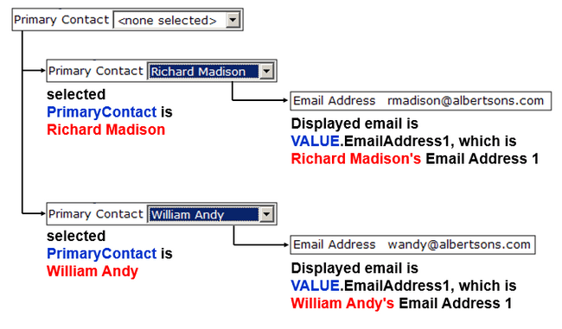

If the value of VALUE has properties that can be accessed through using standard dot notation(VALUE.property)

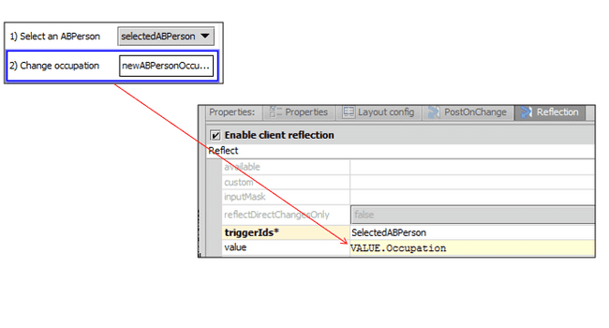

### Complex value reflection

If there is more then one trigger id for a widget then the tokens for the values are in the order that is VALUE1, VALUE2, VALUE3.

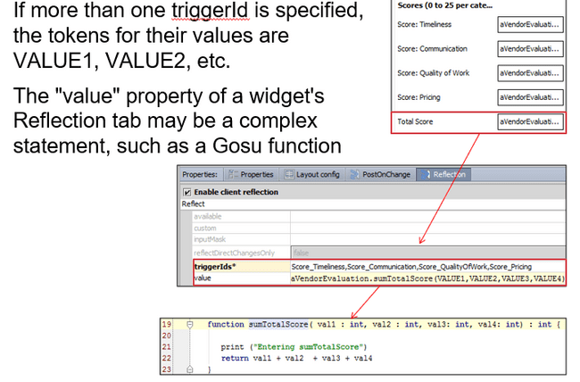

### Difference between client reflection and post on change

|  |  |
| --- | --- |
| Client reflection | Post on change |
| 1. on listening widget | On triggering widget |
| 1. reflection tab | Post on change tab |
| 1. define trigger ids | Define target property |
| 1. specify value property | Assign value with on change |

### What are the properties you configure for widget on post on change?

* disableOnEnter
* onChange
* target

# MODES(C1)

### When to use widget?

In some cases, widgets need to vary significantly based upon the business scenario. In those cases, we can go for the modes.

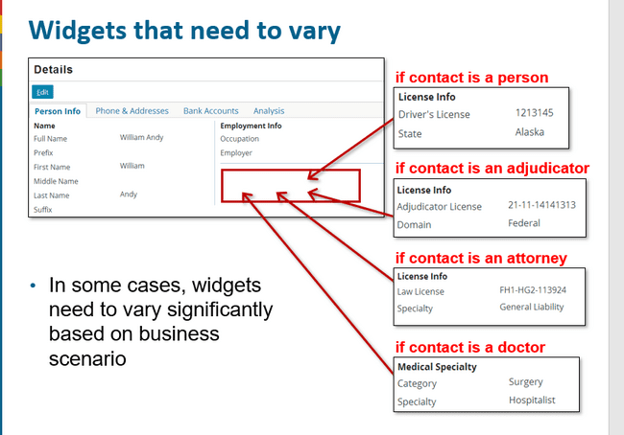

### Disadvantage of not using modes

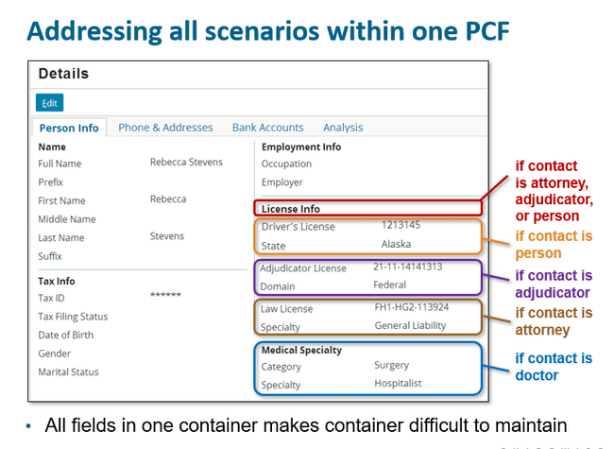

### Using mode give reusability of pcf

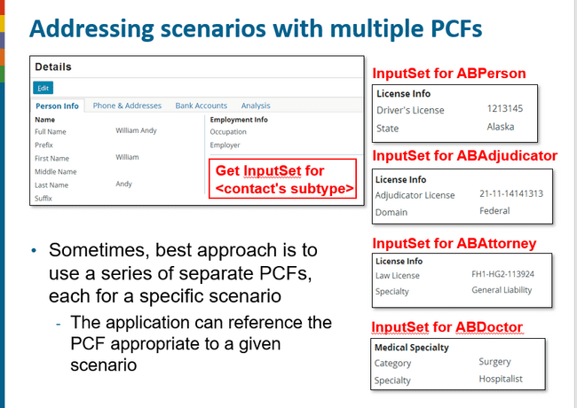

### Mode definition

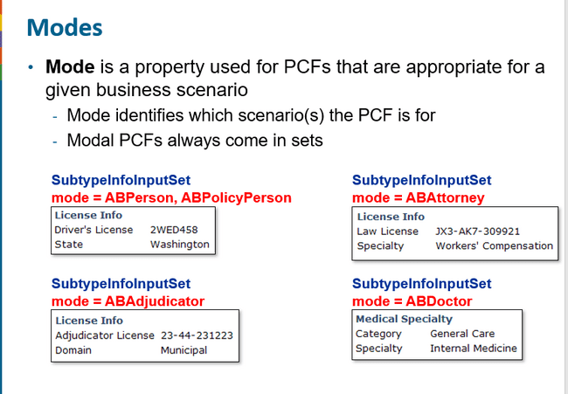

### Default mode

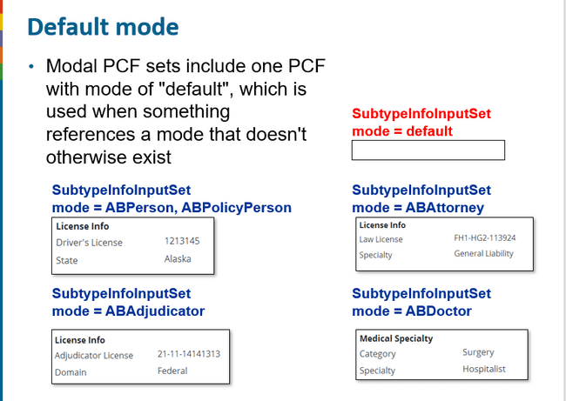

### Steps to create mode

#### Step 1: Create model PCF set

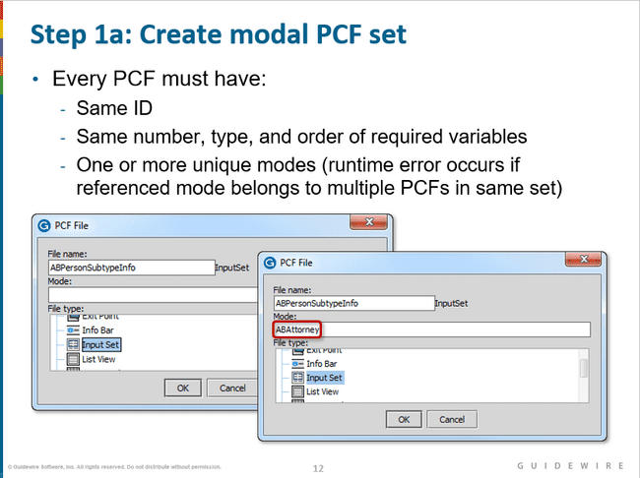

#### Modes and subtypes

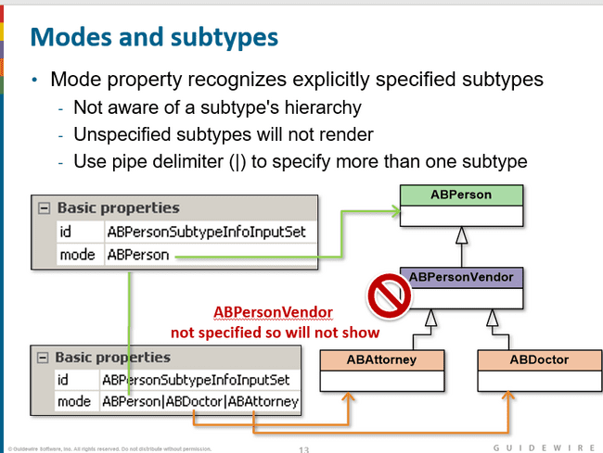

#### Model widgets in studio

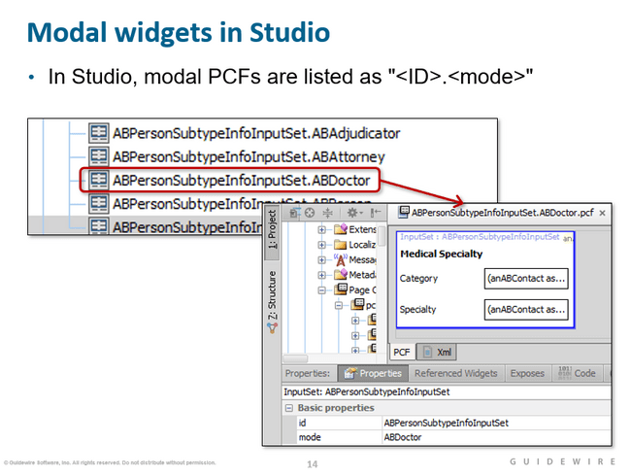

#### Step 2 Create default pcf

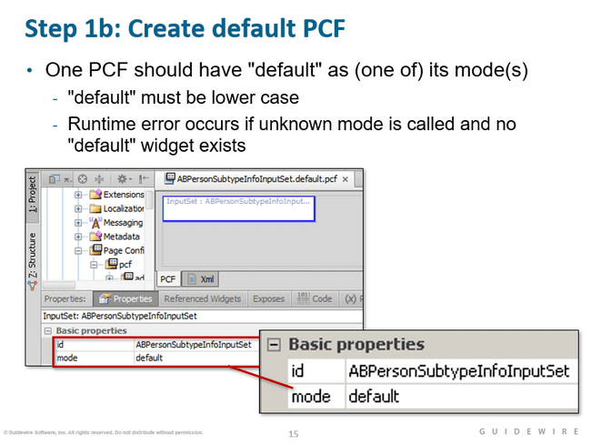

#### Step 3: Ensure same required variables

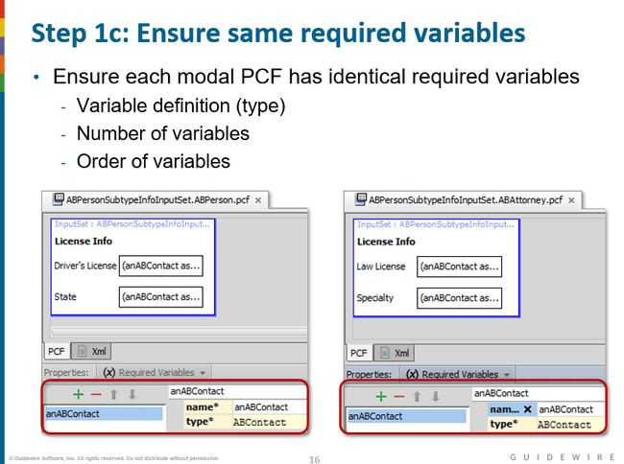

#### How to change modes

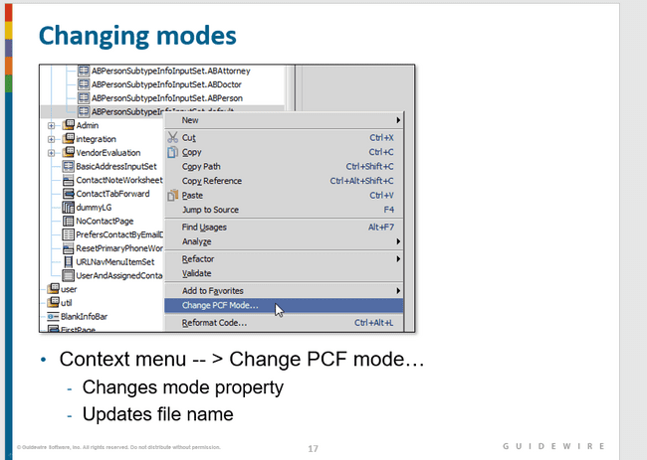

#### Step 4: create reference to pcf set

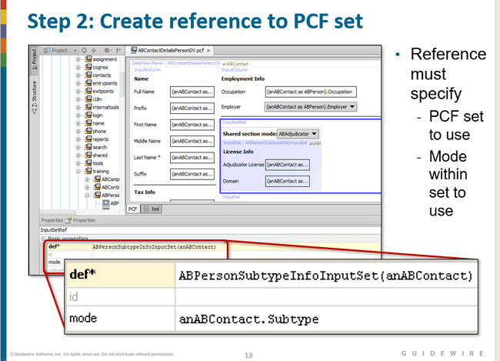

#### Modal references in studio

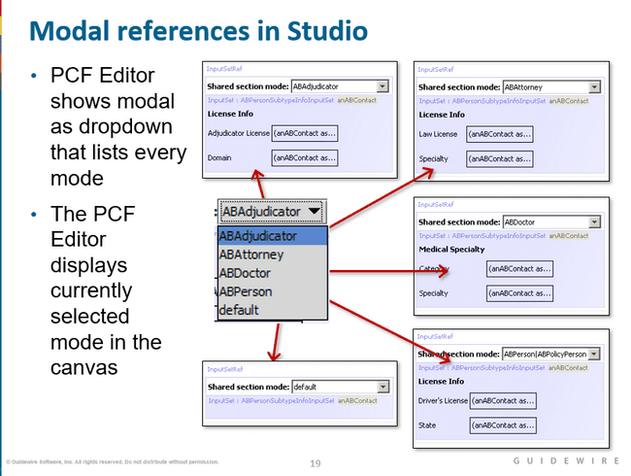

### Model usage scenario

Different type of contacts (individual vs business) and different line of business (auto vs property) we can use the modes.

### Common thing in all pcf

All files should have same required variable as well as the same id

### Can pcf have more than one mode

Yes, a pcf can have more than one mode

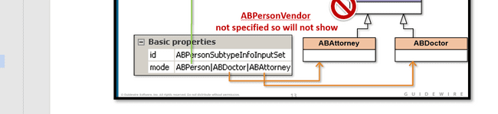

### What happens if a reference identifies a mode, but there is no PCF with that mode in the set?

If pcf with default exist, then that one will be used otherwise we will get the run time error.

### Can the same mode be used by more than one PCF within the same modal set?

No. If the same mode is used in multiple PCFs in the same set, then the application cannot determine which file to use and a runtime error occurs.

## Exercises

### Exercise 1

#### Lab 1

First create the pcf which we want to show for different business scenario. Here all the pcf will have the same name with different mode in it.

To create the pcf

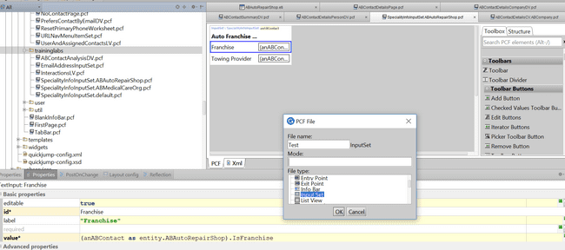

Here only for some pcf types only mode option will be visible like inputset.

These pcf will be visible in the studio as

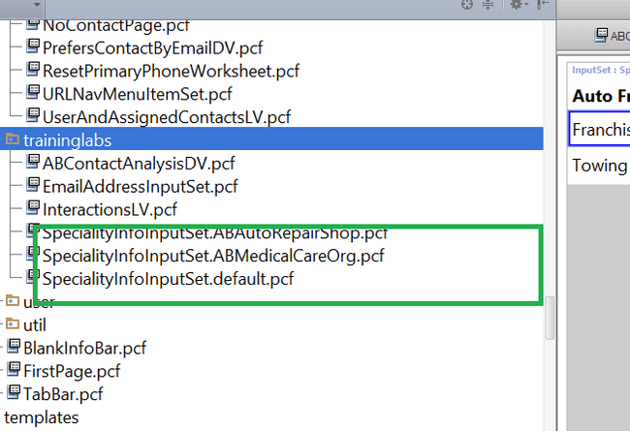

These pcf must specify the same required variables which will be passed like a function call from the parent pcf.

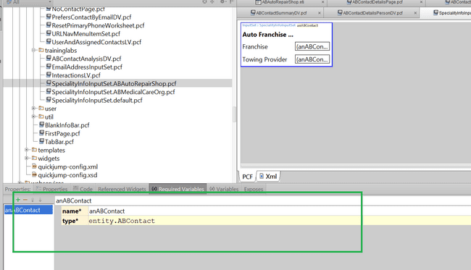

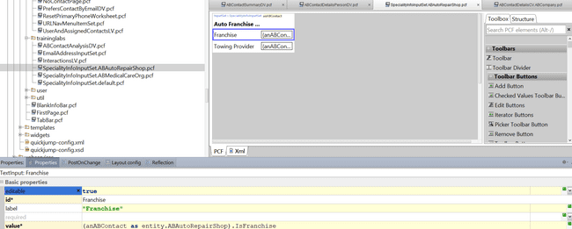

In the parent pcf in def section we must specify the name of the pcf and pass the object as the parameter and specify the mode as well. After specifying the mode only, the specific modal pcf will be called.

To note that parent pcf must specify the input reference to access the input set.

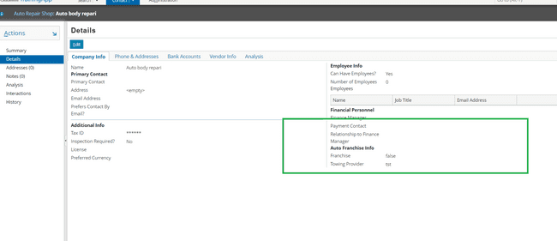

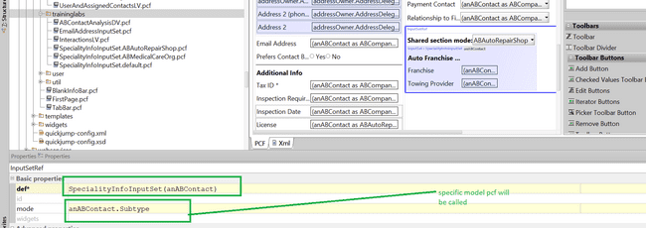

#### Lab 2

Create the pcf first, here name should be same and mode name will be coming after the dot.

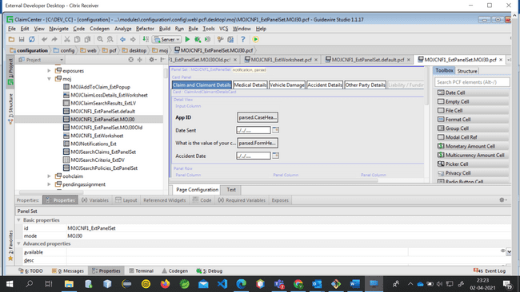

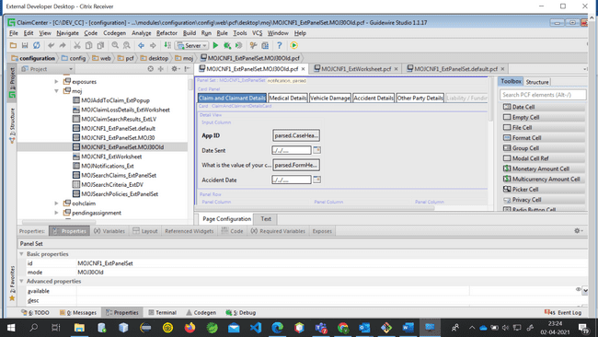

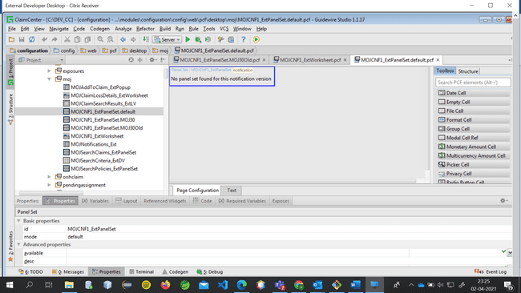

Now go to the parent pcf and write the logic in the mode field

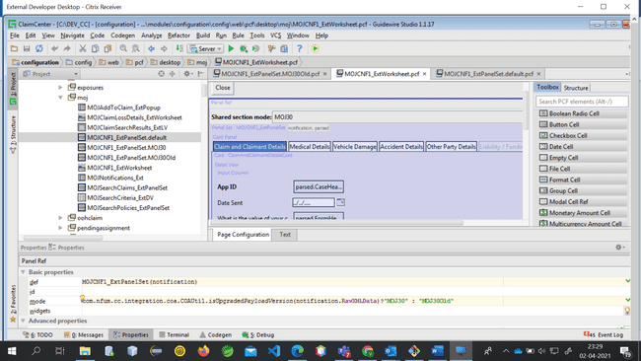

So here whatever mode field is going to return only that pcf will get called.

Here the mode value is hardcoded string. We can also pass the variable value as well. For example here if parent pcf had variable anABContact and we want that based on its subtype the corresponding pcf should be called then we should be writing anABContact.Subtype.

Here to use mode field we have used inputset and panel set references.

# LOCATION Group/References (C1)

## Locations

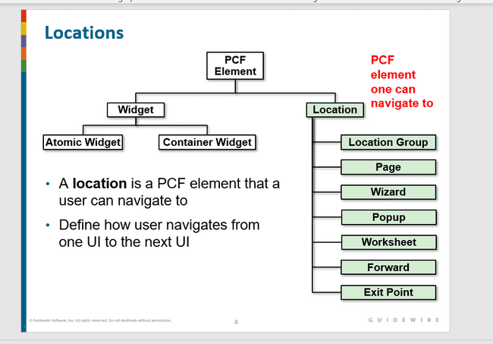

## Types of Locations

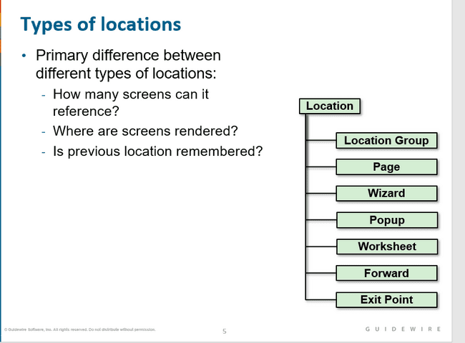

## Page

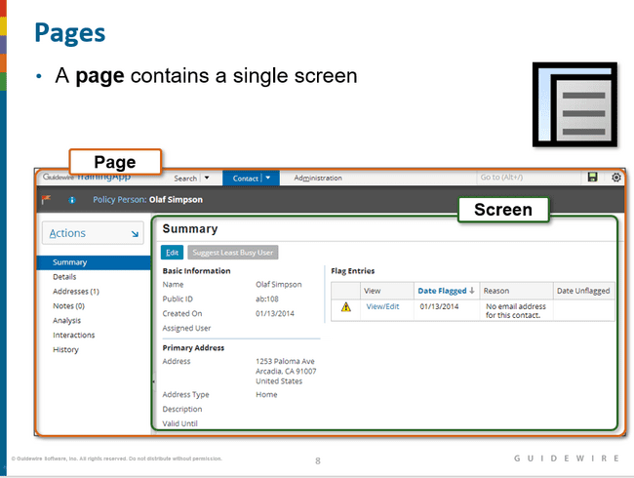

## Location groups

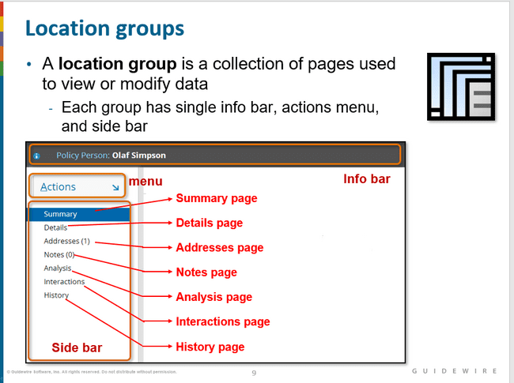

## Wizards

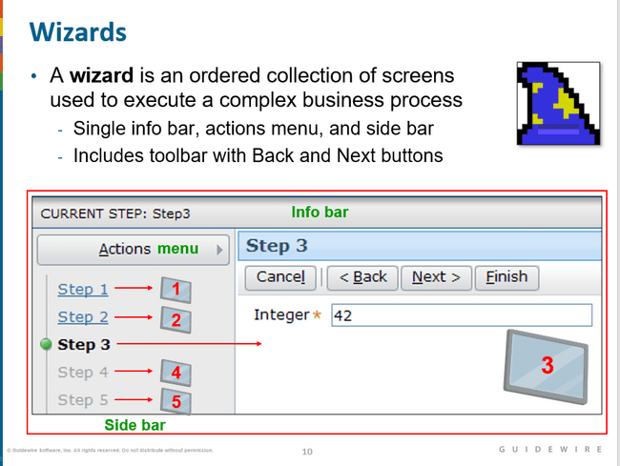

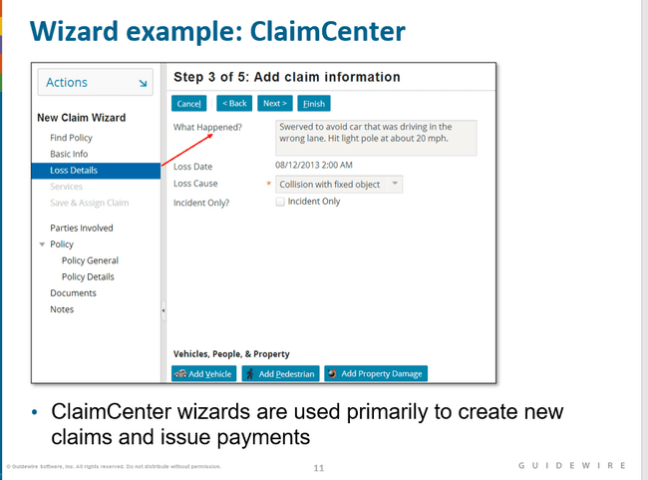

## Popup

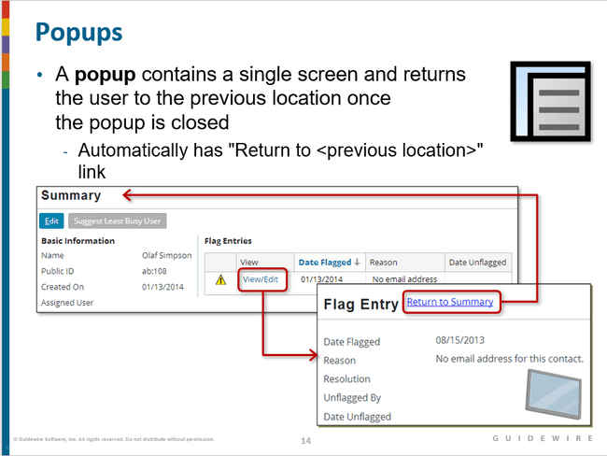

## Worksheets

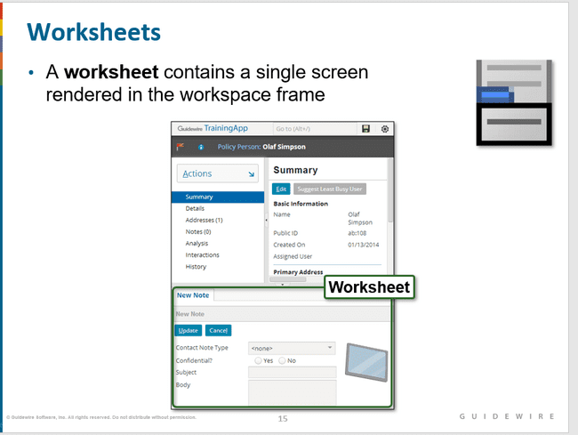

## Forwards

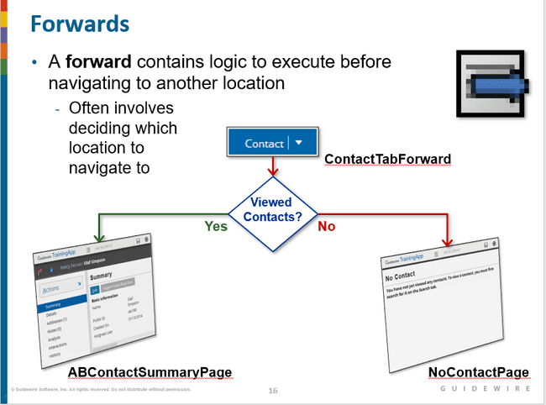

## Exit Points

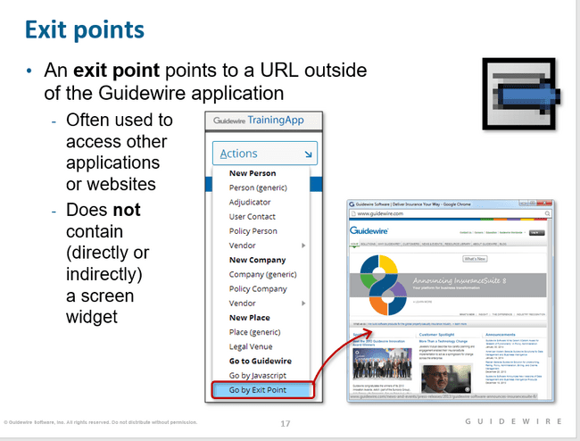

## How to enable navigation

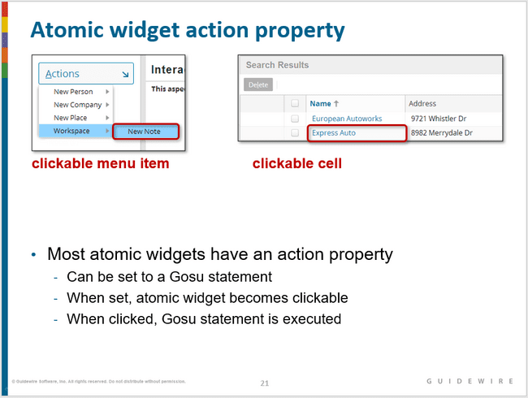

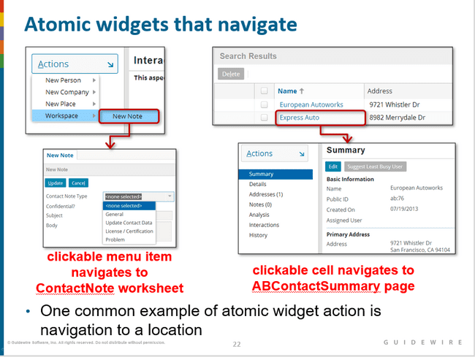

## Location Methods

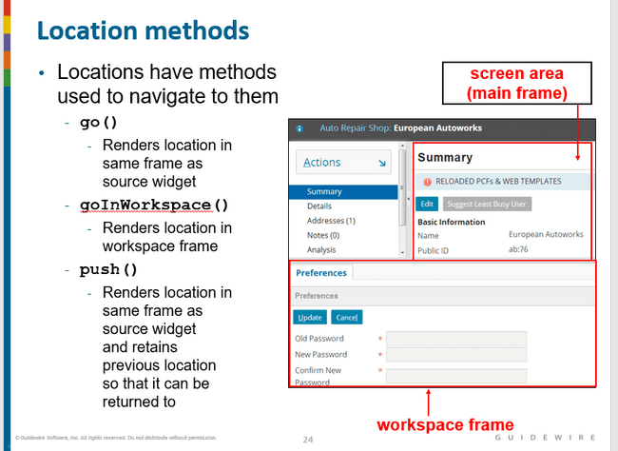

## Steps to enable navigation for given widget

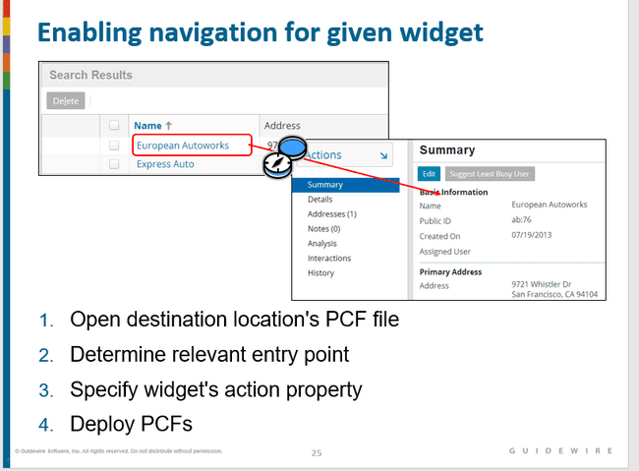

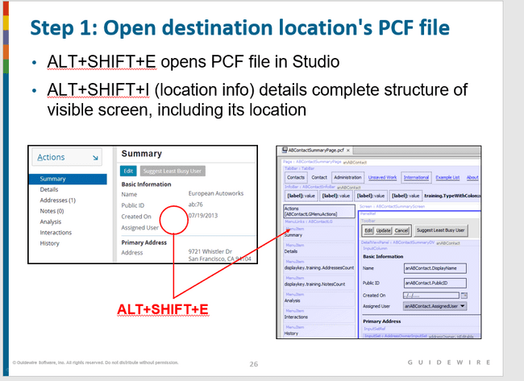

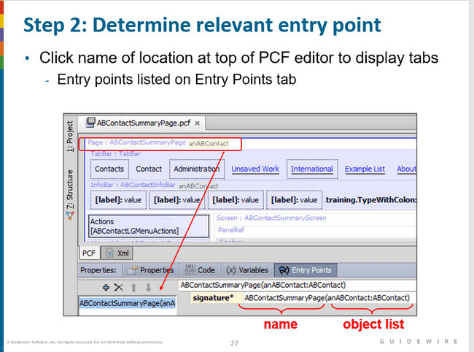

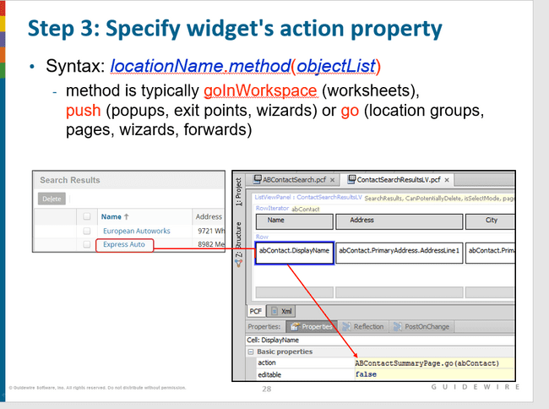

## Location with multiple entry points

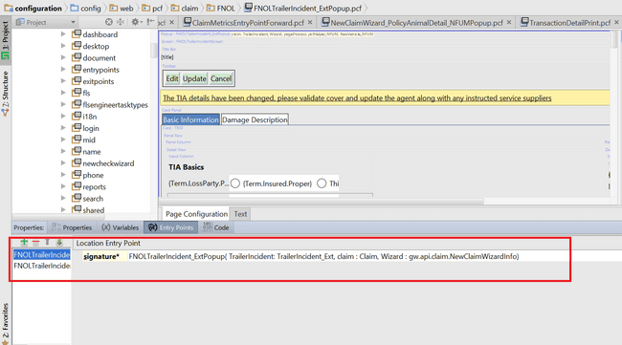

## Notes

### Note1

Entry point is used in the pcf so that the destination pcf can be called with the correct signature only. If we do not specify the entry points , it is possible to call the destination pcf without passing any object inside the calling pcf.

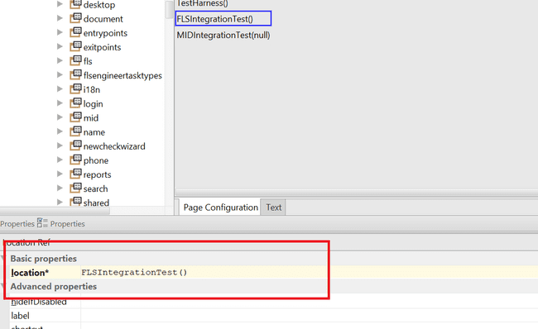

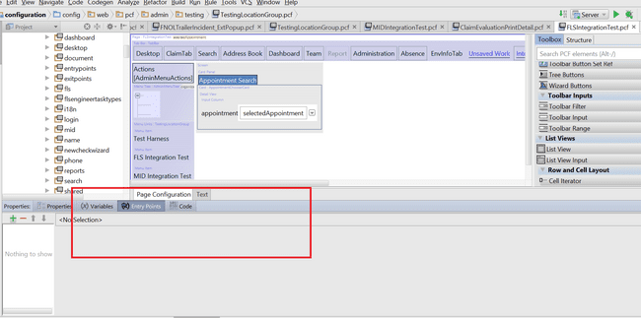

## Exercises

### To create a navigable link to display contact details

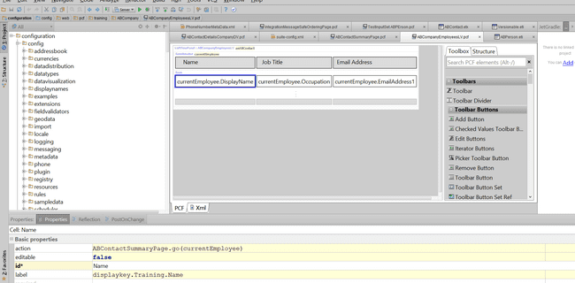

Write code in the action property

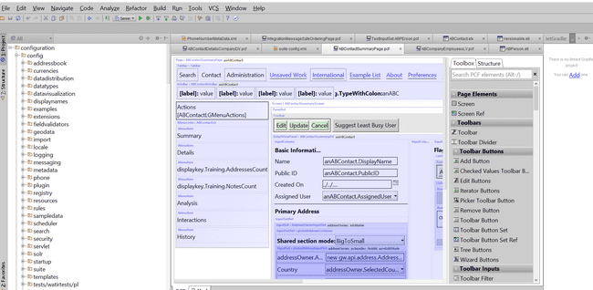

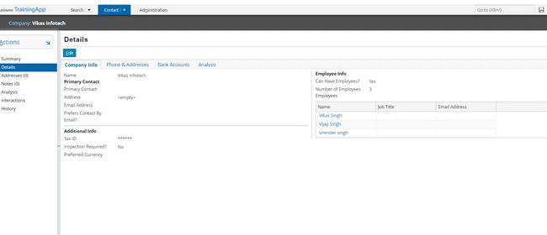

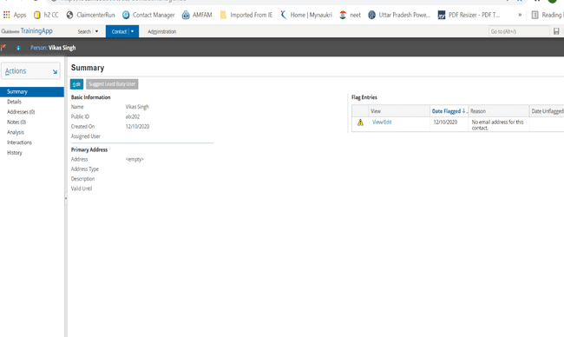

### Location groups and references

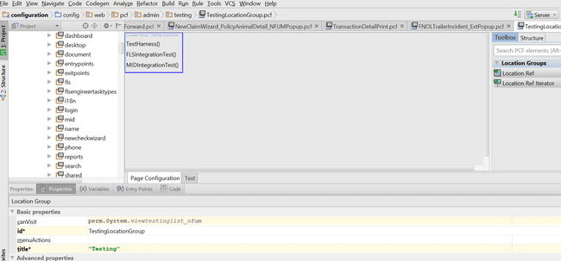

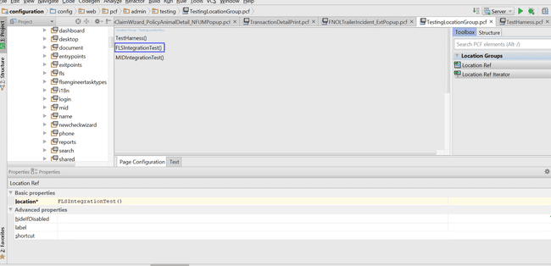

## Questions

#### Which one renders a screen somewhere other than the screen area?

Worksheet

#### Which two contain multiple screens and have their own info bar, actions menu, and side bar?

Location group and wizard

#### Which one typically navigates to one of several locations based on business logic?

Forward

#### Which location does not navigate (directly or indirectly) to a screen?

Exit point

#### For each location, what method would you usually use to navigate to it?

Use go to navigate to pages, location groups, wizards, and forwards.

Use push to navigate to popups and exit points.

Use goInWorkspace to navigate to worksheets

# POPUPS(C1)

## What are popups

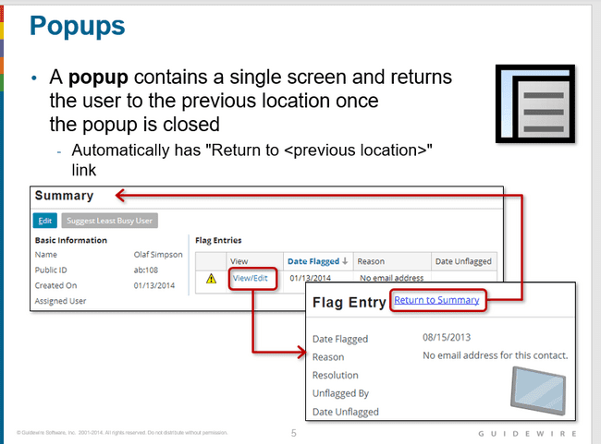

## Popup use case

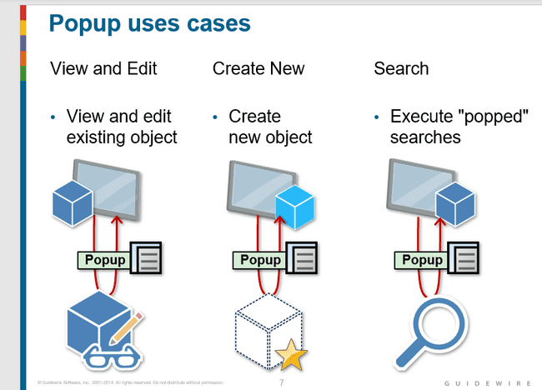

## View and edit existing object

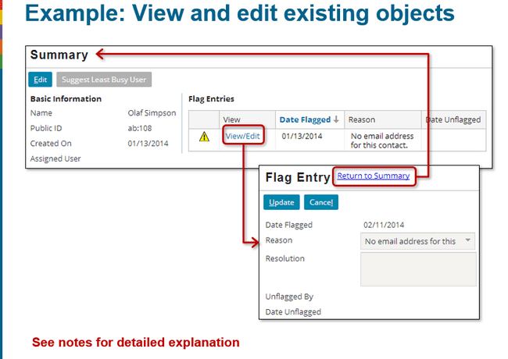

## Create new object

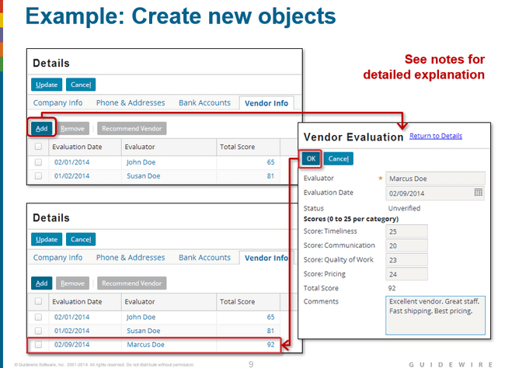

## Popup searches

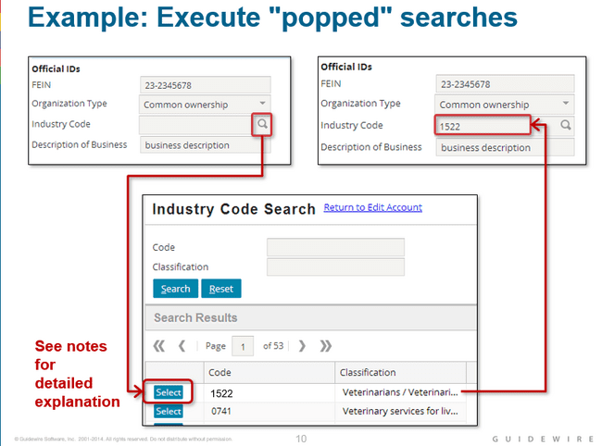

## Popup creation steps

### Step 1: create pop up pcf file

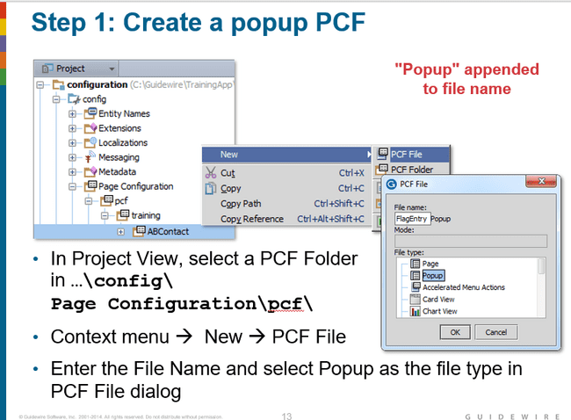

### Step 2: specify variables

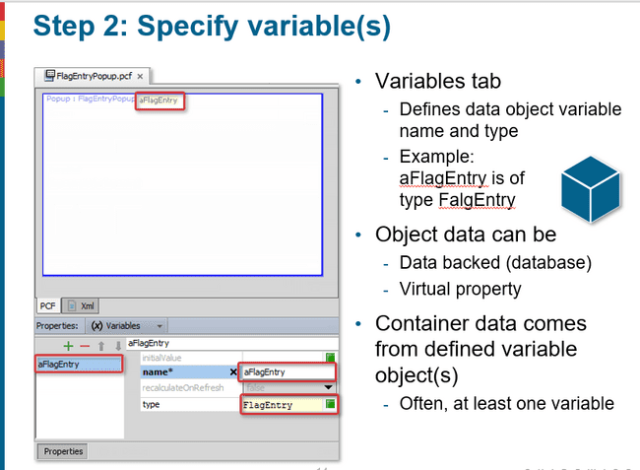

### Step 3: specify properties

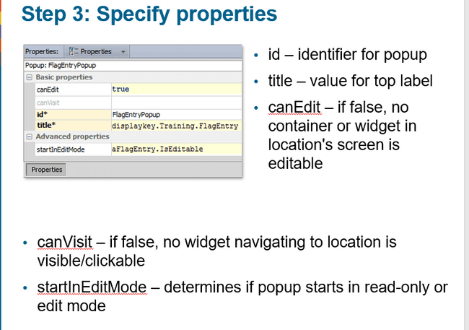

### Step 4: specify entry point

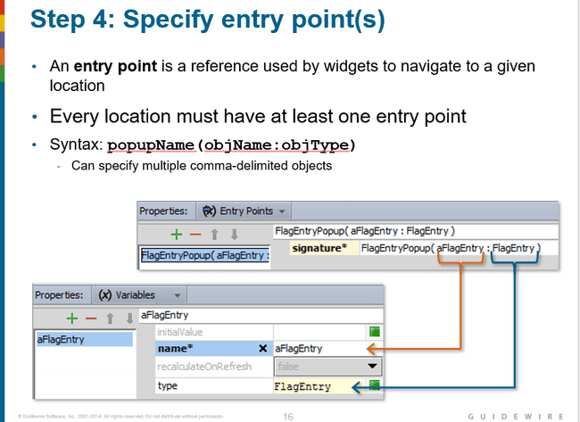

Here whatever aFlagEntry will be passed from the parent pcf will be passed as argument to the aFlagEntry variable. In this way aFlagEntry get initialized.

### Step 5: Add containers and input widgets

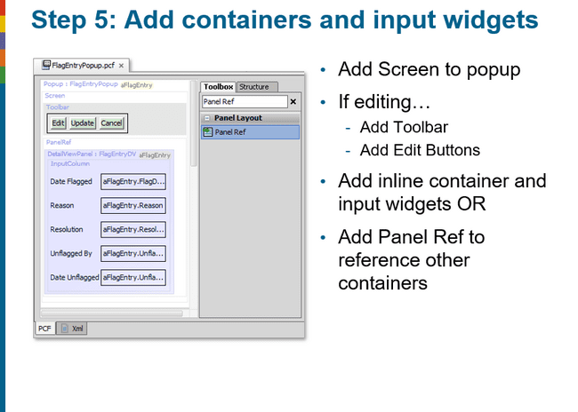

Step 6: Configure navigation widget

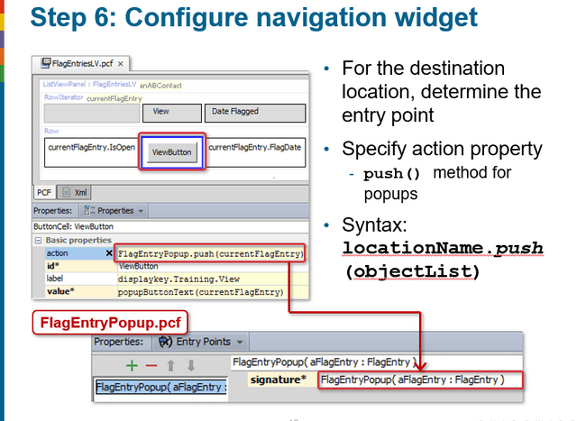

## Exercises

### Exercise 1

Using search popup in order to link contact from contact manager to an entity contact reference.

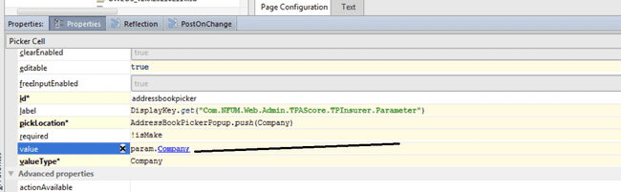

Here we are passing Company as the argument to AddressBookPickerPopup which will start the search in contact manager of type Company.

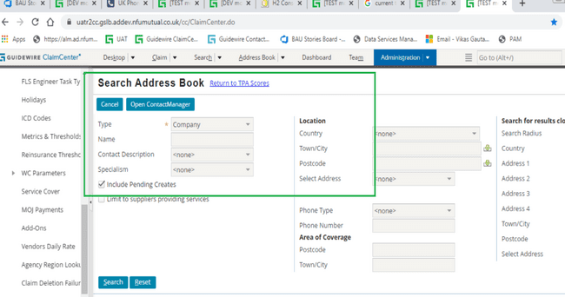

Further it will give us an option to use to select, whatever contact we are going to select that company id will get lined to param.Company and in this way we will build the relationship.

### Exercise 2

Linking notes to payment where when user will click upon the button link notes he will be redirected to a list view having multiple notes.

Then the user can choose from the list which notes he want o link to the payment.

Step 1

First create a picker toolbar button

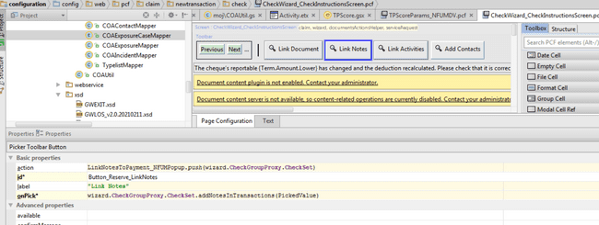Step 2

In the action specify the popup to be called and supply the variable to be passed inside it as well.In order to capture this call in the entry points of the popup we need to specify this signature. This will input the value from the calling pcf and we can access it inside the destination.

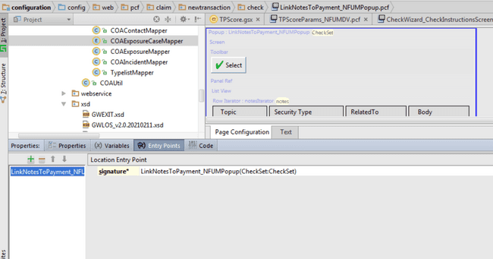

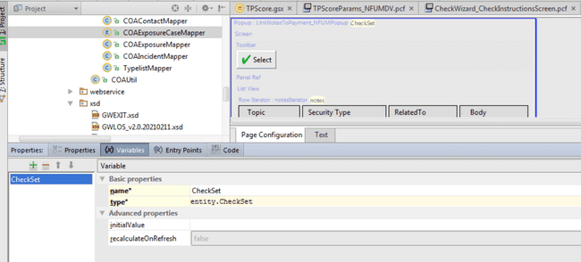

Step 3

Now since this popup is going to return list of notes selected by the user, therefore I need to specify the return type as well to be returned by this pop up.

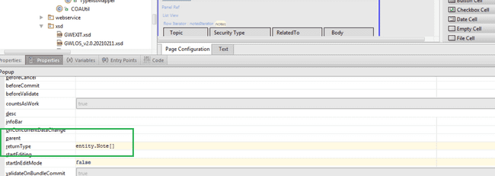

Step 3:

Further in order to capture the selected records I need a checked values tool bar button whose pickValues property is going to CheckedValues and iterator will be the name of list view iterator want it to be applicable.

Also, in row iterator hasCheckBox property must be set as true.

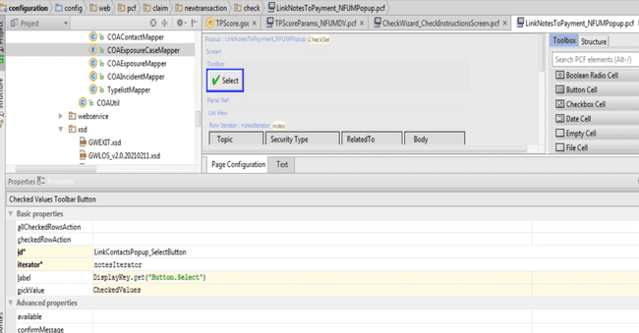

Step 4:

Finally the selected notes will be returned from the popup. Now the control will come to the calling pcf and in that pcf we can perform any action on the records returned using onPick property. Here PICKEDVALUE will hold the object returned from the popup which in our case is an array of notes.

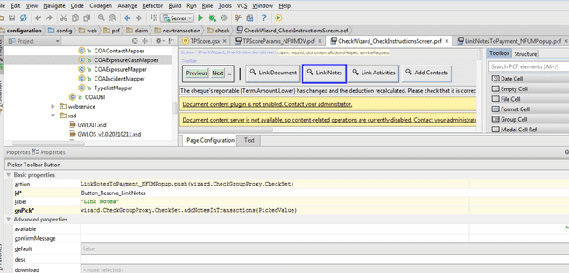

## Questions

### What are the three primary use cases for popups?

View and Edit, Search, Create new Object

### What happens if a location's canEdit property evaluates to false?

The screen and its contents are not editable.

### What happens if a location's canVisit property evaluates to false?

In that case the navigating widget will either be not visible or not clickable.

# BUSINESS RULES (C1)

### What is business rule

Business rule performs an action based upon the condition for the given entity when a specific event occurs on the instance of the entity.

### What is Rule set category?

Rule set category is a collection of rules that have common high-level business purpose.

### What is rule set?

Rule set is a collection of rules that is attached to same entity and shares the common trigger.

### What is root entity?

The root entity identifies the entity with which the rule is associated.

### What is order of rule set?

First parent is executed, and if it evaluates to true then the child rules are executed in the order which is specified.

### How to exit a rule set?

actions.exit()

* + Exit the entire rule set. This will prevent the child rules to also execute.

### What triggers a rule set?

Whenever any change to the root entity is going to occur rule set is going to get trigger. This is different for each rule set.

### What two things are done for a rule whose condition is true that are not done for a rule whose condition is false?

Rule set and its child rules are going to get executed.

### What is the difference between an "execute all" rule set and an "exit after first action" rule set?

Execute all rule set is going to execute all the rules inside the rule set one by one for example in case of validation rule set.

However, in case of exit after rule set not necessarily all the rules are going to execute. When the first true condition has been found the rule set is going to exit. Example in case of assignment rule set when the assignment is successful the below rule set does not execute to prevent re assignment.

### Assignment Rule

This rule is responsible for assignment of user or group to a given entity. This rule set is kind of exit after rule set.

Assignment rules are run when a claim (or exposure) is created and the "use automatic assignment" option is chosen.

The claim is assigned first, and then its exposures. The exposure owner is not necessarily the same as the claim owner. However, unless it meets a special circumstance, each exposure is typically assigned to the same group and user as the claim.

### Validation Rule

Validation which prevents invalid data from getting saved

Validation which manages and enforces object maturity.

# VALIDATION RULES

## Validation

Claimcenter uses validation level to insure that certain specific criteria are met before the claim object can be moved to the higher level. We can view these levels as the maturity levels.

Claimcenter object can always achieve a higher maturity level but can never go backward in validation level.

ClaimCenter runs the validation rules at many different points in the ClaimCenter workflow. ClaimCenter also runs these rules whenever it commits a claim or other validatable business entity to the database

## Types of validation

* Validation preventing invalid data from getting saved.
* Validation which manages and enforces the object maturity.

## Logic that prevents invalid data

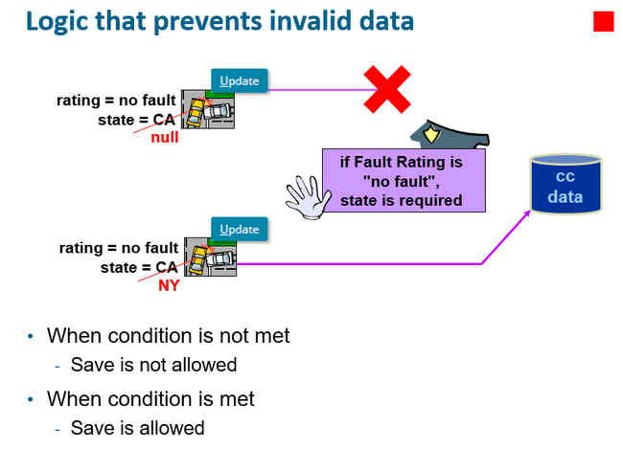

Here in first case when, rating is no fault state is required. But since we are passing state as null therefore the save is prevented in the claimcenter.

But in the second example state is provided, therefore when user clicks on update button save is allowed in the database.

## Logic tied to object maturity level 1

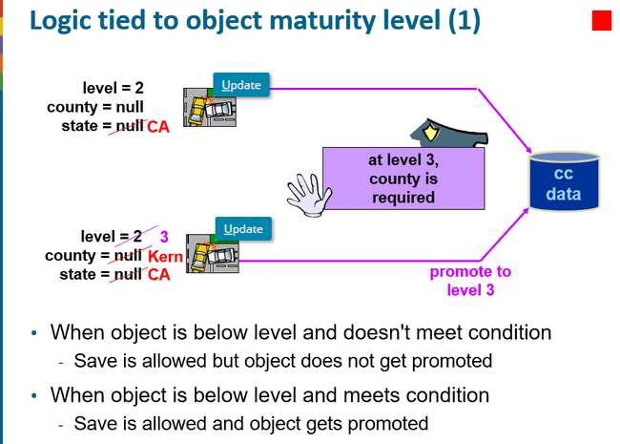

## Logic tied to object maturity level 2

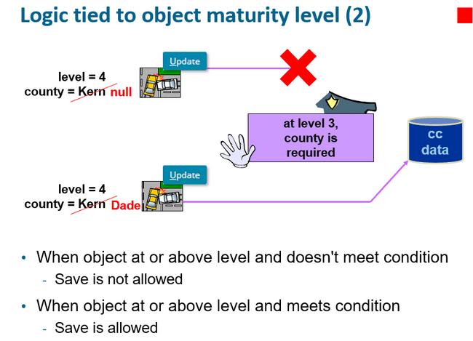

## Enforcing validation of invalid data

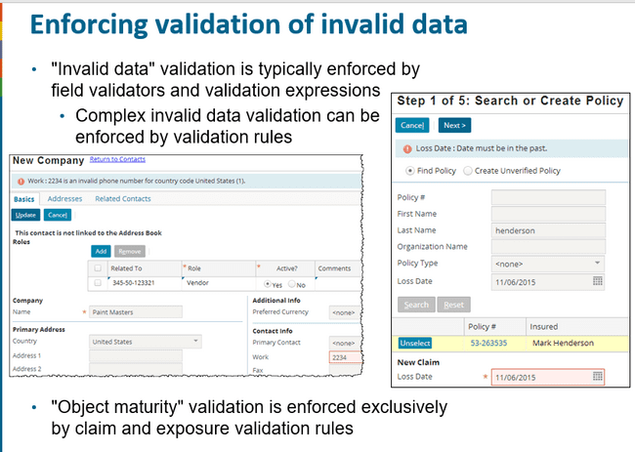

## Claim and exposure validation rule

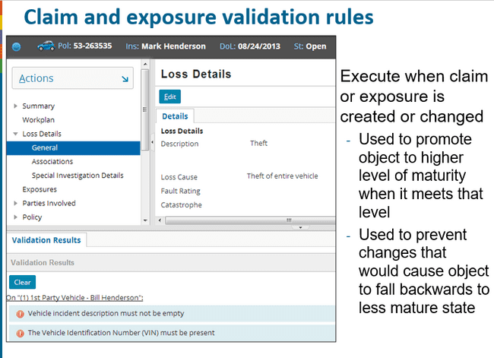

## Validation levels

Validation levels in base claimcenter in order of priority present in validationlevel.ttx

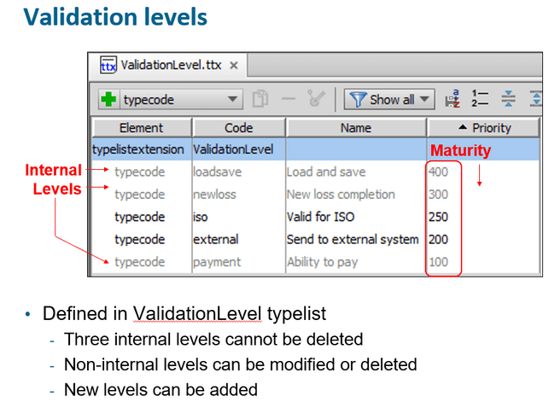

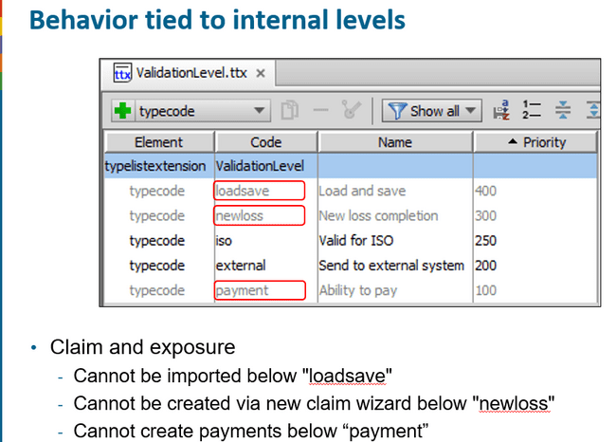

### Load and save

* + Claims and exposures to be imported from the external system must contain minimal set of information to be saved in database

### New loss completion

* + For a claim first in draft state created from wizard must be present in this level for it to be saved in the database.

### Valid for iso (can be removed)

* + (Optional) This level verifies that all required fields are complete before sending to ISO

### Send to external system (can be removed)

* + (Optional) This level can verify if the claim has enough information before it is sent to an external system.

### Ability to pay

* + This level ensures that a claim has all the required data needed to make a payment on it.

## Pre update and validation

1. Pre update rules runs first followed by the validation rule.
2. Pre update rules are for editing or creating objects
3. Validation rules are for validating that the objects are ready to be saved in their current state.
4. *reject()* functions are never called in pre update rules.
5. Changes or additions are never made in validation rules

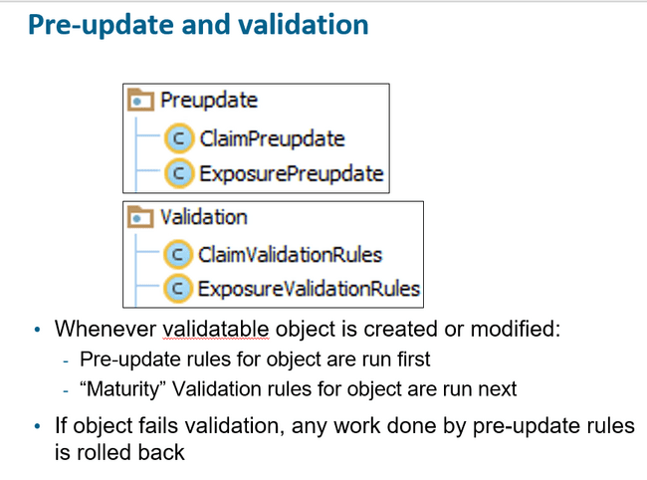

## Object promoted to highest possible level

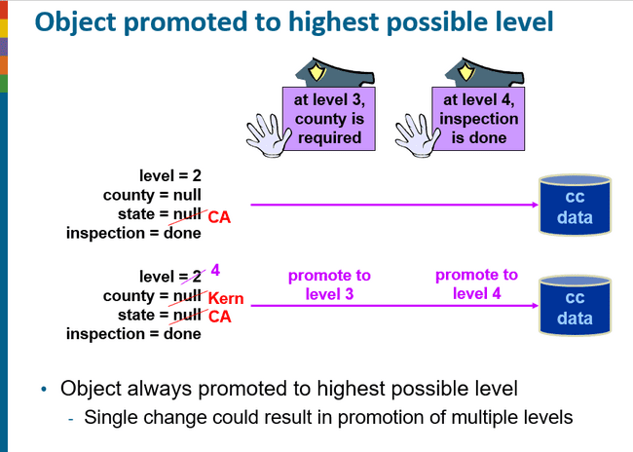

## Related objects can trigger validation

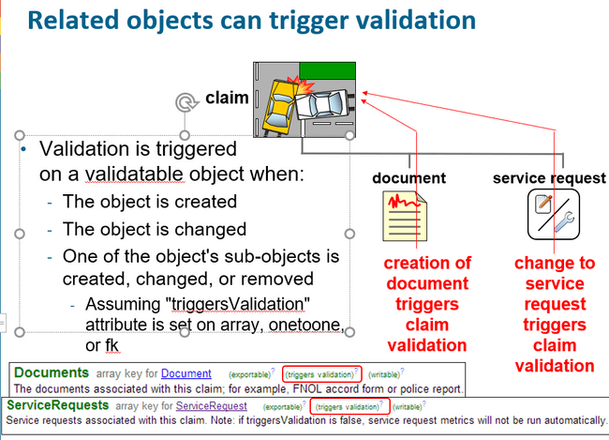

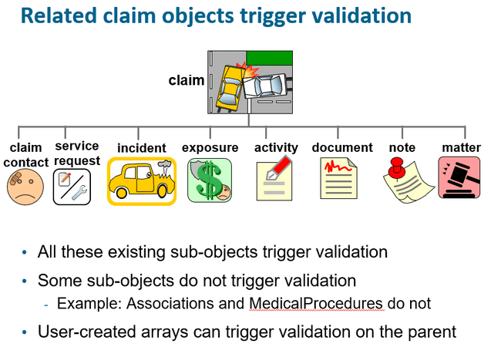

## Validation Rule Errors

Validation rule error occurs when we move the object from higher validation to lower validation level.

For example, if the object has satisfied all the mandatory conditions and is in the validation level of ISO stage and then we make some change breaking iso level condition then basically we are trying to move the object to the lower level of maturity. Here in this case we are going to get the validation error.

However, if we did the same thing but the object is not yet at the ISO level then we are not going to face this error.

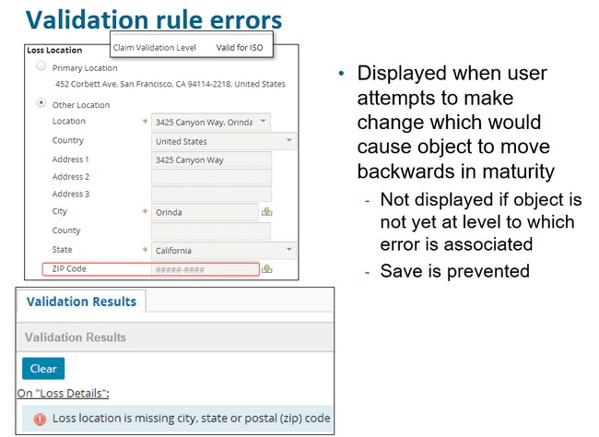

## Validation rule warnings

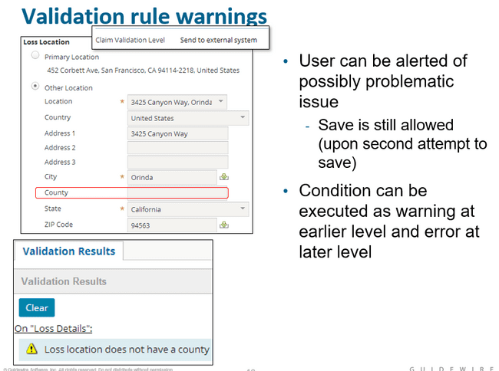

Here in this case the data is allowed to be saved in the database with just a warning given to user regarding the missing field.

## Validation level for given object

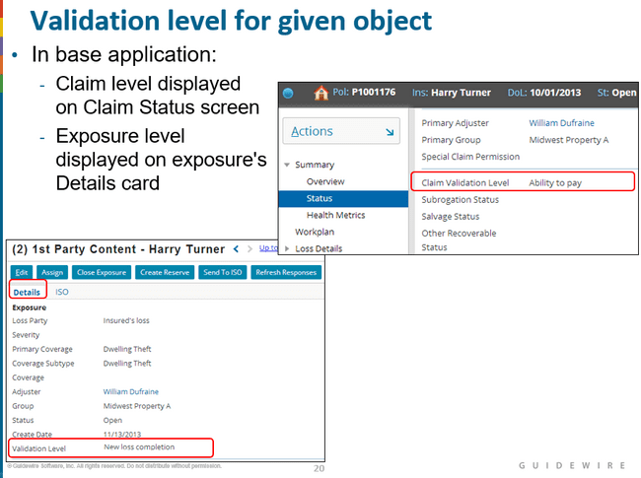

1. Claim and exposure validation levels are independent of one another.
2. A claim could be at "ability to pay" even though all its exposures are at "new loss completion". Similarly, a claim could be at "new loss completion" even though all its exposures are at "ability to pay".
3. In the base application, one of the primary aspects of functionality tied to validation levels is the payment wizard. You cannot initiate the payment wizard if the claim is not at ability to pay (regardless of the maturity of the exposures).
4. If the claim is at ability to pay, you can initiate the payment wizard. However, you can create payments only from reserve lines whose exposures are at "ability to pay". If the claim is at "ability to pay" but none of its exposures are, then you can start the payment wizard, but you have no reserve lines from which to make payments.

## Running validation rules manually

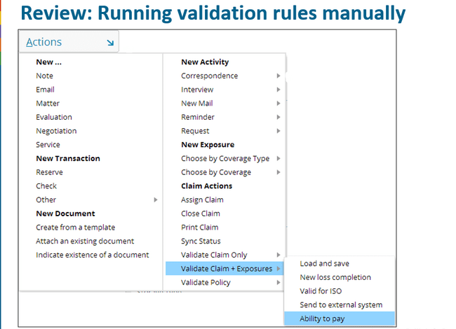

Using this tool feature, we can check for validation level of claim of exposure object which is not yet obtained by it.

## Reject() method

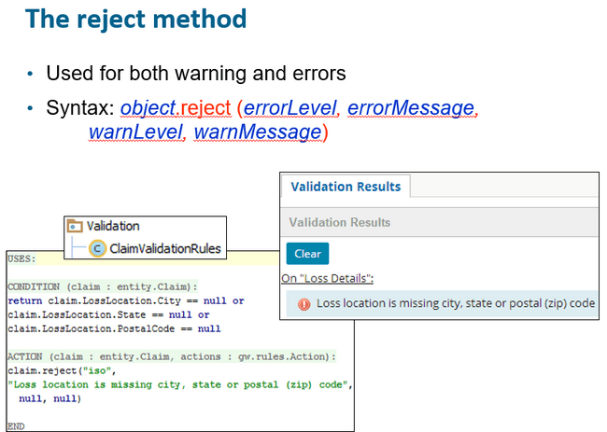

1. In the example above, if a claim's loss location's city, state or postal code is null, then an error is raised at the "iso" level (or higher) with the associated text message.
2. If the claim is not yet at the "iso" level, then this condition will prevent the claim from being promoted to "iso". However, no error message is displayed. (In this situation, a user has created or modified a claim in which the city, state, or postal code is blank. Because the claim is not at "iso" level, the creation or change is permitted, but the claim cannot yet be promoted to "iso" level.)
3. If the claim is already at or beyond the "iso" level, then this condition will prevent the change from occurring. The error message will be displayed. (In this situation, a user has modified a claim in which the city, state, or postal code is blank. Because the claim is at or beyond "iso" level, the creation or change not allowed. Allowing the change would logically move the claim backwards in maturity.)

## Reject method: warning vs error

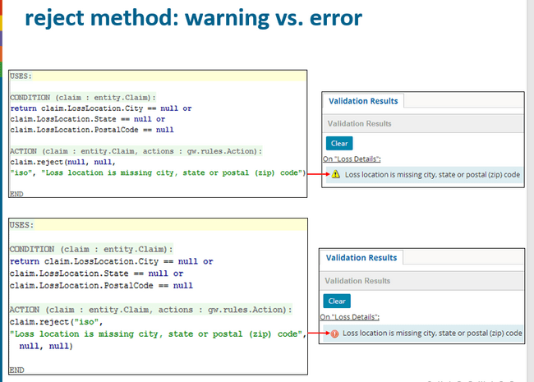

If we are using only warning, then the submission of data will be allowed but the upgrade in level to iso will not take place at this moment.

The user can always find out what is blocking a claim from achieving a new level by using the menu action described previously (Actions > Validate Claim Only).

## reject() method warning and error

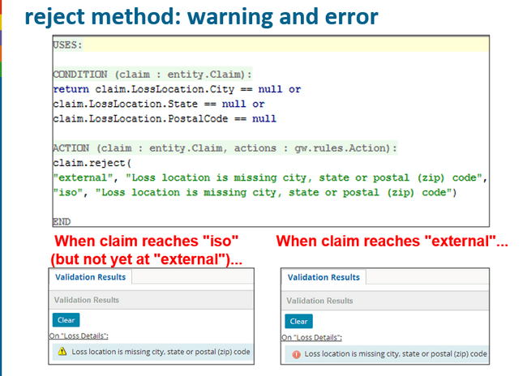

If a single condition raises both a warning and an error, the warning should be at an earlier level of maturity. Otherwise, the user will never be warned, because the error gets enforced first

## The rejectField() method

The difference between reject() and rejectField() is that rejectField() highlights the field containing the data that triggers the error or warning. rejectField() possesses an additional argument for this purpose (the first argument).

The strRelativeFieldPath argument is the relative path rendered as a string from the root object (where the root object is the object the method is on) to the field that failed validation. Do not specify the root object in the relative path string.

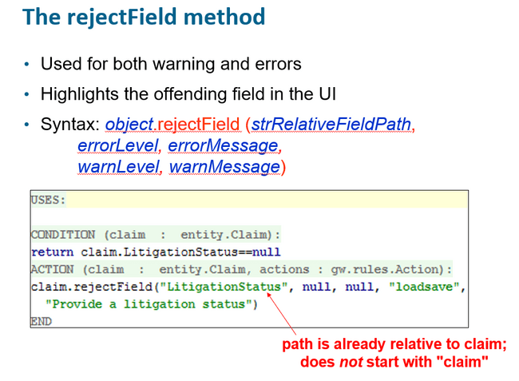

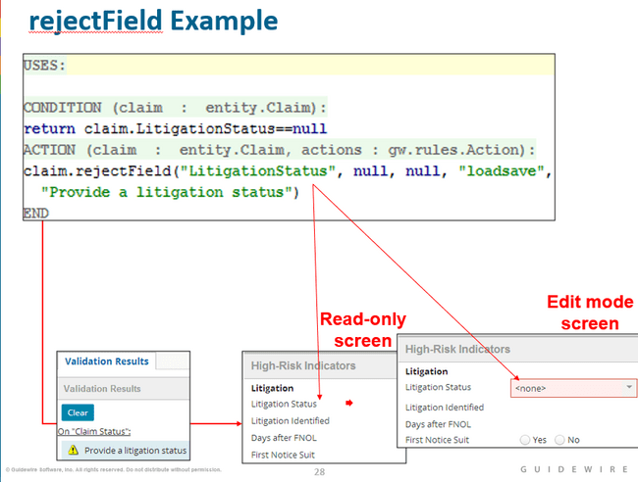

1. When the screen is in read-only mode, the validation results in the workspace at bottom appears but the red outline does not. Instead, a red arrow identifies the offending field.
2. When the screen is in edit mode the field appears in red outline
3. If the user is on another screen, an underlined navigation link to the screen with the maturity validation problem is provided (On “Claim Status”:).

## rejectSubField() method

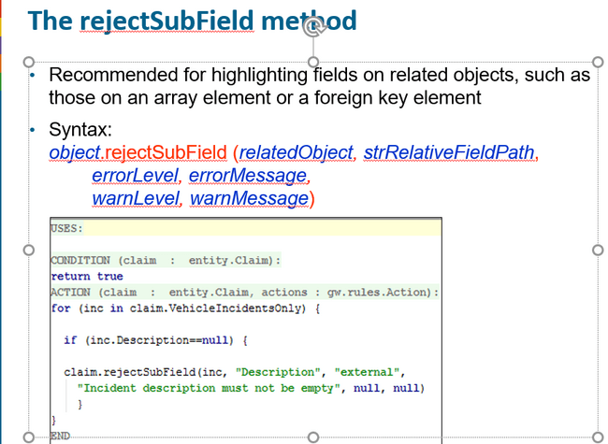

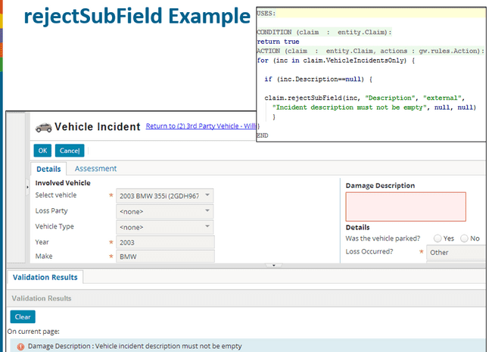

# CLAIMCENTER RULES

## Claimcenter Business Rules

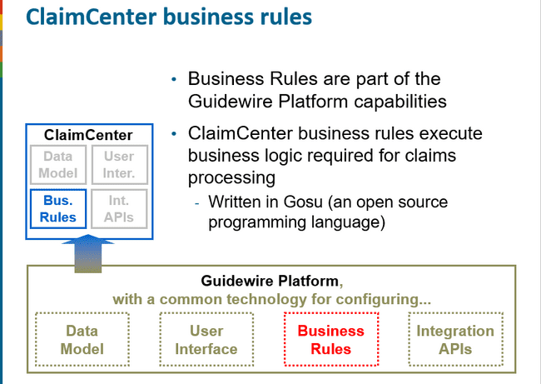

## Business rule set categories

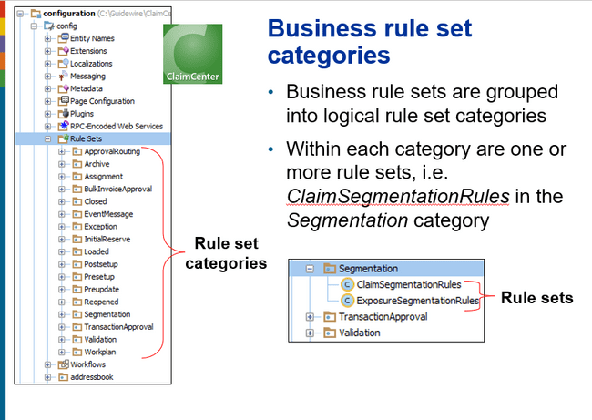

## Business Rule Sets

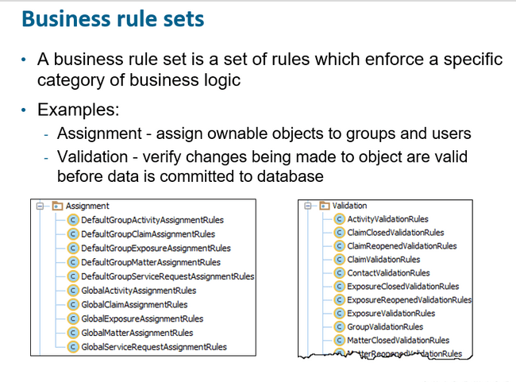

## Business Rule Triggers

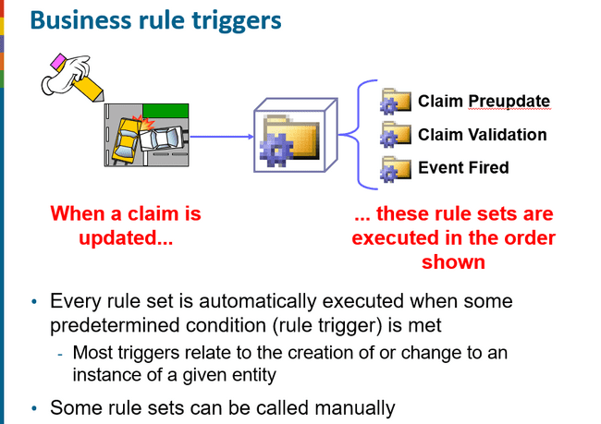

## Business Rule Set Execution Order

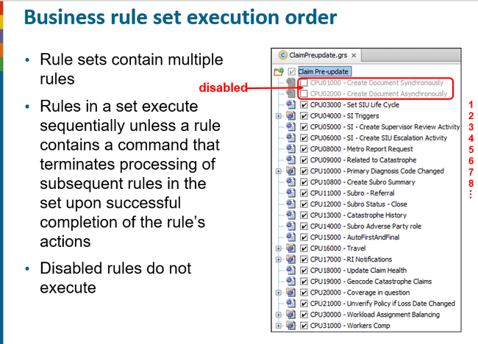

* Claim preupdate and validation rules does not make use of actions.exit() which will prevent other rules to execute.
* Segmentation rules makes use of actions.exit()
* Assignment rules also make use of actions.exit() to terminate rule execution once an activity, claim, assignment, or matter has been assigned.

## Business functions trigger rule set categories

When creating a new claim following rules are triggered in order

* Presetup(set of automatic actions)
* Segmentation categorise)
* Assignment (determine the responsible party)
* Workplan (add initial activities)
* Post setup (set of automatic actions)
* Validation(check for missing information or invalid data)

However, when we are updating the claim only two rule set are triggered

* Preupdate( set of automatic actions)
* Validation( check for missing information or invalid data)

## Claim intake process: automated claim set up

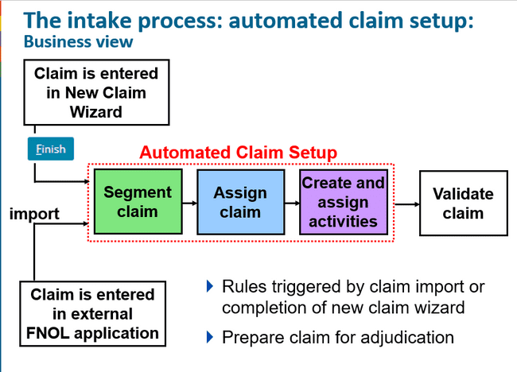

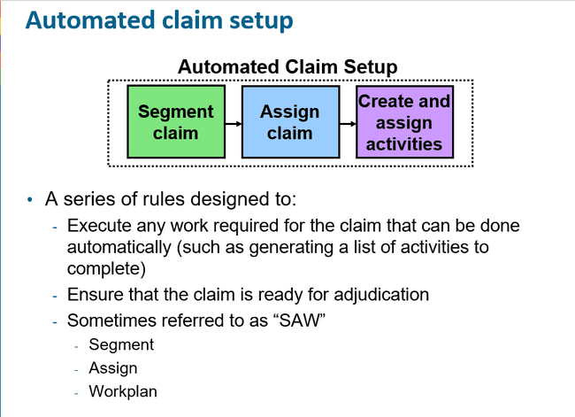

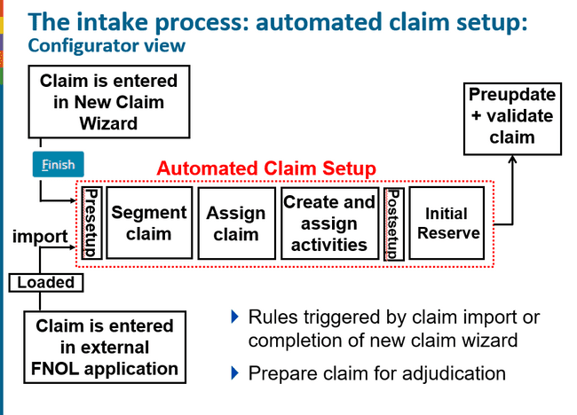

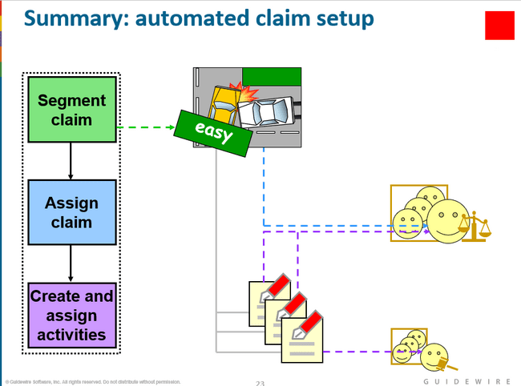

Segment Claim : easy or complex

## Exposure in Claim set up

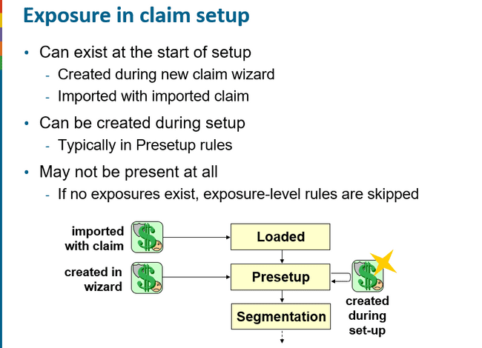

## Loaded Rules

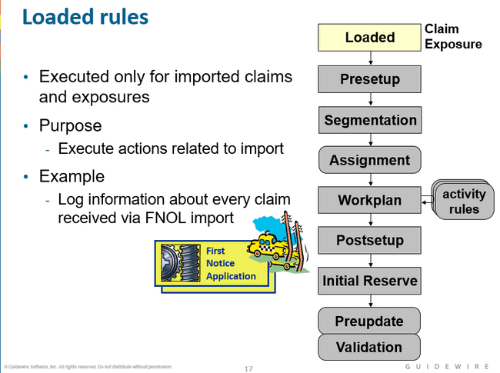

* Claim Loaded rules execute when a new claim is loaded through the FNOL import interface. ClaimCenter executes Loaded rules when it finishes importing or “loading” a claim from an external FNOL source
* The purpose of this rule category is to make any changes necessary to convert initial claim data from an external format into a suitable structure for ClaimCenter. In addition, you can create Loaded rules to record the import of claims.
* You can create whatever rules are appropriate to handle the import of new claims
  + Sanity checks
  + Data aggregations and transformations
  + Data and naming reconciliations
  + Claim import logging

## Presetup rules

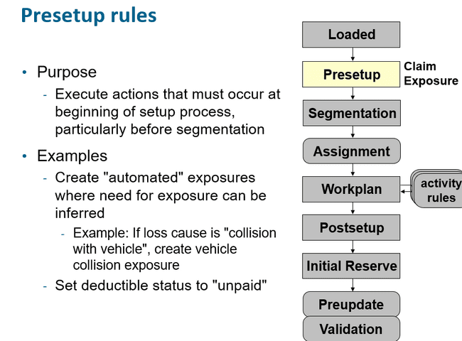

Presetup rules are used to take action on a claim or exposure before it is segmented. This is particularly important since the segmentation (and therefore assignment) of exposures and claims might depend on work performed in the presetup rules.

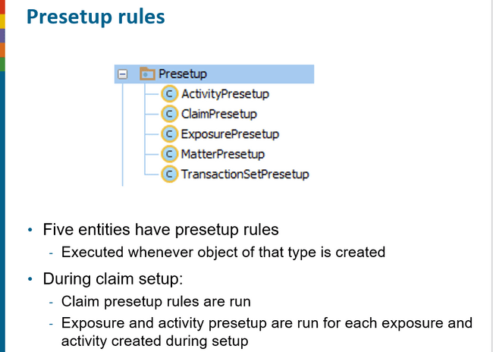

Executed when object is of type is created. When modified its not executed.

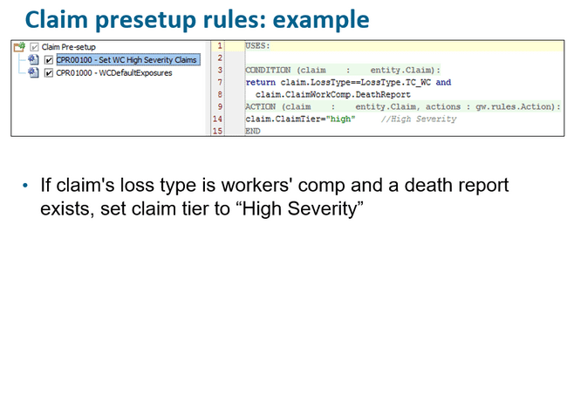

## Segmentation Rules

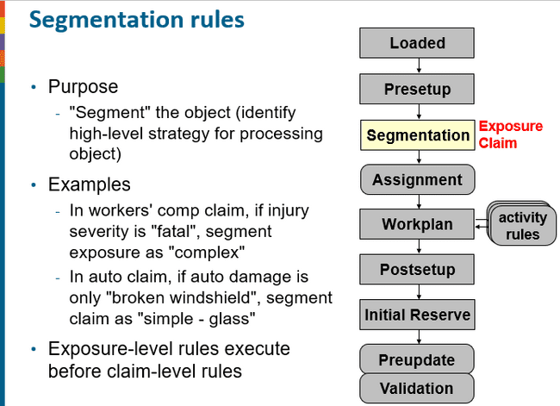

Exposure-level segmentation is done before claim-level segmentation because claim segmentation often depends on the outcome of exposure segmentation.

Segments are high-level categorizations that are used to simplify logic in later rule sets, such as:

* + Assignment routing
  + Activity creation
  + Initial reserves

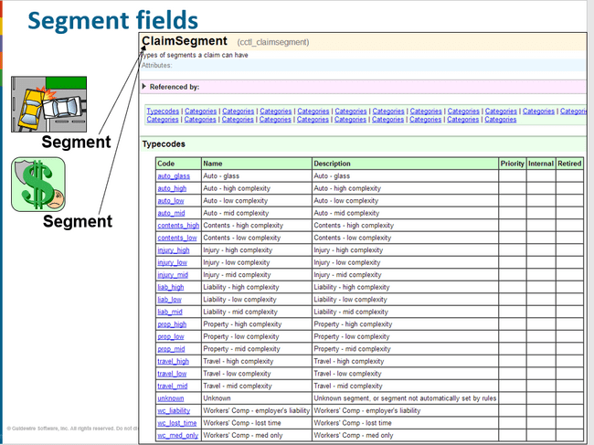

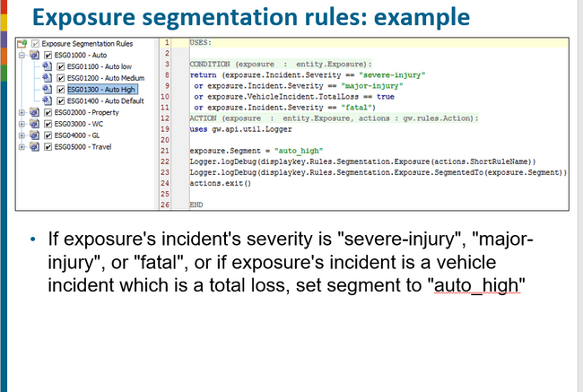

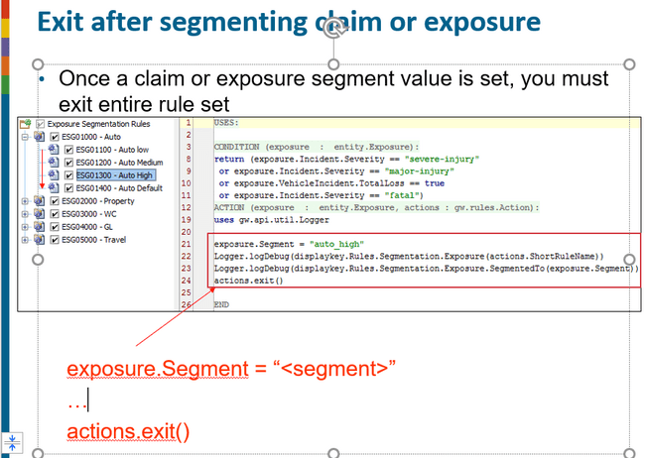

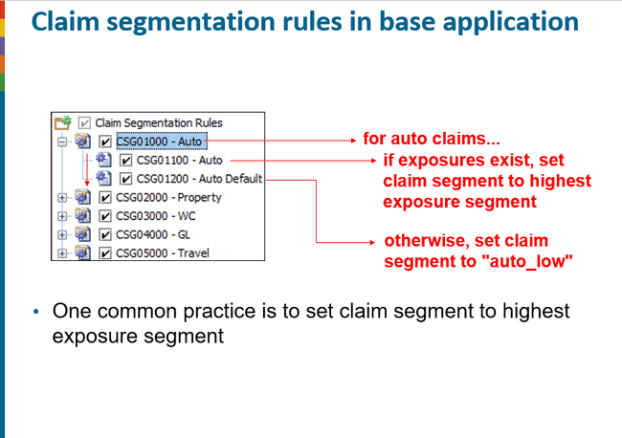

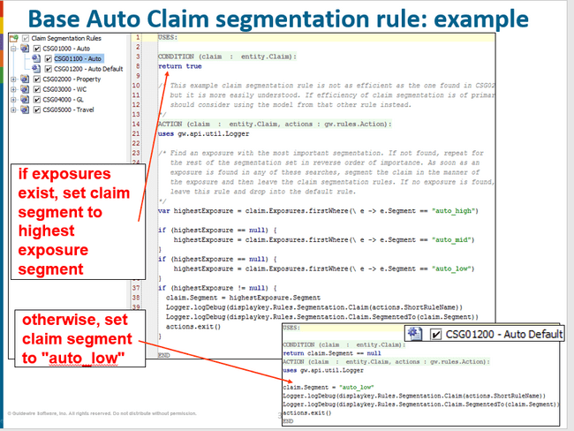

## Assignment Rules

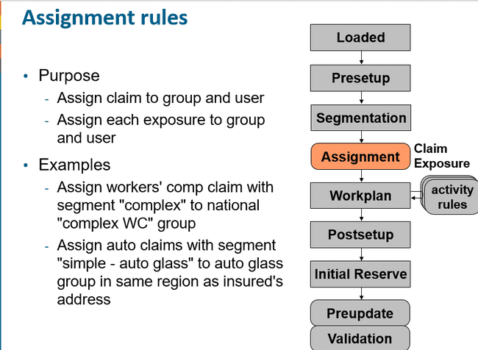

## Segmentation vs Assignment

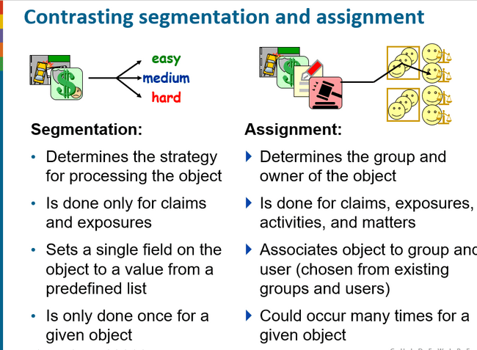

## Workplan rules

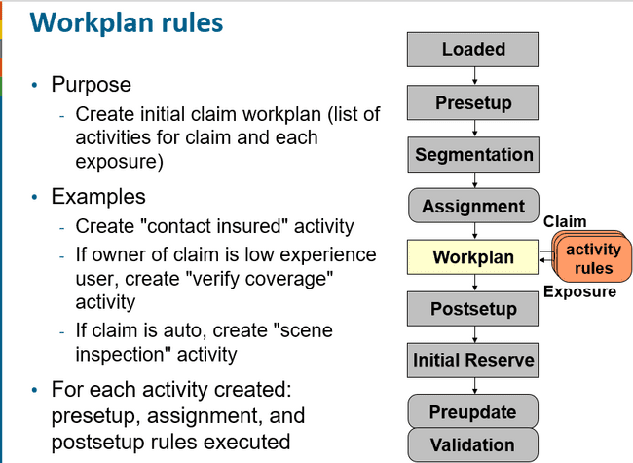

Workplan rules are used to create initial activities for a claim (first) and then the exposure. For example:

* 1. Investigate accident scene (claim level)
  2. Get police report (claim level)
  3. Contact claimant (exposure level)
  4. Get damage estimates for vehicle (exposure level)

Each new activity is run through its own Presetup, Assignment and Postsetup rule set

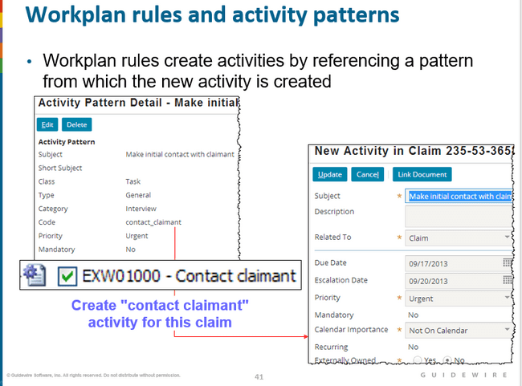

Before you can create a workplan rule which will create a certain type of activity, you must create the pattern for that type of activity

## Activity Patterns

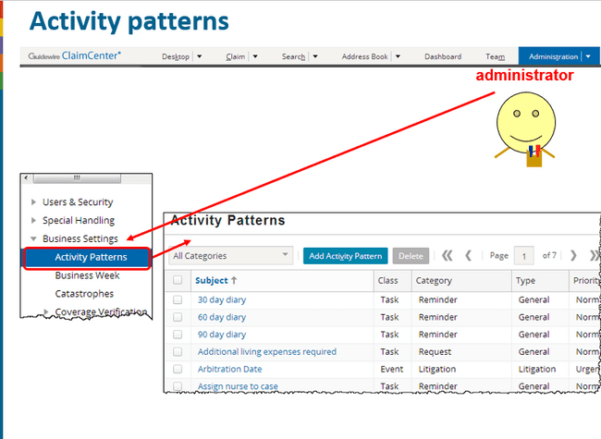

Activity patterns are typically created and modified only by administrators. A user with sufficient permissions to view and edit activity patterns can navigate to the Activity Patterns list by going to the Administration tab and clicking the Activity Patterns menu link

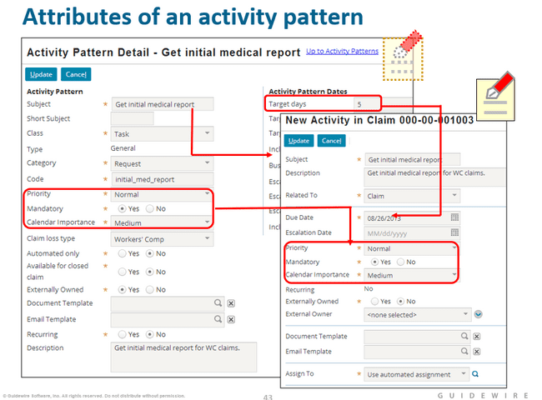

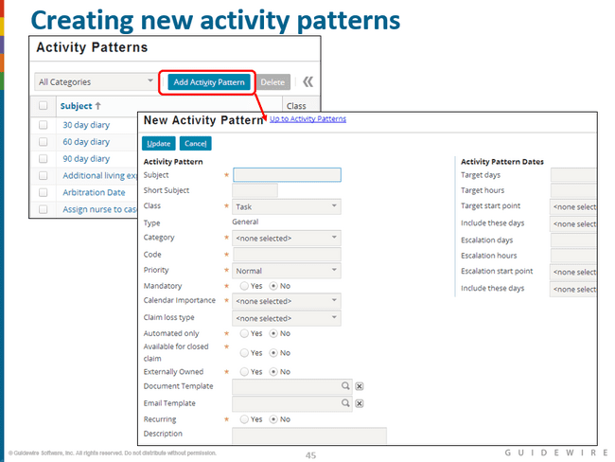

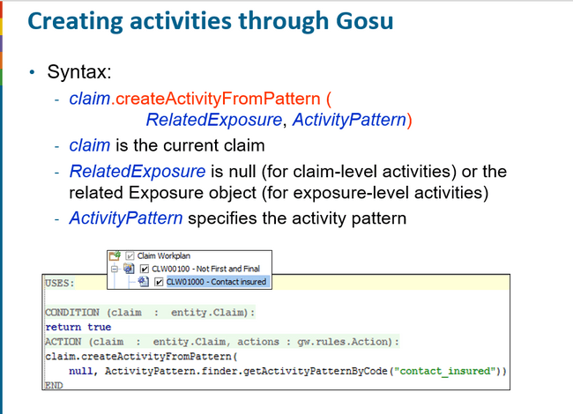

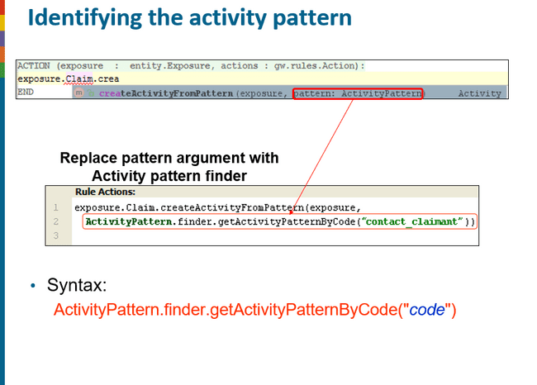

## Post set up rules

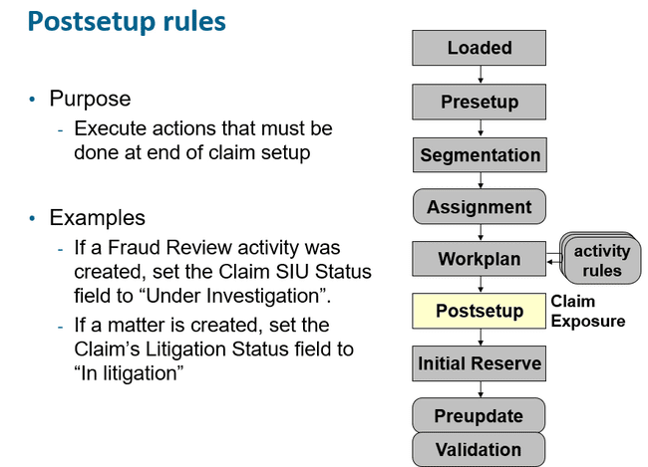

## Initial Reserve Rule

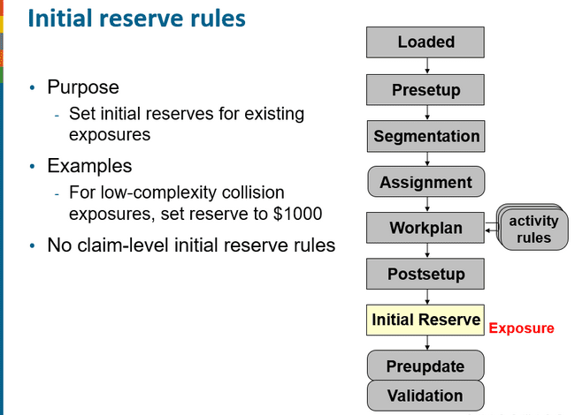

## Preupdate and validation rules

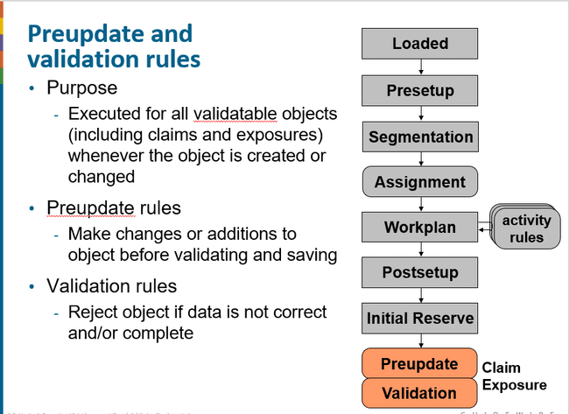

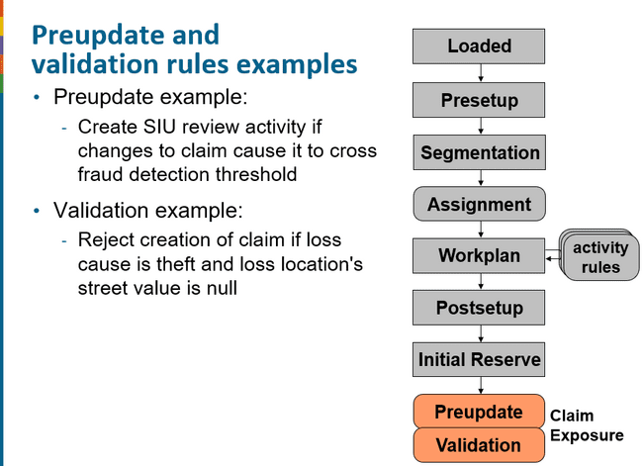

## Rule sets in studio

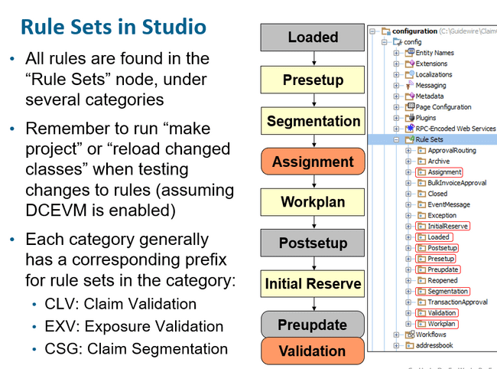

# ENHANCEMENTS

### What is enhancement?

Enhancement is a set of code that enhances the functionality of the guidewire entities.

Enhancement is always entity specific.

### What are the elements of the enhancements?

Enhancements can have the following properties

* Getter ( which calculate the derived values)
* Setter ( which set fields in case additional logic is needed)

### How to use the getter?

Some data does not need to be stored inside the database because it can be derived from other values.

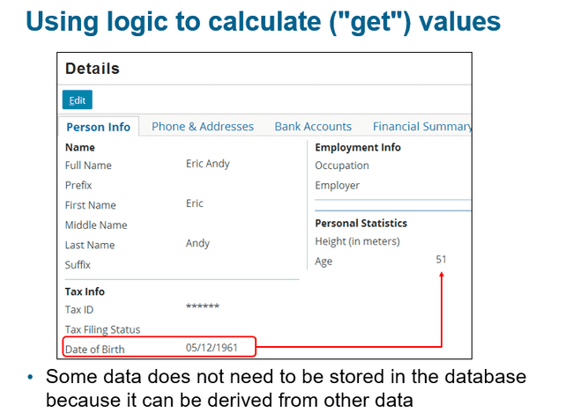

### Getter properties

Getter property is used to calculate a derived value. This property is not declared at the data model level and is neither stored in the database as well.

The property should not be used to alter any data value and is null safe as well.

Example : ABPerson.Age

### Example of enhancement getter

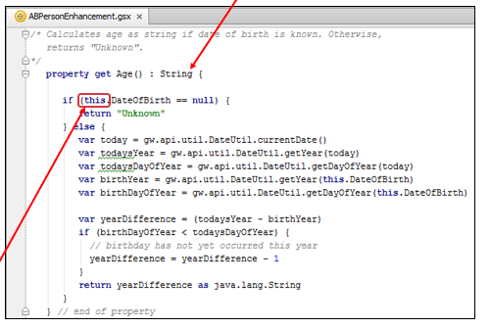

Here this refers to the calling object.

### How to use logic to set values

In some cases, logic is needed to display and modify values in that case we can use setter logic.

Example if the user enters input value in the cm but value stored in database is in meters then the input can be captured using the enhancement which will set the value inside the database in the meters.

Further when trying to view the value getter will be called automatically and using the getter logic, we can display value in whichever order we want.

### Setter property

Setter takes input value and used to modify an associated object. Here also the property is not declared at the data model level. The value modified by the setter is usually stored inside the database.

### Setter Example

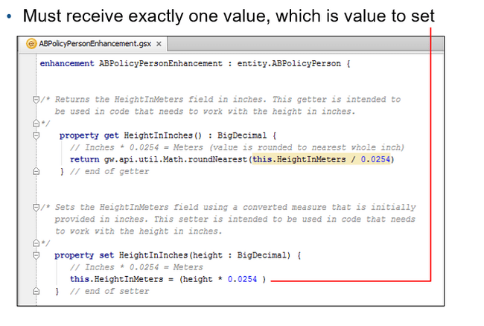

### Enhancement methods

Methods is a set of statements that execute a logical unit of work.

It can receive any number of input arguments and optionally return a value as well.

### Enhancement method example 1

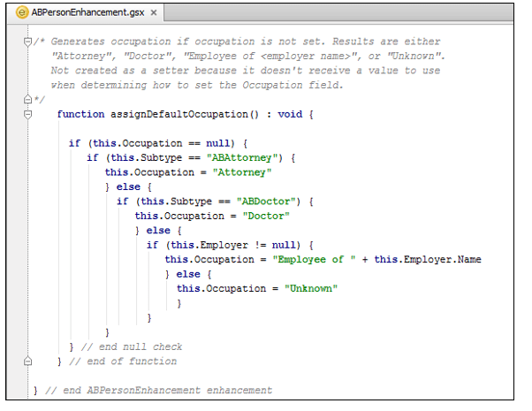

### Enhancement method example 2

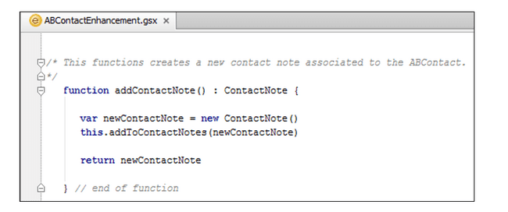

### To whom enhancements are available

Enhancements are strictly available to the given type only.

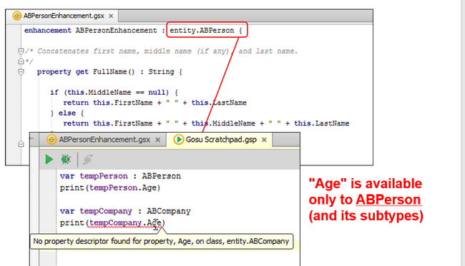

# MISCELLANIOUS

### EDGE FOREIGN KEY

You use the <edgeForeignKey> element to define a reference to another entity, in a manner similar to the <foreignkey> element. However, you use an edge foreign key in place of a standard foreign key to break a cycle of foreign keys in the data model. Guidewire defines this element in the data model metadata files as the <edgeForeignKey> XML subelement.

A chain of foreign keys can form a cycle, also known as a circular reference, in the data model. As an example of a circular reference, entity type A has a foreign key to entity type B, and B has a foreign key to A. Circular references can occur with more extensive chains of foreign keys, such as A refers to B, which refers to C, which refers to A.

The ClaimCenter data model does not permit circular foreign keys reference, because ClaimCenter cannot determine a safe order for committing the entity instances in a circular reference to the database.

For example, entity types A and B have foreign key references to each other. The foreign keys create a circular reference. Suppose that a bundle contains a new instance of A and a new instance of B. The circular reference would cause a foreign key constraint to fail upon committing the bundle. If ClaimCenter commits A before B is committed and, in the database, a constraint failure occurs on the foreign key from A to B. The converse order of committing B before A causes a similar failure.

An edge foreign key in place of a standard foreign key resolves circular references so ClaimCenter can determine a safe order for committing the entity instances within a cycle.

An edge foreign key from A to B introduces a new, hidden associative entity with a foreign key to A and a foreign key to B. The edge foreign key associates A and B without establishing foreign keys in the database directly between them.

With an edge foreign key, ClaimCenter can safely first commit new object A, then new object B, and finally the edge foreign key instance.

### Required vs Local Variables

These are variables which are accessible within the scope of the page.

Local variables are variables which are declared inside a pcf which are not present in the parent pcf or has nothing to do with parent pcf if exist.

These variables can be accessed in the pcf in which it is declared as well as inside the child pcfs as well.

In order to access them in the child pcf we must use the required variables.

So from the parent pcf that variable can be passed to child pcf using the def property.

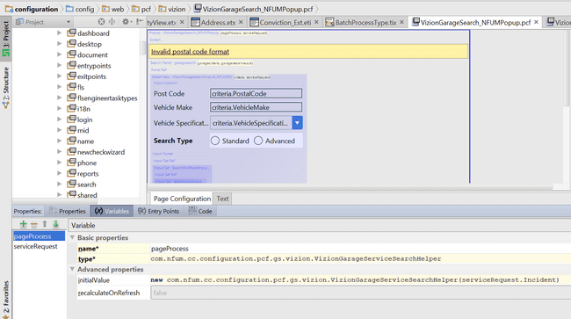

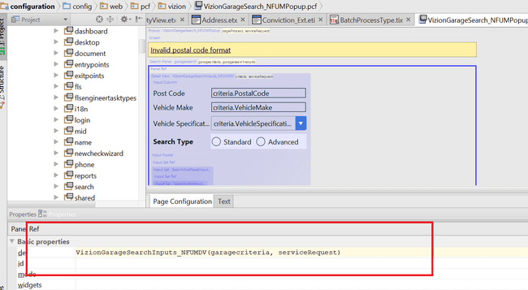

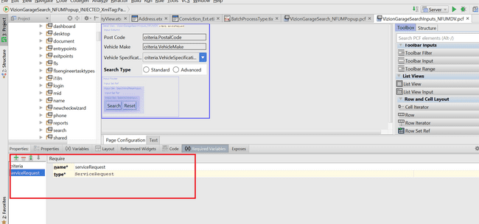

### EffDated Entity

This is an editable entity in guidewire with additional effective date fields meaning start dates and end dates. To create such type of entity just select effdated while creating a new entity from the editor.

Some of the columns which are inherited by the effdated entity includes.

Effective Date: Date at which the entity becomes effective.

Expiration Date : Date at which the entity expires or is no longer effective.

Example of such kind of entity is policy period.

### Implement many to many relationships between two entities

Example we want to create many to many relationships between claim and contact.

1. First create a new entity of type version able in nature.
2. After creating the entity add non nullable foreign key referencing both the entities here claim and contact.
3. Add unique index on each foreign keys.

To access this relationship you need to keep an array reference in either claim or contact.

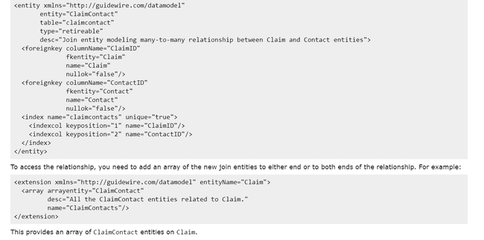

# ClAIMCENTER

## PAYMENTS

### LifeCycle of check

# Practical’s

### List View

#### using nonentity collection

Here I am trying to use list view without using of any entity. It is like trying to iterate through a user defined collection.

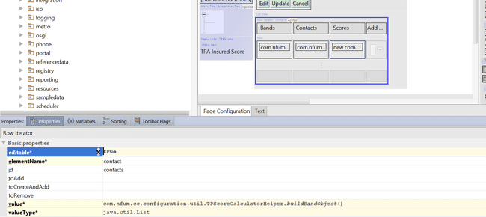

buildBandObject will return a collection item which is nonentity

Here contact is like for each variable. This variable will hold each element of the collection which is accessible through the row.

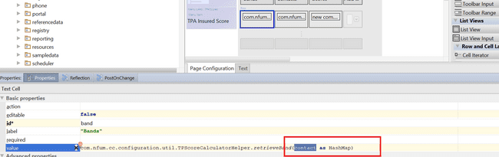

#### Scenario : data model implementation of array

Here in this scenario we are trying to implement a data model having two entities. One is root entity and other is array entity.

The root entity contains reference to the array entity.

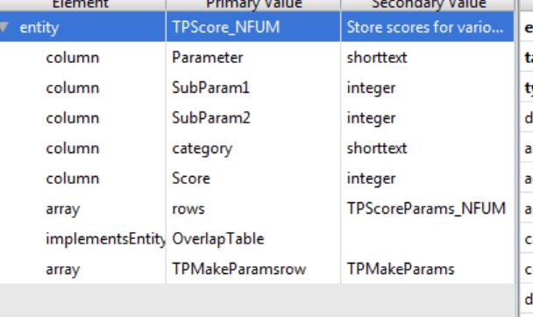

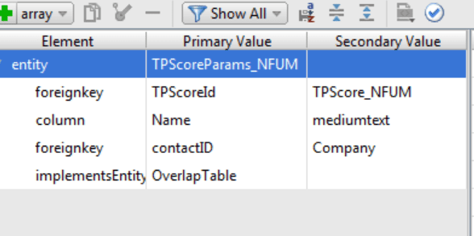

Here one band having score can have many insurer companies which are tracked in the array.

These companies will be added by the user and configuration should be such user will add the companies to the band from interface and that should settle in DB accordingly.

First create the initial object of the band.

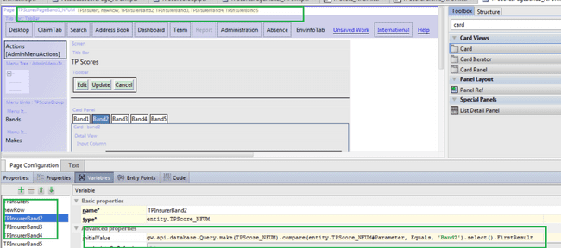

Then create a list view with the iterator buttons associated to row iterator.

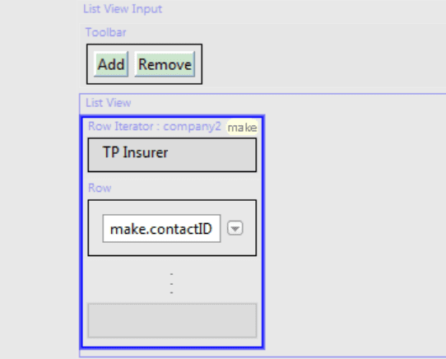

Next we want that whenever user clicks on add button the entry made by the user should create objects and must be put as an array in the main entity.

To do this whenever clicks on Add button, I should create the object of the array entity which should be inserted to the root entity.

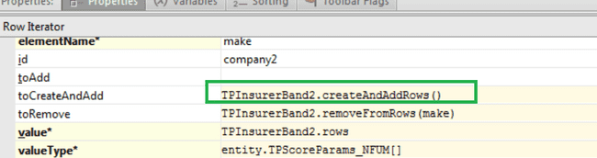

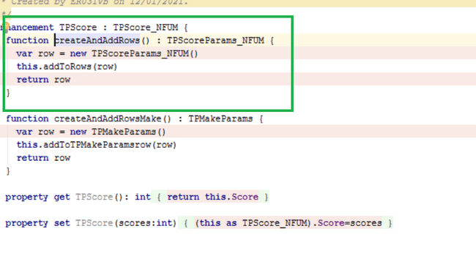

Here the row iterator is going to be of array type so whatever elements user is going to add will be captured by the row iterator and set in the root object as well.

Element name will be used to reference the iterating object of the array of row iterator.

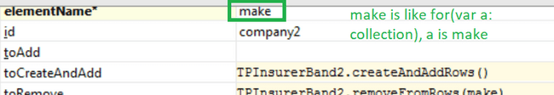

To remove the elements from row iterator main collection.

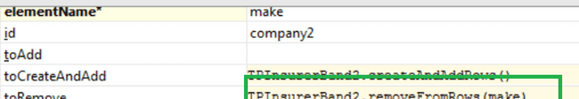

Using row only we will be accessing the iterated element which is present in the elementName

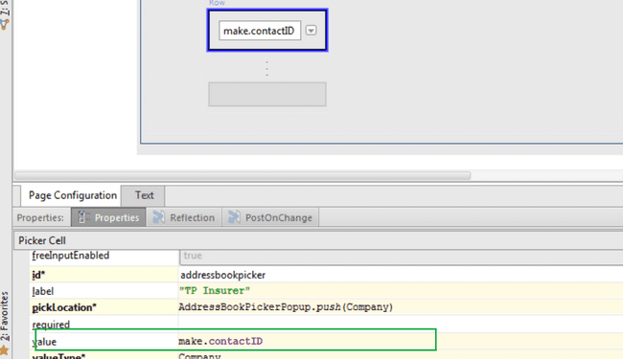

Here value is going to the id be contact id which will be picked from the contact manager using the picker cell.

So, the steps are

User clicks on the add button, which will create one object of array entity and push to main object. For each element of the array row is shown. Here in the row we can set any value which will get adjusted to the model.

Here we are using Contact reference id from the contact manager.

#### Linking widgets

Add the iterator button first

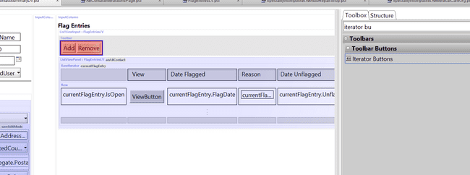

Then click on link widgets

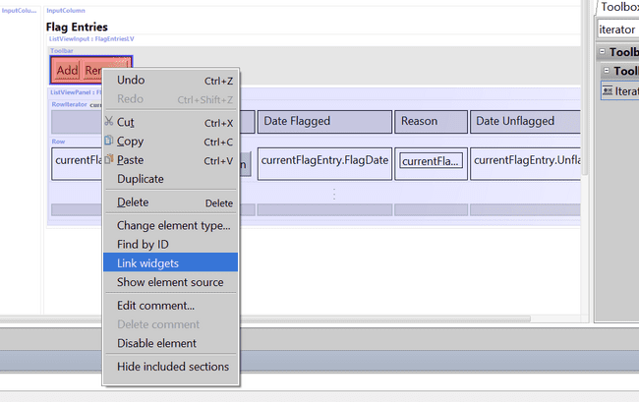

Then click on row iterator button, this click will not be visible.

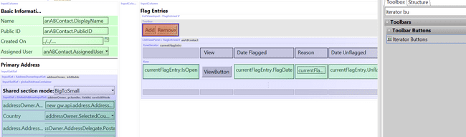

Then click on button.

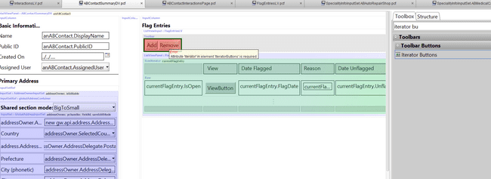

Linking widget using expose

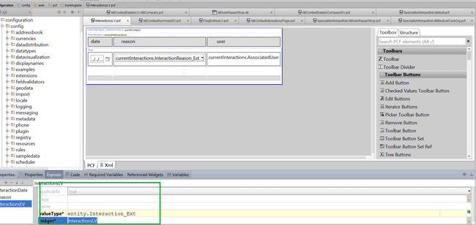

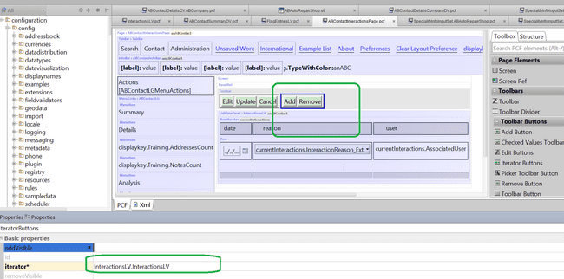

### Modes

#### Lab 1

First create the pcf which we want to show for different business scenario. Here all the pcf will have the same name with different mode in it.

To create the pcf



Here to get the mode active the pcf must be specified as input set only.

Remaining pcf will be created with the same name but with different mode. Here mode is acting as the subtype.

These pcf will be visible in the studio as



These pcf must specify the same required variables which will be passed like a function call from the parent pcf.





In the parent pcf in def section we must specify the name of the pcf and pass the object as the parameter and specify the mode as well. After specifying the mode only, the specific modal pcf will be called.

To note that parent pcf must specify the input reference to access the input set.





### Enhancement

#### Scenario

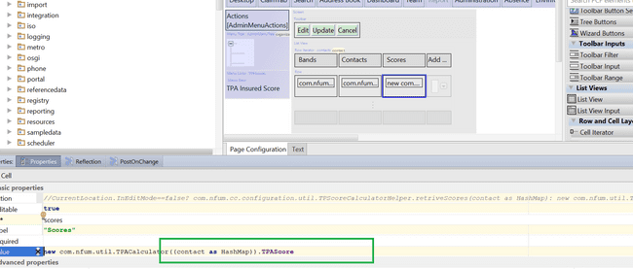

Since here the field is editable and its not associated to any current object of entity type therefore it becomes important to write enhancement getter and setter.

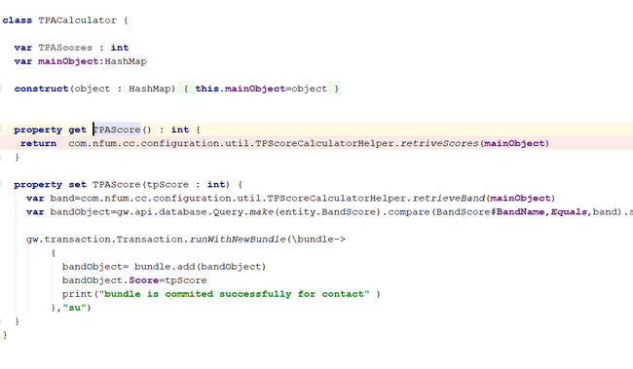

If the score here was associated to some entity and TPAScore was one of its field then we don’t need an enhancement here.

### Nesting of pcf elements

#### DetailView ->Input Column->(TextInput , ListViewInput -> ListView)

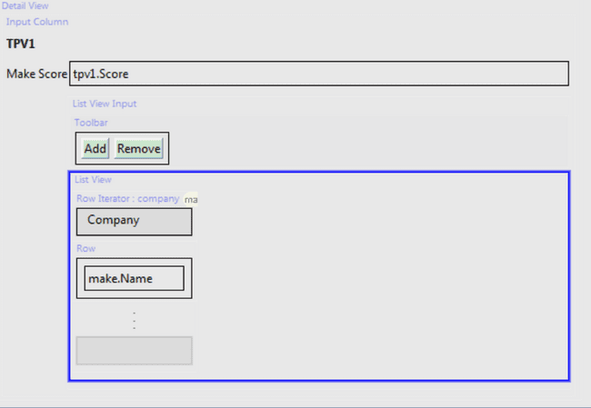

### Queries

#### Intersect operation

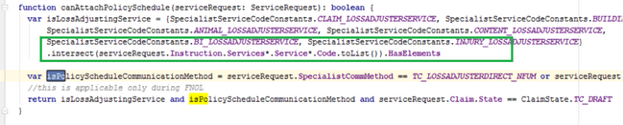

#### Fetch all the elements of collection having sub collection/array

This operation will fetch the common elements between the two list items

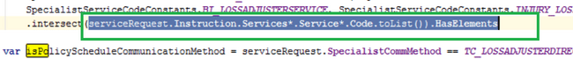

#### Get checks utility

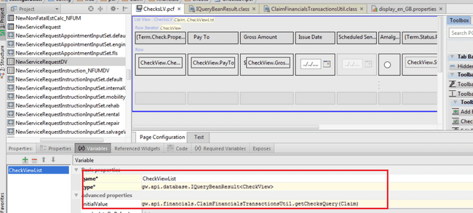

### Operations

#### beforeCommit

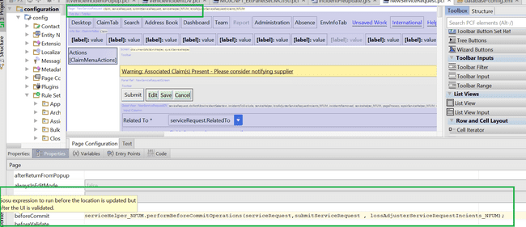

This function will be called when we click upon the ok button of the page, that is once the validation is completed it will be called.

#### Using display key



### Scenarios

#### Helper or virtual classes do not need to use getter

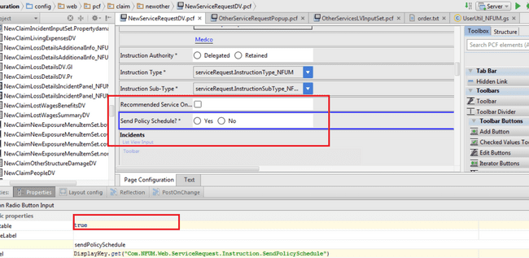

Here the field but the class is helper class and we are not going to persist its fields hence the concept of getter and setter does not come into the picture.

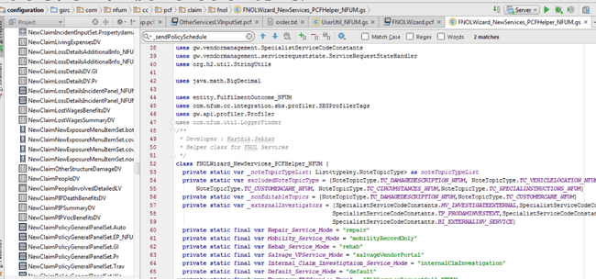

This is a helper class

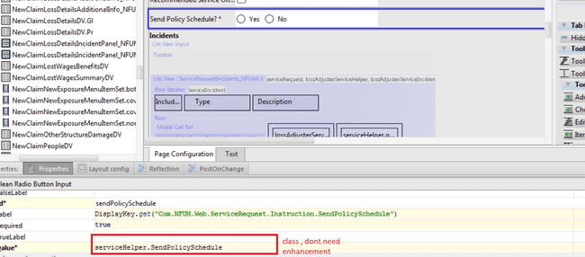

### Web Services

#### Publish and consume demo

This web service is simple demo to fetch contact information from contact manager into claimcenter.

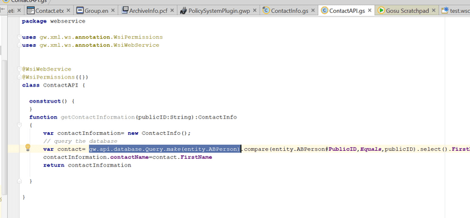

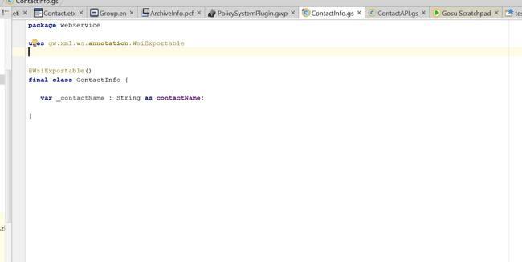

Since our api is going to return an instance of class, hence that class must mandatory be marked as exportable and should be declared as final as well.

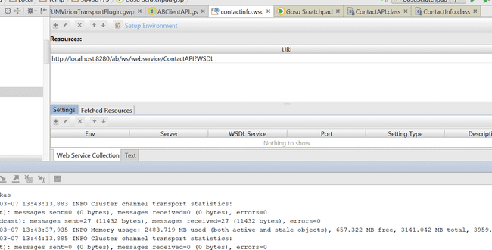

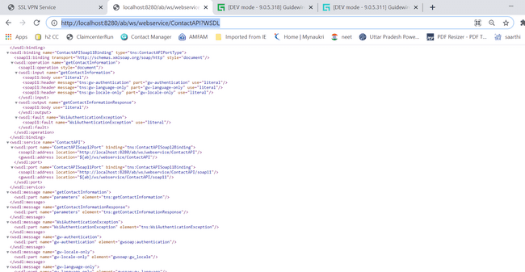

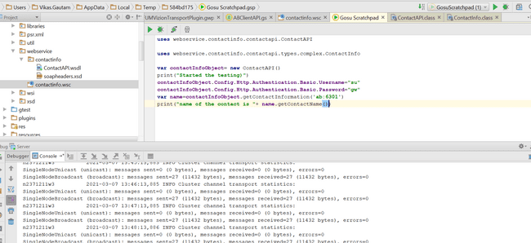

#### Generate wsdl for local service

Here if want to generate a local wsdl for the API we wrote we can go for the command

Gwta regen-wsi-local

